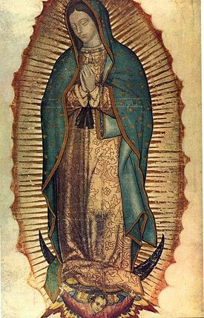
The Virgin of Guadalupe (Virgen de Guadalupe). Miguel González. c. 1698 C.E. Based on original Virgin of Guadalupe. Basilica of Guadalupe, Mexico City. 16th century C.E. Oil on canvas on wood, inlaid with mother-of-pearl.

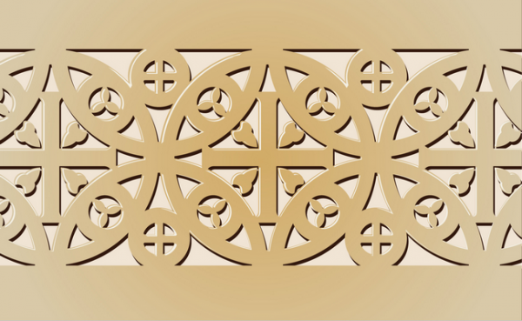
Early Europe and Colonial Americas Module III

This not the work in the image series. Go to http://collections.lacma.org/node/222405.

Citations: https://www.khanacademy.org/humanities/art-americas/new-spain/viceroyalty-new-spain/a/virgin-of-guadalupe

The Virgin of Guadalupe is oil on canvas on wood, inlaid with mother-of-pearl (enconchado). Invented in Mexico, the enconchado technique consisted of placing tiny fragments of mother-of-pearl onto a wooden support or a canvas, and then covering them with a yellowish tint and thin glazes of paint. The technique, which is inspired on Asian decorative arts, imparts a brilliant luminosity to the works due to the iridescence of the shell fragments. Throughout the colonial period there was a significant influx of Asian goods to Mexico via the legendary Manila Galleons that connected the East to the West. The Japanese embassies of 1610 and 1614 to Mexico also contributed to the fashion for Asian inspired objects. Interestingly, at the beginning of the seventeenth century Japan and New Spain made attempts to formalize trade relations, but the effort was thwarted in part due to Japan's desire to curtail contact with the West following the country's unification. As the art historian Sonia Ocaña Ruiz has noted, by the second half of the seventeenth century the importation of Japanese goods to the colony had radically decreased, which may have spurred the creation of Asian inspired objects in New Spain to fulfill local demand (e.g. ceramics, folding screens, and enconchados)

Citations:
http://collections.lacma.org/node/222405

