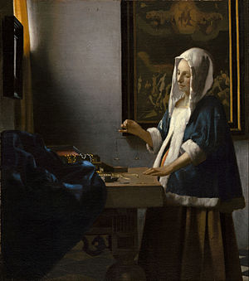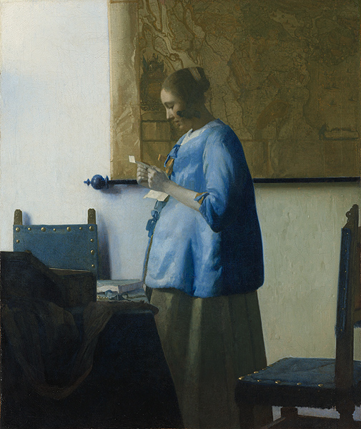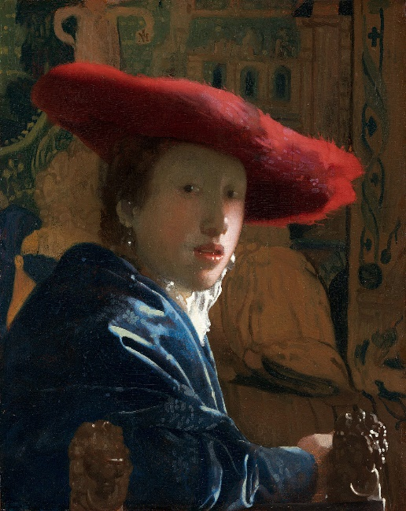

**Vermeer**

**by Howard Nemerov**   
  
Taking what is, and seeing it as it is,  
Pretending to no heroic stances or gestures,  
Keeping it simple; being in love with light  
And the marvelous things that light is able to do,  
How beautiful a modesty which is  
Seductive extremely, the care for daily things.  
  
At one for once with sunlight falling through  
A leaded window, the holy mathematic  
Plays out the cat's cradle of relation  
Endlessly; even the inexorable  
Domesticates itself and becomes charm.  
  
If I could say to you, and make it stick,  
A girl in a red hat, a woman in blue  
Reading a letter, a lady weighing gold . . .  
If I could say this to you so you saw,  
And knew, and agreed that this was how it was  
In a lost city across the sea of years,  
I think we should be for one moment happy  
In the great reckoning of those little rooms  
Where the weight of life has been lifted and made light,  
Or standing invisible on the shore opposed,  
Watching the water in the foreground dream  
Reflectively, taking a view of Delft  
As it was, under a wide and darkening sky.