The Great Sphinx
Giza, Egypt. Old Kingdom, Forth Dynasty. c. 2550-2490 B.C.E. Cut limestone
Source: http://www.ancient-hebrew.org/ancientman/1038.html
By: Andi Sells
Along with many other pieces of this time, it is funerary
Living rock: carved out of existing stone
The Sphinx can be found with the Great pyramids

Face of a pharaoh (Khafre) and body of a lion

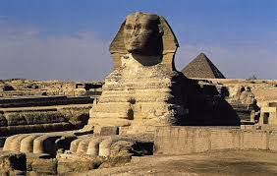
Located on the Giza plateau, on the bank of the Nile River
A lot like the Lamassu in that it is a guardian statue
Very eroded and has lost its nose
Built to guard the pyramid of Khafre
The Sphinx is a total of 65 feet tall
A guardian type structure of the

