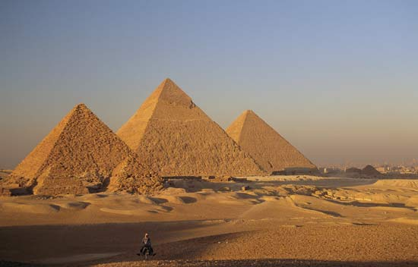
The Great Pyramids of Giza
Context: The weight of the pyramid is estimated to be 5,955,000 tons, if multiplied by 10^8 gives an estimate of earth’s mass.

Form: During the Neolithic era, researchers are working to understand the sophisticated methods they used when building the pyramids
Content: Established to have around 2,300,00 stone blocks that weigh from 2 to 30 tons each and some over 50 tons
Function: The ancient Egyptians built pyramids as tombs for the pharaohs and their queens
Context: The Pyramid of Menkaure and the Great Pyramid of Khufu are precisely aligned with the Constellation of Orion
Cairo, Egypt. Neolithic Era, Limestone, c. 2589-2504 BC
Sources: www.ancient-code.com/25-facts-about-the-great-pyramid-of-giza/

Context: A monument to commemorate the pharaohs Menkaura (one on the farthest left), Khufu (middle and largest), and Khafre (farthest right)
:
Context: The interior temperature is constant and equals the average temperature of the earth, 68 Degrees Fahrenheit

Form: The Great Pyramid (middle one) is so tall that it can be seen from the mountains in Israel and possibly even the moon
Content: Said to have been the tallest structure in the world for 3,800 years
Function: The pyramids are built upward to be closer to the gods

