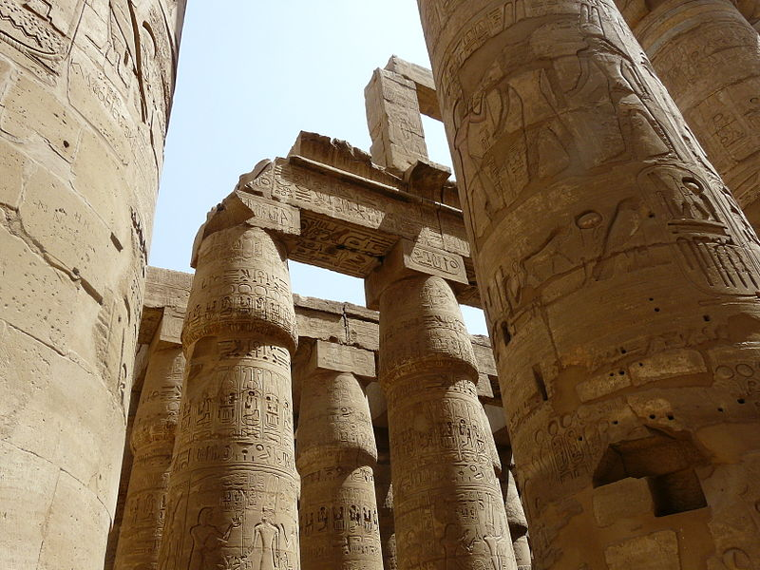
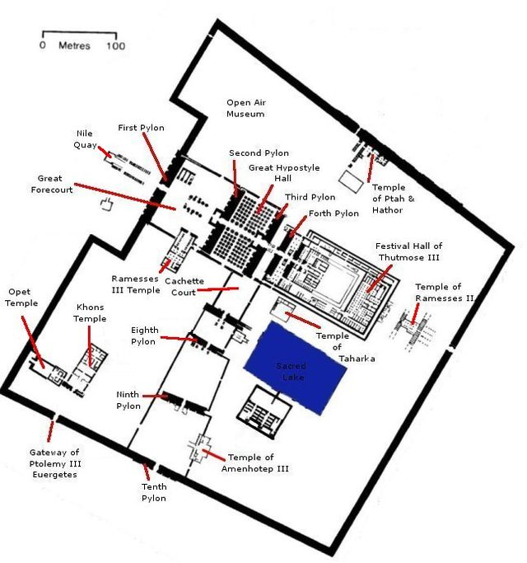

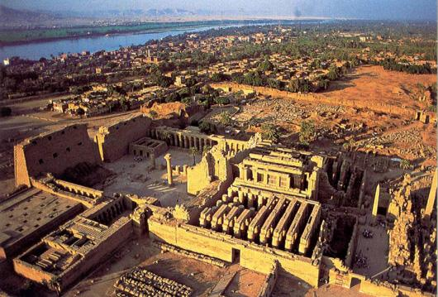

"Temple of amun karnak". Licensed under Public domain via Wikimedia Commons - http://commons.wikimedia.org/wiki/File:Temple_of_amun_karnak.jpg#mediaviewer/File:Temple_of_amun_karnak.jpg

"Karnak-Hypostyle3" by Kurohito - Own work. Licensed under Creative Commons Attribution-Share Alike 3.0-2.5-2.0-1.0 via Wikimedia Commons - http://commons.wikimedia.org/wiki/File:Karnak-Hypostyle3.jpg#mediaviewer/File:Karnak-Hypostyle3.jpg

"Tempelanlage Karnak 2" by RThiele - Own work. Licensed under Creative Commons Attribution-Share Alike 3.0 via Wikimedia Commons - http://commons.wikimedia.org/wiki/File:Tempelanlage_Karnak_2.jpg#mediaviewer/File:Tempelanlage_Karnak_2.jpg

The overall structure of the Egyptian temple was designed to symbolize the universe at creation and was structured to simplify the procession of the god during annual festivals. According to Egyptian mythology, the world emerged as a mound out of a watery void, the model for which was clearly the annual flooding of the Nile. The sanctuary was always located at the highest point of the Egyptian temple because it was supposed to represent this mound. As the floor of the temple gradually sloped upward, the ceiling also sloped downward. The symbolism is that one would move from the brightly lit courtyard into the dark, sacred sanctuary. (www.saylor.org)

In the Egyptian creation myth, the creator god lived in a reed hut atop the primeval mound. The massive stone structure of the Egyptian temple symbolized this most basic form. The temple primarily is the residence of the god, where he/she could be fed, clothed, and cared for. During its annual festival, the god statue would be taken from the temple, symbolically reenacting life’s emergence from the watery void. (www.saylor.org)

1.
The key difference between Karnak and most of the other temples in Egypt is the length of time over which it was developed and used. Construction of temples started in the Middle Kingdom and continued through to Ptolemaic times. Thirty pharaohs contributed to the buildings.

2.
The first pylon, which is the current entranceway to the great Temple of Amun-Re, is composed of two massive blocks framing a large portal. The pylon is the rising sun- the ceremonial entrance way. In the view of a temple being a symbol of creation, the pylon represents the edge of the world- the horizon separating non-creation (the outside) from creation (the temple). The walls of the pylon are often decorated with carved and painted scenes of the pharaoh, gods and goddesses, but his one is plain. On the west face of each block, vertical grooves served to house the poles for flags. Two huge wooden doors that were only opened on very special occasions and during festivities once blocked the entrance to the temple. (http://www.egyptvoyager.com/karnak.htm)

3.
The courtyard was a large open room without a roof. The open court symbolizes the land.. The columns along the northern and western walls stand for the vegetation that usually grows on the edge of the land. The inner walls showed the pharaoh making offerings to the gods and goddesses. The outer walls showed scenes of the pharaoh in battle. People were only allowed to enter the temple courtyard on festival days. The priests performed purification rituals in the courtyard so that they and the king could enter the temple. Altars featuring burnt offerings or animal sacrifices were located on the sides.

4.
The Great Hypostyle Hall of Karnak, located within the temple complex refers to a to
hall covering an area of 50,000 square feet. 134 papyrus capital columns in 16 rows supported the roof; the 2 middle rows are higher than the others. The columns are 33 feet (10 m) in circumference and 80 feet (24 m) tall.

5.
Originally the stone above the capitals supported a massive roof, with only small clerestory windows. Purposefully, these small windows provided dim lighting for the symbolism of this room. The hall represented a papyrus swamp at the beginning of time. The taller middle columns represented open papyrus plants that are further developed in their growth, owing to their being nearer to the daylight. The outside columns were closed papyrus buds. Only the priests and the pharaoh would be allowed to enter the hall. This room would have been used for performing religious rituals. (http://www.ancientegypt.co.uk/temples/explore/hypo.html)

6.
The walls of the Great Hypostyle Hall were, like most other walls, covered with representations of Amun, the principal deity of the temple. The pharaohs are often shown presenting offerings or performing rituals for the gods. Very common themes represented on the outside walls are hunting and war scenes, showing the victorious pharaoh hunting down and destroying the forces that oppose the forces of creation.

7.
Lying at the end of the temple’s main axis through a set of double doors was the most sacred part of the temple, the sanctuary. Only the king and high priest could enter. In larger temples, the sanctuary was separated from the hypostyle hall by additional halls or chambers like the offering hall, where sacrifices to the god were made. In the sanctuary, the statue of the god was often housed. The structure of the sanctuary was based on a simple reed hut whose walls were decorated with reliefs illustrating cult practices. The main image representing the god was usually made of precious materials. (www.saylor.org)

