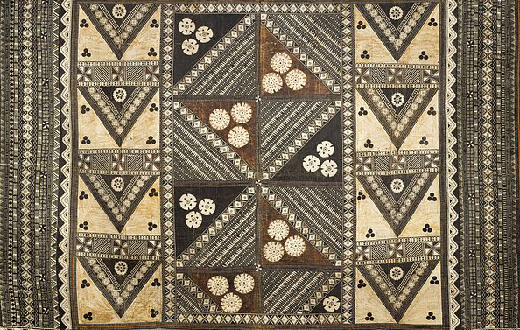

Pacific Arts

Tamati Waka Nene. Gottfried Lindauer. 1890 C.E. Oil on canvas
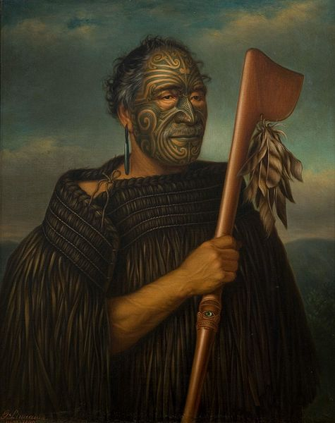

Photo Citation: Gottfried Lindauer [Public domain], via Wikimedia Commons

Gottfried Lindauer was born in Pilsen, Bohemia in 1839. He trained as a portrait and figure painter at the Academy of Fine Arts in Vienna. In 1873, Lindauer immigrated to New Zealand and immediately travelled widely. The artist secured many portrait sittings from prominent Māori.
The work is a portrait of a Maori man, Tamati Waka Nene, a leader of Ngati Hao who converted to Wesleyan Christianity and welcomed trade with Europeans. He wears the distinctive tattoos of the culture, the ta moko.
“In pre-European Māori culture, many if not most high-ranking persons received moko, and those who went without them were seen as persons of lower social status. Receiving moko constituted an important milestone between childhood and adulthood, and was accompanied by many rites and rituals. Apart from signaling status and rank, another reason for the practice in traditional times was to make a person more attractive to the opposite sex (Wikipedia).”

Citation:
""Tamati Waka Nene," by Gottfried Lindauer (1890) — Fine Art Print." Renfield's Garden. Web. 12 Apr. 2015. <http://www.renfieldsgarden.com/product/tamati-waka-nene-gottfried-lindauer-1890/>.
Tā Moko." Wikipedia. Wikimedia Foundation. Web. 12 Apr. 2015. <http://en.wikipedia.org/wiki/Tā_moko>.

