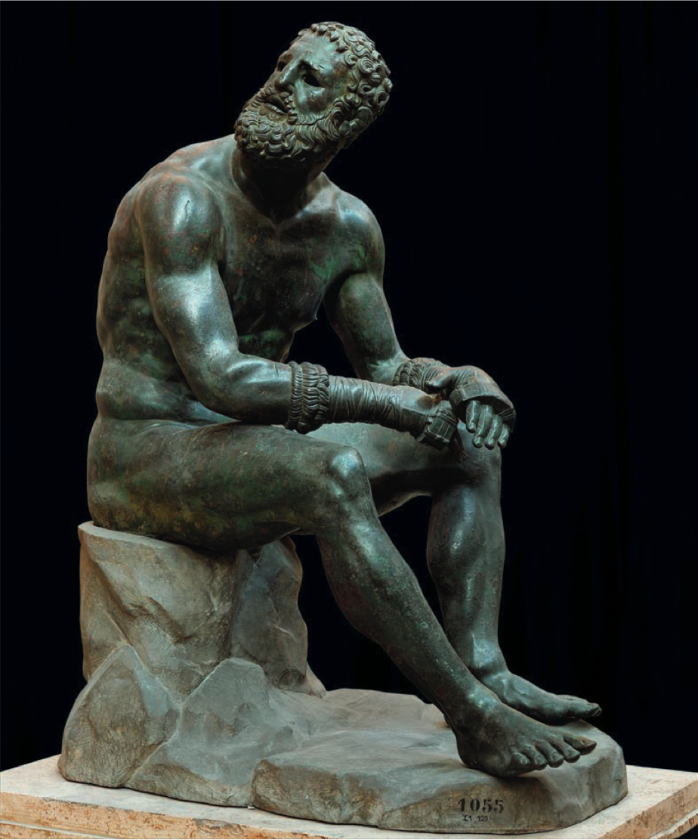

Content: There is copper inlaid in the boxer’s wounds to show that he has been injured.

The Seated Boxer

Apollonius

Bronze

Life size

Form: Although he looks defeated, he also has a presence as if he was ready to get up and fight again because of his tense muscles.

Function: To Show emotion, sadness, and defeat through the sculpture’s face and form.

Form: The way he is positioned, in not only a seated position but a very slouched one, shows that he is suffering and exhausted.

Context: It is believed to be from someone’s bath which back then was used as a place to clean yourself as well as a social place.

Context: Greek boxing focused on hitting the other person’s head rather than their body which is why he has many injuries to the face and his body still looks good.

Form: He doesn’t have any eyes, just eye sockets. Usually there would be eyes inlaid there, probably made out of ivory.

Content: This is one of the only Greek sculptures that wasn’t marble. Most of the bronze statues were melted down so the metal could be reused.

Context: In Hellenistic Greece, the people portrayed in these sculptures were less beautiful and “god-like” compared to classical Greek art and more like average people.

Context: Created in Hellenistic Greece. This time was known for having emotion shown through art.