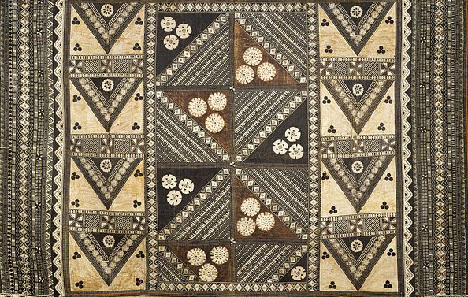

Pacific Arts

Navigation chart. Marshall Islands, Micronesia. 19th to early 20th century C.E. Wood and fiber
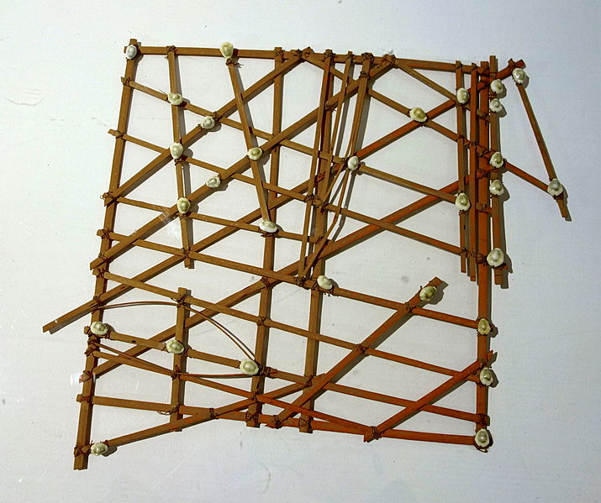

Image Citation: By Velvet (Own work) [CC BY-SA 4.0 (http://creativecommons.org/licenses/by-sa/4.0)], via Wikimedia Commons

The Marshall Islands in eastern Micronesia consist of thirty-four coral atolls spread out over an area of several hundred miles. In order to maintain communication between the islands, the Marshall Islanders built seafaring canoes. The islanders developed a name for their ability to navigate between the islands.
In order to determine a system of navigation, the islanders created charts that marked the locations of the islands as well as the swell and wave patterns. The charts were made of wooden sticks made of coconut fiber. The horizontal and vertical sticks are the supports, while the diagonal and curved ones symbolize the wave swells. Cowrie or other small shells represent the location of the islands. The charts were not constructed to scale, and navigators memorized the chart before the journey was made.
Charts were highly individualized. Sometimes, the person who made the chart could only read it.

Citation:
"Navigation Chart (rebbelib)." British Museum. Web. 12 Apr. 2015. <http://www.britishmuseum.org/explore/highlights/highlight_objects/aoa/n/navigation_chart_rebbelib.aspx>.

Citation:

