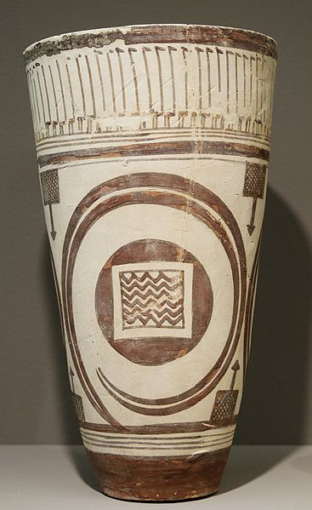
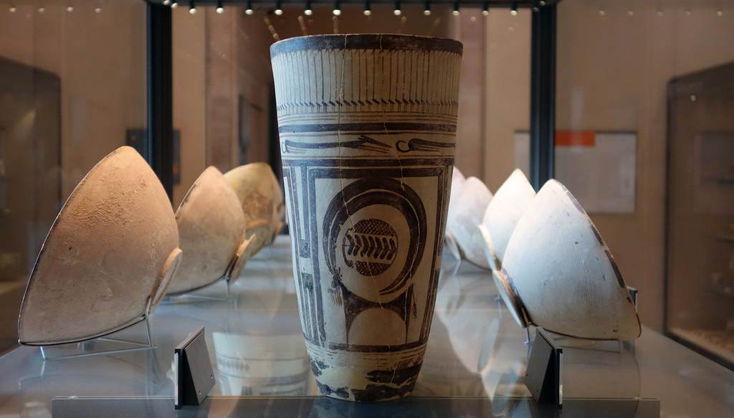
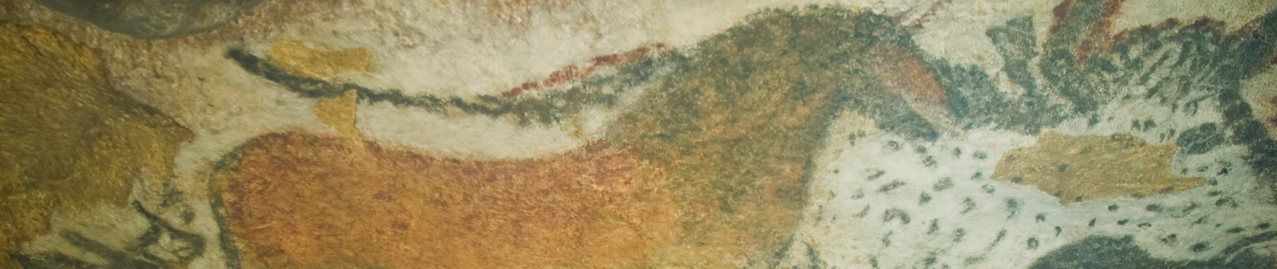
Citation: FlickFlickr/License/profzucker/https://www.flickr.com/search/
?l=deriv&q=bushel%20with%20ibex

© Marie-Lan Nguyen / Wikimedia Commons /
CC-BY 2.5, via Wikimedia Commons

Bushel with Ibex Motifs, Susa, Iran. 4200 – 3500 B.C.E. Painted terra cotta.
This large, hand built ceramic vessel a stylized decoration that symbolizes the environment of the first agricultural communities of the ancient Near East. This bushel could have been used for the storage of items, again showing a shift to a more stable community. The bushel was found in a funerary area, indicating the importance of death in the society. The people were becoming even more aware of their natural surroundings, being able to find clay and heat it to a certain temperature to harden the clay.

A frieze of water birds runs around the top. The repeated parallel lines of their necks, which suggest a flock, create rhythm. (Caubet)
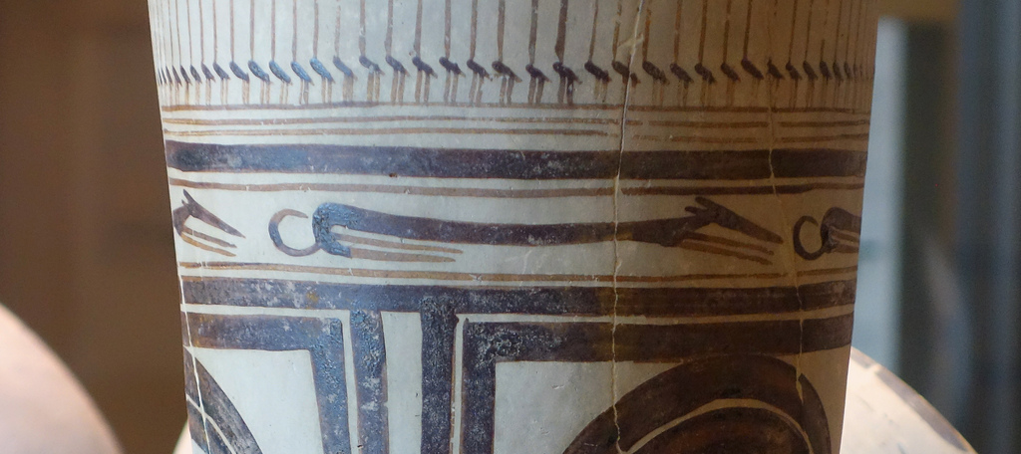

Flickr/License/profzucker/https://www.flickr.com/search/
?l=deriv&q=bushel%20with%20ibex
The next register depicts running dogs with long, slender bodies. These canines are possibly the ancestors of the salukis, hunting dogs. (Caubet)
Flickr/License/profzucker/https://www.flickr.com/search/
?l=deriv&q=bushel%20with%20ibex

The main register of the vase is decorated with large rectangular panels. Some historians believe that these shapes may symbolize fields and villages and waterways. In the center of teach panels is the majestic figure of the ibex, a large mountain goat. Created with geometric forms, small details such as the beard and tail make the goat easily recognizable. Its abstracted, oversized horns fill the negative space.
(Caubet)
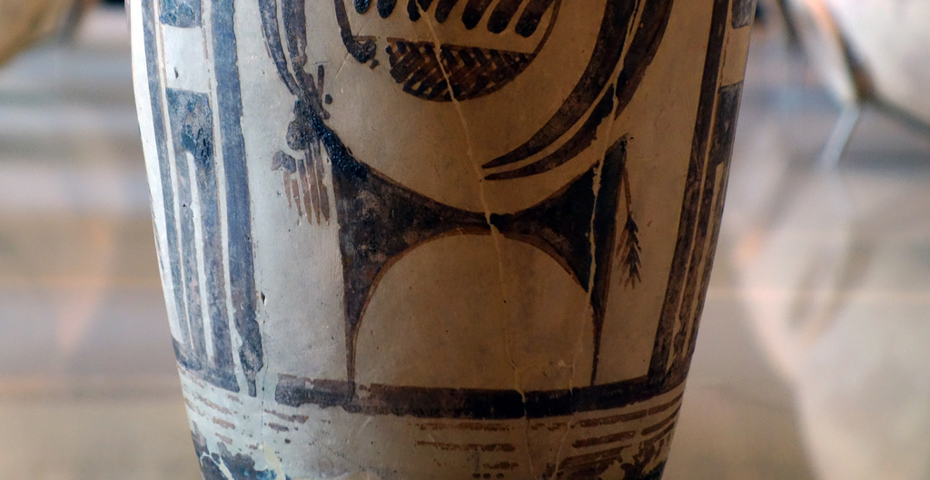

Flickr/License/profzucker/https://www.flickr.com/search/
?l=deriv&q=bushel%20with%20ibex

Citation:
Caubet, A. (n.d.). Bushel with Ibex Motifs. Retrieved September 28, 2014, from http://www.louvre.fr/en/oeuvre-notices/bushel-ibex-motifs

More Information:

http://smarthistory.khanacademy.org/susa-ibex.html
http://www.louvre.fr/en/oeuvre-notices/bushel-ibex-motifs

