Tlatilco female figurine. Central Mexico, site of Tlatilco. 1200–900 B.C.E. Ceramic
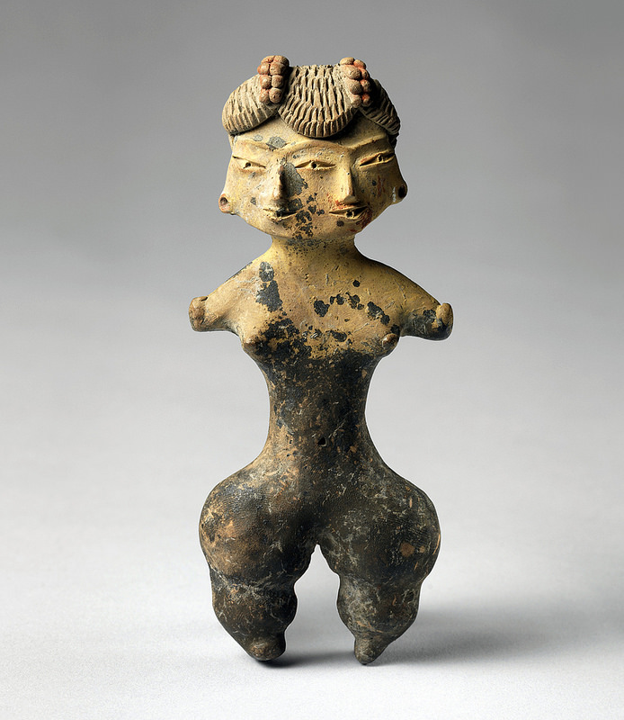
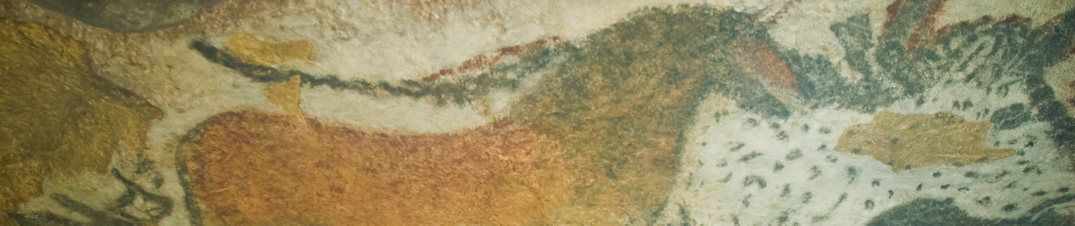

Citation:Flickr/Steven Zucker/ https://www.flickr.com/photos/profzucker/15611689328/sizes/c/

.

Many Tlatilco figurines show deformities or other anomalies, including a "duality" mask and several two headed figures. This has led some researchers to wonder whether Tlatilco was perhaps a cluster site for conjoined twins.
The name "Tlatilco" means "the place of occult (or hidden) things". The name was given by a group of Nahuatl speakers because when they arrived in the valley, the culture of Tlatilco had already disappeared.(Wikipedia/Tlatilco)
Female figurines similar to this one have been found in excavated ancient sites, throughout Central Mexico. The primary material used by the Mesoamerican cultures was clay. Although little is known about the function of these objects in Pre-Columbian society, it has been suggested that they are related to fertility and maternity. The figures are small and were found in burials for accompanying the deceased in the afterlife as well in dwellings. The characteristic qualities of works like this one are small breasts, cinched waists, stump-appendages, and thick thighs. Some of the female statuettes are naked while others wear short skirts and wear jewelry. This detailed ornamentation may indicate role or status. ("Precolumbian Collection." )

Citations:
"Precolumbian Collection." Precolumbian Collection. Web. 4 Oct. 2014.
"Tlatilco." Wikipedia. Wikimedia Foundation, 26 Sept. 2014. Web. 4 Oct. 2014. <http://en.wikipedia.org/wiki/Tlatilco>

