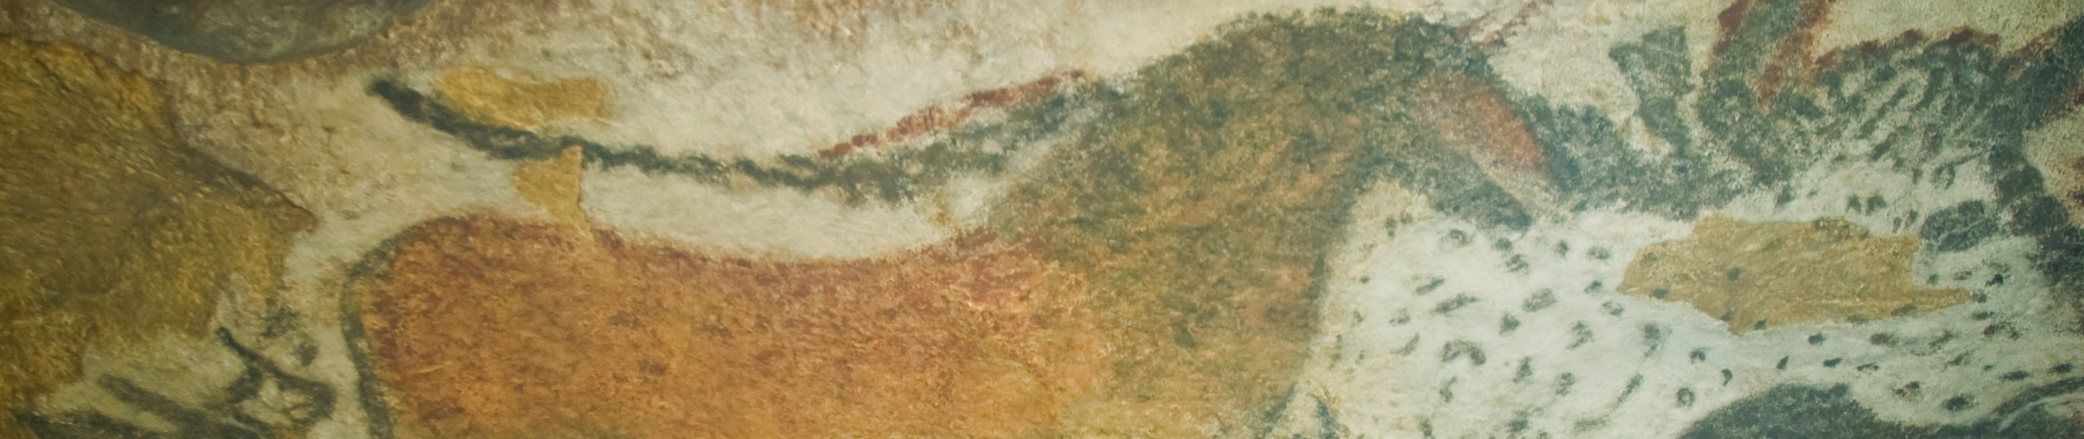

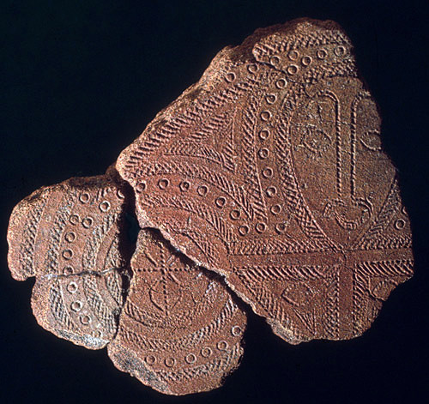
Terra cotta fragment. Lapita. Solomon Islands, Reef Islands. 1000 B.C.E. Terra cotta (incised).

Image Citation: Flickr/ProfZucker https://www.flickr.com/photos/profzucker/15612056877/sizes/o/
The term Lapita refers to an ancient Pacific culture that archaeologists believe to be the common ancestor of the contemporary cultures of Polynesia. The term 'Lapita' was coined by archaeologists after mishearing a word in the local language, xapeta'a, which means 'to dig a hole', during the 1952 excavation in New Caledonia (Wikipedia, http://en.wikipedia.org/wiki/Lapita).
Lapita art is best known for its ceramics, which feature intricate geometric patterns that occasionally include anthropomorphic faces and figures. The low-fired earthenware pottery is typically decorated with a dentate (toothed) stamp. It has been theorized that these decorations may have been transferred to or from less hardy mediums such as tapa (bark cloth), mats or tattoos (Wikipedia).
Each stamp consisted of a single design element that was combined with others to form intricate patterns. In this example, a stylized human face is incorporated into the intricate circular designs.
Many Lapita ceramics are large vessels, and it is thought that they were used for cooking, serving, or storing food. (Wegella)

Citation:
Wegelle, J. (2000, January 1). Lapita Pottery. Retrieved September 27, 2014, from http://www.metmuseum.org/toah/hd/lapi/hd_lapi.ht

