Athenian agora. Archaic through Hellenistic Greek 600 B.CV.E. – 150 C.E. Plan  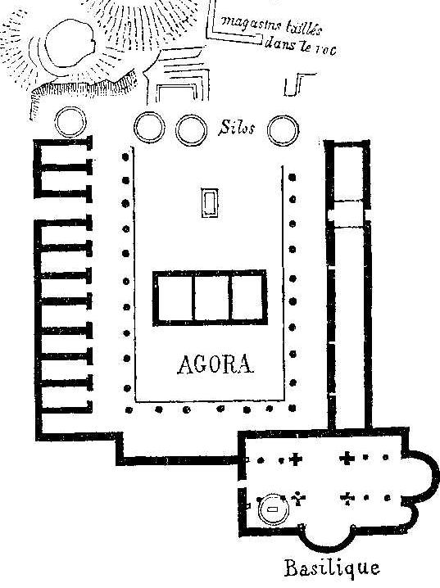  agora.jpeg | Content:  The agora is an open space or square used for the congregation of a city.  The agora is the center of the city.  The agora is placed on the hill in the center of Athens showing it is a place of importance and power.  Style:  It was built at the convergent place of the three roads to and through Athens.  Contextual Analysis:  The Athenian agora was the first known plan of a local meeting place amongst a city that is specifically designed for politics and town center. The term agora is not special to Athens, however it appears that Athens had the first intentionally planned and constructed agora. Within the agora market places flourished and it was an area where all classes could meet.  The Athenian agora was sacked and rebuilt many times and sets the stage for the layout of cities for many years to come.  The thought behind the agora and having a town meeting place builds the trend for modern Western civilization.  The Athenian agora still today is an important part of the city, however it has been modernized.
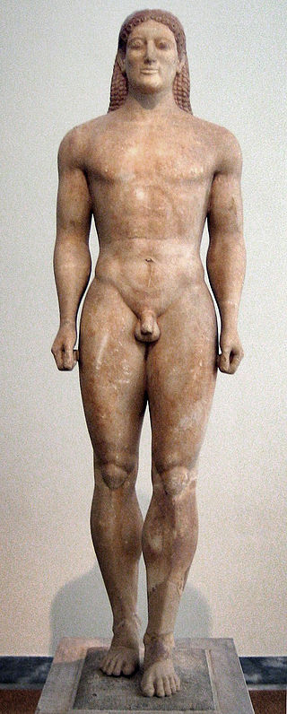  Anavysos Kouros. Archaic Greek. c. 530 B.C.E. Marble with remnants of paint.  Anavissoskorous.jpeg | Content:  A kouros is a male “youth” statue.  This Archaic statue is larger than life (6'4" tall) and  The inscription around the base invites visitors to stay and morn Krousos.  Style:  The statue shows great strides in the field of naturalism.  The proportions of the body are so naturalistic that they border on realism.  The rounded-ness of the body, face, torso, and limbs shows attention to the naturalistic elements.  Still, the piece is still very much stylized about the face and hair. There are no individual characteristics except for the Archaic Greek smile.  It was created with subtractive sculptural technique.  Contextual Analysis:  This statue was commissioned by the family of Kroises, the young man sculpted as the Anavysos Kouros, who died nobly in a battle.  The statue was placed over his grave with an inscription to remember and mourn him. The sculpture is an example of family patronage of art, funerary statuary for the common people, and the advances made towards naturalistic, individual characteristics even if they are fully accomplished in this piece.  The frontal position with one foot forward is seen in Egyptian art as well and shows the power and authority of the figure.  (http://www.cram.com/user/jsalka)
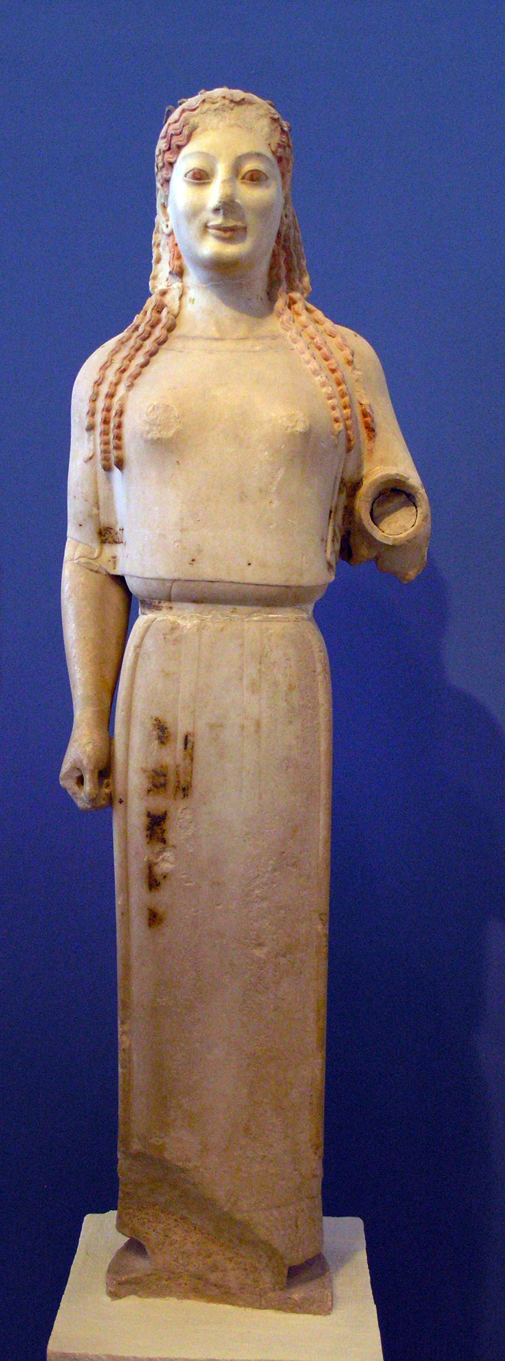  Peplos Kore from the Acropolis. Archaic Greek. c. 520 B.C.E. Marble, painted details.  Peploskore.jpeg | Content:  This is an Archaic votive sculpture of a young woman, known as a kore. The broken hand was offering an object to the Athena. The hand, emerging into our own space, breaks out of the mold of static Archaic statues  She is sculpted from marble and is 4' high and there are still traces of encaustic paint left.  The sculpture is named for the peplos garment she is wearing.  Style:  It is made with a subtractive technique.  This kore is naturalistic but still very frontal in design.  She has softer characteristics and features that enhance her feminine figure. She also bears the famous Archaic Greek smile.  Contextual Analysis:  This sculpture is mainly still preserved (and still carries traces of encaustic paint) because it was buried for 2,000 years after being knocked down at the Acropolis in a Persian raid. The Athenians always buried the destroyed pieces, so this one was no exception.  This piece has been so well preserved essentially because the Persians sacked the acropolis and thus the piece was buried under the ruble and preserved.  In this piece the understanding of sculpture and the natural positions of a human body clearly develops as seen in the freed arm. This is one of the first times we see a freed limb from the rest of the figure, making it a major innovation in art.  The wet drapery style is still used by artists during this time to show that they can depict the human body correctly.  (http://www.cram.com/user/jsalka)
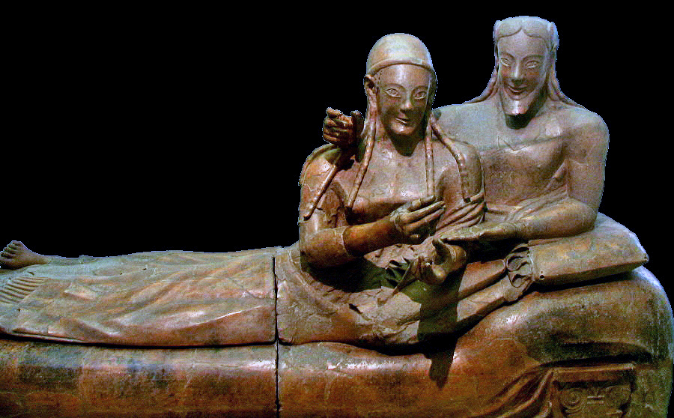  Sarcophagus of the Spouses. Etruscan. c. 520 B.C.E. Terra cotta.  Sarcophagusofthesouses.jpeg | Content:  The work is funerary statuary made of terra cotta.  In the sarcophagus, the two figures recline as equals as they participate in a banquet.  The work shows the tenderness between the Etruscan man and woman through their gestures and embrace.  It is unknown what they were holding.  The work is two meters long.  Style:  The work is made out of fired terra cotta clay.  It was painted in bright colors.  It was molded and fired in four separate sections.  The figures were modeled separately and then placed on top of their bed.  Though their skin and hair color may be different, both figures have similar facial features—archaic smiles, almond shaped eyes, and highly arched eyebrows. These features are typical of Etruscan figures.  Context:  Much of Etruscan artwork was made with wood and terra cotta. Much of the artwork has deteriorated over time. Because this is obviously a burial piece, it is clear the Etruscans believed in honoring the deceased through a burial process. Bodies were cremated before being placed into the sarcophagus. It is unknown who this sarcophagus was made for. The couple would have been wealthy to afford this luxury.  The banquet was part of a religious ceremony in that the relatives of the deceased took part in a banquet. It was believed that the spirit of the deceased was also present.  Since the figures are reclining on a banqueting couch, the objects they could have been holding may have been wine cups, or representations of food.  Unlike women in ancient Greece or Rome, upper class Etruscan women actively participated in public life and images of women engaged in these activities appear frequently Etruscan art.  (http://www.cram.com/user/jsalka)
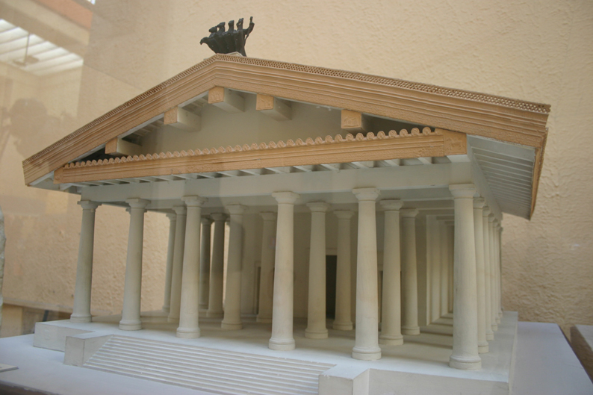  Temple of Minerva (Veii, near Rome, Italy). 510 – 500 B.C.E. Original temple of wood, mud brick, or tufa (volcanic rock  Templeofminerva.jpeg | Content:  The temple was an Etruscan temple to the goddess Minerva that was  It had three cellas, a raised floor, and a front porch.  It had a Greek pediment, but the sculptures were acroteria. They were placed on the roof.  The temples made of wood-and terra cotta so they deteriorated.  Style:  The colonnades were wooden, the walls were of sun-dried mud brick, and the roof was tiled.  The entrance to the temple was only accessible from the narrow staircase that led to the temple floor.  The columns did not have flutes (smooth).  Contextual Analysis:  Etruscan culture was linked culturally to Archaic Italy. Culturally influenced artwork can be found. The Romans absorbed the Etruscans culture, but the artwork is different from both Greek and early Roman styles.  This temple was reconstructed and the floor plans made from the notes of the Roman architect Vitruvius. The statuary of the temple was all terracotta (including the sculpture of Apollo) and was traditionally placed on the roof of the temple in the classic Etruscan fashion.  (http://www.cram.com/user/jsalka)
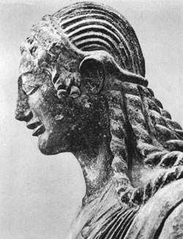  Sculpture of Apollo, Master sculptor Vulca. c. 510 – 500 B.C.E. terra cotta sculpture.  Veiiapollo.jpeg | Content:  The sculpture is a large-scale terra cotta sculpture.  It was a central figure in the rooftop narrative of the Temple of Minerva. It would have been placed at the peak of the temple roof.  The statue is dressed in a tunic and short cloak.  The sculpture is advancing towards the left with the right arm outstretched and bent (may have held a bow).  Style:  It is an additive terra cotta sculpture.  The Archaic smile is unquestionably related to Archaic Greek models, but the action and movement of the pose is Etruscan.  It was painted in bright colors.  Contextual Analysis:  The desire to create temples for the gods may have been inspired by contact with Greek culture. Original Etruscan worship was in open-air sanctuaries.  The temple of Minerva was a temple to the gods, thus why there is this statue of Apollo. The Etruscans assimilated the Greek gods.  Apollo is a Greek god they eventually became a Roman god.  The sculptor may be named Vulca. The Roman writer Pliny recorded that in the late 6th century B.C.E. an Etruscan artist by the name of Vulca was summoned from Veii to Rome to decorate an important temple there.  (http://www.cram.com/user/jsalka)
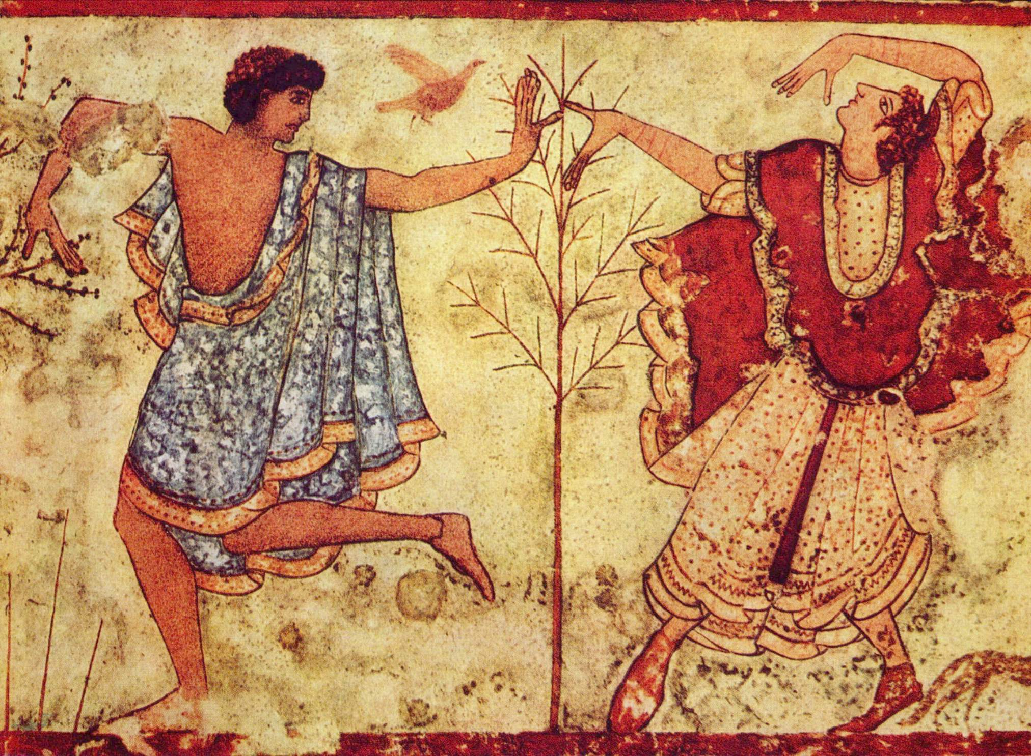  Tomb of the Triclinium. Tarquinia, Italy. Etruscan. c. 480 -470 B.C.E. Tufa and fresco.  Tombofthetriclinium.jpeg | Content:  This is a subterranean, multi-chambered family tomb cut of a dark limestone called tufa.  Inside the tombs there are paintings depicting banqueting couples.  Style:  These tombs were arranged in a necropolis with arranged streets like in cities.  The work is created in buon fresco, which paint is applied on wet plaster.  secco paintings inside them had Etruscan characteristics in the figure's exaggerated expressions and gestures with their enlarged hands.  The figures are created in composite views.  The men are depicted with dark skin and the women with light skin.  Contextual Analysis:  This tomb was that of a wealthy family and was a common practice for the people of the time. The painted banquet scenes to create a joyful tone and help them convey the Etruscan belief that death was a celebration of life. In the paintings it is clear it is a celebration, showing the Etruscans believed in the celebration of passing rather than the mourning.  (http://www.cram.com/flashcards/unit-two-ancient-mediterranean-5048998)
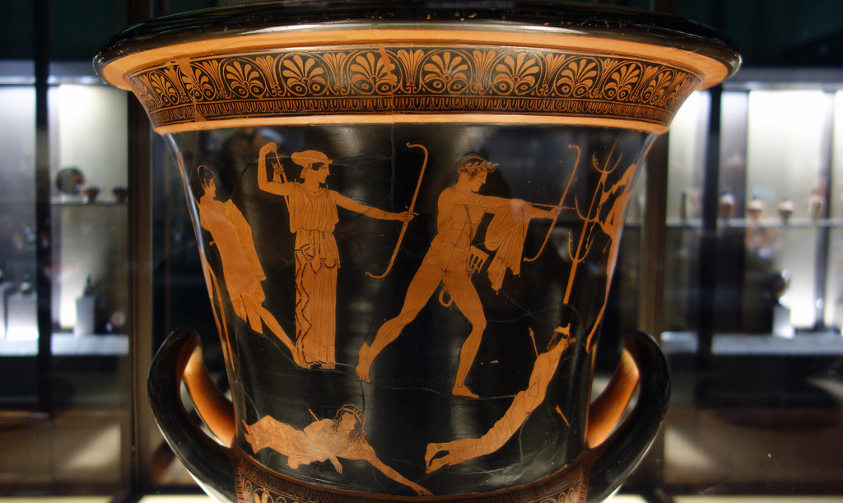  Niobides Krater. Anonymous vase painter of Classical Greece known as the Niobid Painter. c. 460 – 450 B.C.E. Clay, red-figure technique (white highlights).  niobideskrater.jpg | Content:  This ceramic krater is made of red clay with black glaze to create a negative effect with light space figures and patterns surrounding the vase.  The painted figures tell the mythological story of the massacre of a goddess' children.  Style:  The krater vase was wheel thrown, with the red clay created the backdrop for the black underglaze in a style called red-figure decoration. The glazed decoration includes a schematic illustration, which uses a landscape in order to tell a story.  Context:  The initials found on this vase identify it as one of the Niobides Painter's works. It is unknown whether the initials pertained to one artist, a group, or a collective studio.  Vases like this one served no other purpose except to be on display to the public in areas like markets, temples, cemeteries, etc. This one is particular illustrates the myth of the goddess Niobid. Niobid was a goddess of beauty and had many children. She challenged the goddess Lido (mother of Artemis and Apollo) and Lido punished Niobid for the challenge by killing of Niobid's children.  The message of the narrative is never challenge the gods. The vase was teaching the ways of religion and morals.  (http://www.cram.com/user/jsalka)
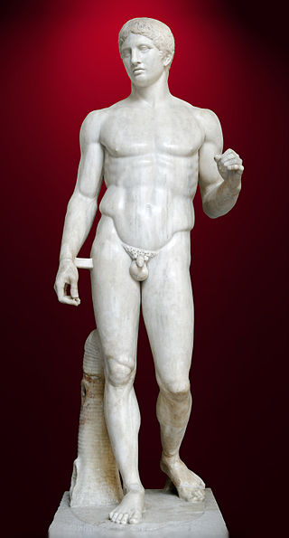  Doryphorus (Spear-bearer). Polykleitos. Original 450 – 440 B.C.E. Roman copy (marble) of Greek original (bronze).  Doryphorus.jpeg | Content:  The Doryphorus is exactly what his title describes his to be- a spear thrower.  The sculpture is of a nude, young man that once held a wooden spear in his left hand.  The form is a collection of opposites: tension versus relaxed pose, and limbs in opposition.  Classical sculpture shows the movement to realism.  Style:  The piece is very Classical Greek, with naturalism and something close to realism in effect.  The posture of the statue is contrapposto, with a relaxed, twisted stance and free arms and legs.  To stand, however, the statues still needs additional sculpted support like the tree stump.  Context:  The sculptor of this piece, Polykleitos, created the Doryphoros to give evidence to a book Polykleitos had written entitled "Canon". The treatise was all about the precise, mathematical measurements and proportions that could be used in creating the most realistic depiction of a human body. The book of Polykleitos also explored the concept that beauty could be achieved when statues were carved using the harmonious, proportional ratios. The ideas of Polykleitos were accepted and utilized in Greece.  (http://www.cram.com/flashcards/unit-two-ancient-mediterranean-5048998)
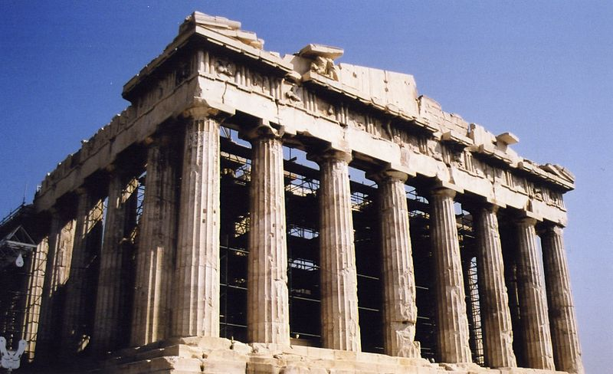  Acropolis. Athens, Greece. Iktinos and Kallikrates. c. 447 – 424 B.C.E  Parthenon.jpeg | Content:  The acropolis is a hilltop of a stone that is the highest part of the city. The word means “high city.”  It is built on high point to be closer to the gods; hence the temples are located there.  This was the main temple dedicated to Athena. It once housed the Athena Parthenos.  The temple is marble, has a large cella, a row of peripteral columns, and a decorated sculptural pediment.  Style:  The temple was built using the mathematical equation: x=2y+1. Meaning, the length of one side of the temple is twice the other side plus one, this also pertains to the number of columns on each side.  The temple is mainly Doric but still hold innovation in its roomy cella with an Ionic frieze.  Contextual Analysis:  Context:  According to the mythology, Athena was chosen as the patron god of Athens when she out-gifted the god Poseidon by creating the olive tree for the first king of Athens. The king chose her gift over Poseidon's salt-water spring and she became the symbol and adoration of the city of Athens.  The Parthenon also once housed a massive, regal statue of Athena called the Athena Parthenos, which was supposedly decorated with ivory and gold. It was probably taken and/or destroyed in one of the many sack of Athens by the Persians and other empires.  (http://www.cram.com/flashcards/unit-two-ancient-mediterranean-5048998)
Acropolis. Athens, Greece. Iktinos and Kallikrates. c. 447 – 424 B.C.E  AcropolisatathensSitePlan.png  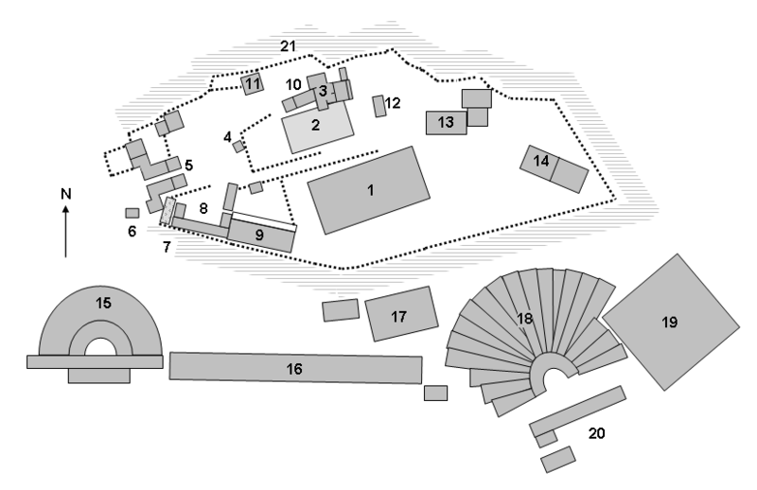 | Content:  This is a complex in Athens built on a prominent hill and consisting of a multitude of Greek temples, amphitheaters, statuary, etc.  Style:  The Acropolis was built on a high, central point on the landscape. It was surrounded by a "propylaia", a main gate and was mostly built using mathematical precision and Doric principals.  Context:  As the cultural, economic, artistic, and technological height of the entire Greek civilization, the city of Athens sought ways of expressing and celebrating their dominance over the Mediterranean.  The Acropolis was a way to accomplish all of the above while simultaneously creating public spaces and honoring the gods. The complex was the object of Athenian pride.  This pride lent itself to the creation of art dedicated to all things Athenian. Such works included the Parthenon, its pediment statuary, the Temple of Athena Nike, Victory adjusting her sandal, and the Plaque of the Ergastines.  `
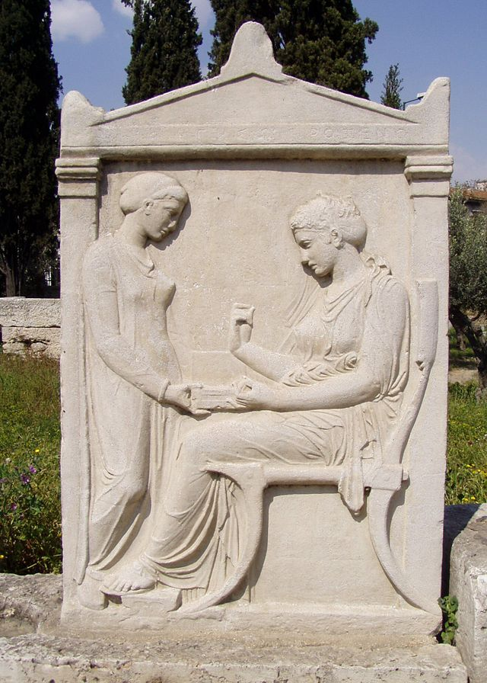  Grave Stele of Hegeso. Attributed to Kallimachos. c. 410 B.C.E. Marble and paint.  Gravesteleofhegaso.jpeg | Content:  This is a carved piece depicting a sitting woman and her slave/servant.  It's made of marble and was once painted.  The work serves as a grave stone/stele.  The work is an intimate scene of Athenian life.  Style:  This is a marble piece carved in low relief, with the seated woman carved larger than the slave.  The piece was also once painted.  The intimate scene of the two women is a representation of the humanistic ideals of the Greek culture.  Context:  The Greeks buried their dead and marked the ground with carved stella like this one, similar to gravestones.  This stele is interesting because it not only shows the woman of the household, who is usually not made public, but it shows an intimate scene between a lady and her servant.  This choice of a domestic scene speaks to the gender roles of Greek civilization.  Hegeso is carved larger than her slave/servant, in order to show the hierarchal scale between master and slave.  The two figures are also shown passing a family relic between them. The intimacy of the scene creates a humanistic element in the stella and is a look into the normal lives of Athenian.  (http://www.cram.com/flashcards/unit-two-ancient-mediterranean-5048998)
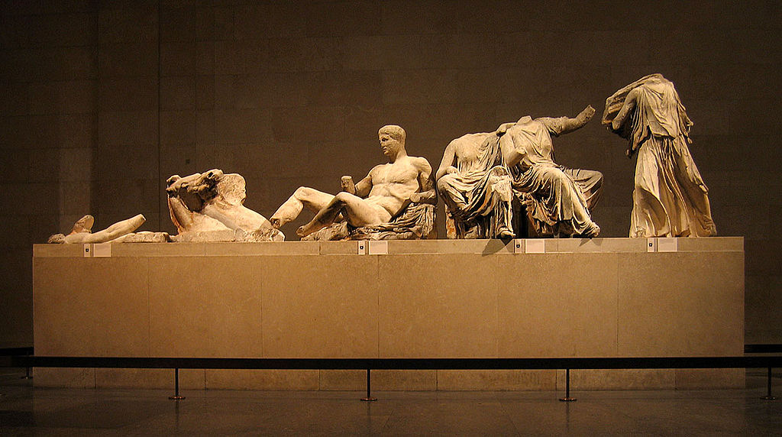  Helios, horse and Dionysus. Parthenon pediment.  Acropolis. Athens, Greece. Iktinos and Kallikrates. c. 447 – 424 B.C.E  ElginMarblespediment.jpeg | Content:  These sculptures, named for what they portray, are massive sections that were meant to decorate the east pediment of the Parthenon. They depict gods, (possible) heroes, and normal spectators watching the birth of Athena.  This sculptural group was created for the - east pediment.  The group is part of a narrative that depicts the birth of the goddess Athena.  Style:  The subtractive marble sculptures are modeled in segments that fit together and then fit into the triangular section of the pediment.  The show high technical and artistic ability.  The drapery folds are remarkably detailed and elegant. The drapery follows the gentle contours of the forms.  The postures of the figures are created to fit the sloping roofline of the pediment.  The sculptures were painted in encaustic.  Contextual Analysis:  The pediment itself was a beautiful praise to Athena, and a narrative of her birth story.  Zeus, the god of the sky and ruler of the gods, began to suffer with a terrible headache, which grew progressively worse. The other gods asked Zeus' son Hephaestus, blacksmith of the gods, if he would try to cure Zeus' headache. Hephaestus hurled his ax into Zeus' skull and split his head open. Athena leapt out of Nike came forward to crown Athena with a laurel wreath, symbol of victory.  During the rise of Christianity in Europe, various groups tore down the "pagan" representations and sculptures left by the ancient Greeks, including those found on the Parthenon.  Phidias is thought of the sculptor of these sculptures.  (http://www.cram.com/flashcards/unit-two-ancient-mediterranean-5048998)
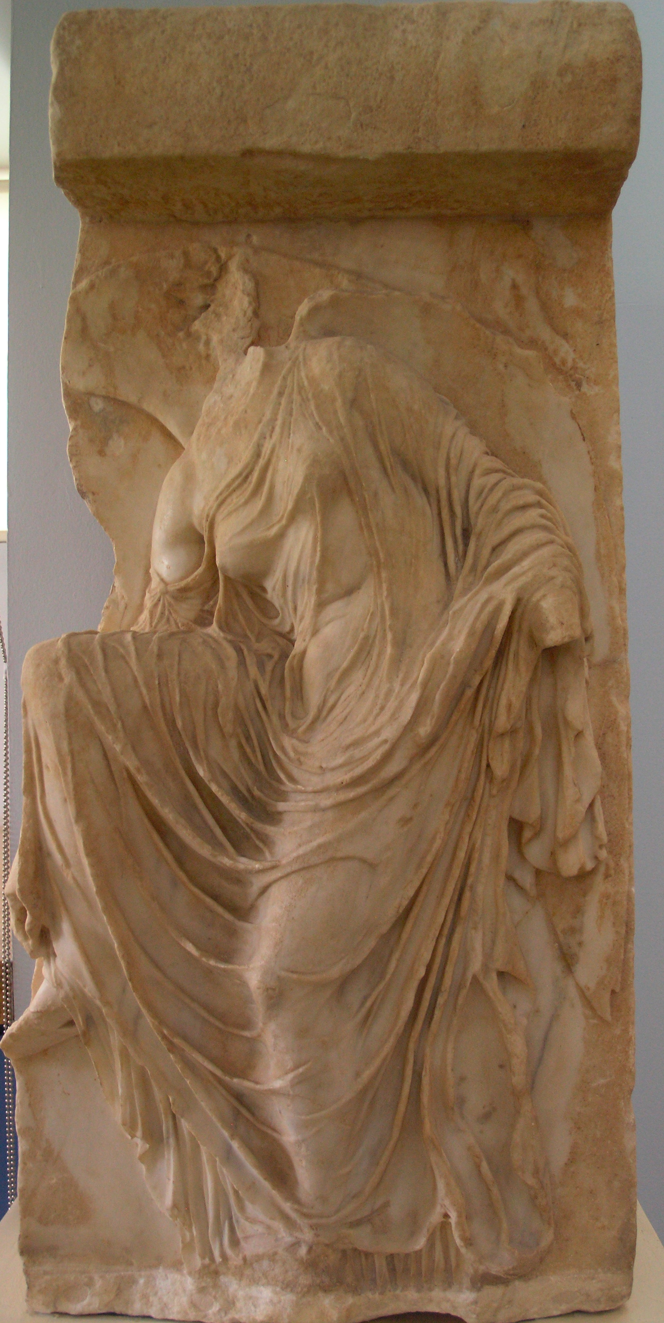  Nike adjusting her sandal.  Acropolis. Athens, Greece. Iktinos and Kallikrates. c. 447 – 424 B.C.E  Nikeadjustingsandals.jpeg | Content:  This is a marble carving that was once a section of a frieze that stood 3 ft. tall.  It depicts the goddess of victory, Nike, adjusting her sandals.  Style:  It is carved in high relief and elaborate technical abilities displayed in the folds and movements of the clothing. The carving is also depicted in a unique position that suggests humanism and realism.  Context:  The fact that a goddess here is depicted adjusting her sandal, is a very humanistic choice. Normally gods were depicted in strong, divine stances so this carving is unique in the fact that the goddess Victory is depicted in the act of something very normal.  The elegant, rippling of cloth shows a much deeper understanding of sculpture. It represents a transition into the beginning phases of Hellenistic Greece.  (http://www.cram.com/flashcards/unit-two-ancient-mediterranean-5048998)
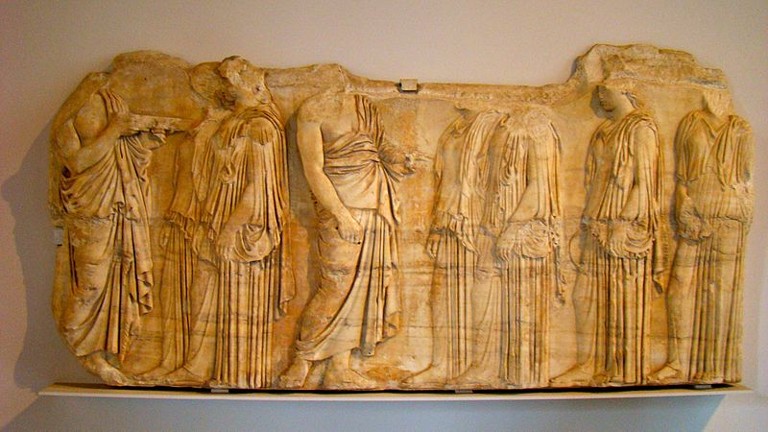  Plaque of the Ergastines  Acropolis. Athens, Greece. Iktinos and Kallikrates. c. 447 – 424 B.C.E  Plaqueofthergastines.jpeg | Content:  This was a section of the frieze that decorated the Parthenon.  It pictures a group of people partaking in the Great Panathenaea festival  parade that an annual holiday.  The scene depicts a Panathenaic festival procession of citizens.  Two priests meet six Ergastines, young women in charge of weaving the peplos over garment given to Athena, as they walk in procession towards the assembly of the gods.  Style:  The Ionic carving on the cella utilizes advanced proportional techniques used to make the carving viewable from the perspective of people looking up at friezes on the Parthenon.  The proportional illusion included a lower relief at the bottom of the frieze carving and a higher relief at the top.  The background of the frieze was painted blue while the figures' hair and parts of their clothing were highlighted in gold. Additional accessories (objects and jewelry, etc.) were modeled separately in metal and applied to the finished frieze, but are lost.  Contextual Analysis:  The scene is of a human event, again showing the importance and beauty of human life in Greek culture.  The work also shows the depiction of human events on the same building as scenes depicting the gods and religion.  The friezes of the Parthenon were meant to convey stories and messages to the public of Athens.  (http://www.cram.com/flashcards/unit-two-ancient-mediterranean-5048998)
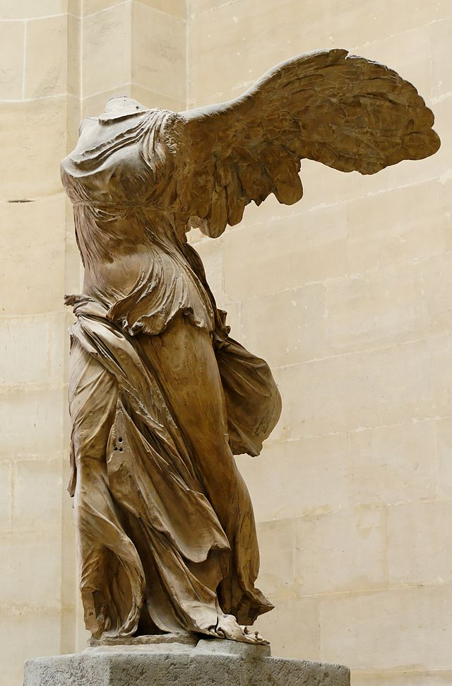  Winged Victory of Samothrace. Hellenistic Greek. c. 190 B.C.E. Marble.  Nikeofsamathrace.jpeg | Content:  This marble statue is of the winged goddess of victory and was originally the top section of a celebratory, public fountain where the statue stood over the prow of a Greek warship.  It is 8 feet 1 inch tall.  Style:  The piece is Hellenistic, with the emphasis on the dramatic stance and movement.  The clothing is highly detailed and is sculpted in such a way that suggests the goddess is taking heading towards the wind.  The statue displays the traditional realism but is created with more expressionism.  The work was probably painted.  Context:  With the Greek empire at its peak, conquest overseas and in neighboring lands was crucial to the expansion of Greek culture. The Winged Victory of Samothrace was sculpted to represent Greek military power and conquest abroad.  The goddess victory was sculpted with wings and standing on the prow of a Greek warship. This is symbolic of the Greek's belief that their military endeavors were led by divine power.  This sculpture is significant because it departs from pure rationalism and goes into expressionism and the introduction of feeling and emotion into art.  (http://www.cram.com/flashcards/unit-two-ancient-mediterranean-5048998)
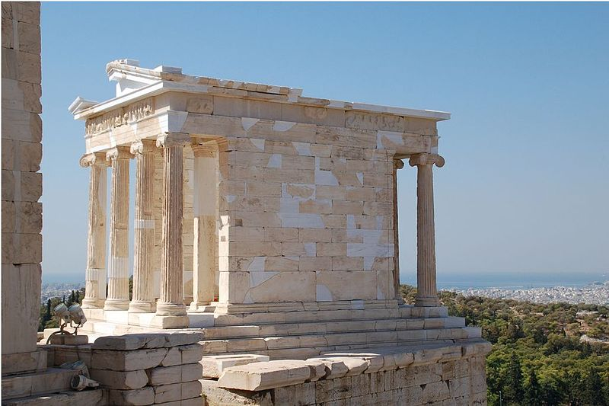  Temple of Athena Nike  Acropolis. Athens, Greece. Iktinos and Kallikrates. c. 447 – 424 B.C.E  Templeofathenanike.jpeg | Content:  This temple is dedicated to Athena and Nike, a goddess of victory. Much smaller than the Parthenon, it sits on a section of the Acropolis overlooking Athens. Its plan includes a single cella and rows of columns attached to the front and back porches.  Style:  This marble temple was built it an amphiprostyle plan that was later seen in Roman temples.  The columns had Ionic capitals and were freestanding in front of the facades on the east and west sides. The other sides were built with flat, undecorated walls.  Context:  The temple was built to commemorate an Athenian victory over the Persians. The temple was dedicated to two goddesses that were attributed to the Persian defeat: Athena, goddess of wisdom and battle strategy and Nike, the goddess of victory.  (http://www.cram.com/flashcards/unit-two-ancient-mediterranean-5048998)
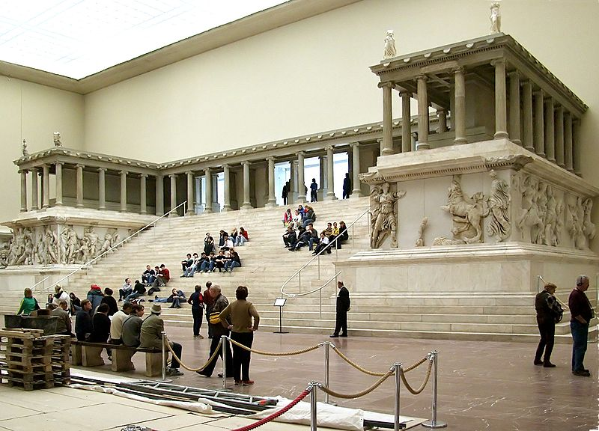  Great Altar of Zeus and Athena at Pergamon. Asia Minor (present day Turkey). Hellenistic Greek. c. 75 B.C.E. Marble (architecture and sculpture)  Pegamonaltar.jpeg | Content:  This temple was built on a large mountain in Turkey and carved of marble.  It has a massive relief around the base This frieze is over 7 feet tall.  Style:  This temple was constructed much differently than traditional Greek temples.  The structure included a higher staircase and two arm-like structures of the temple coming forward from the main cella.  The temple also includes a massive frieze with large, high relief sculptures and colonnades.  Context:  This temple was built near the end of the Greek empire, explaining the unconventionalities from the classical Greek architecture.  The lower frieze also was a new development in the temple's construction. It is too large and too low to be compared to the friezes on the Parthenon or other Greek structures. The size and location of the frieze may have been made for the intention of displaying the figures.  The friezes are very elaborate stories of war, victory, and domination.  (http://www.cram.com/user/jsalka)
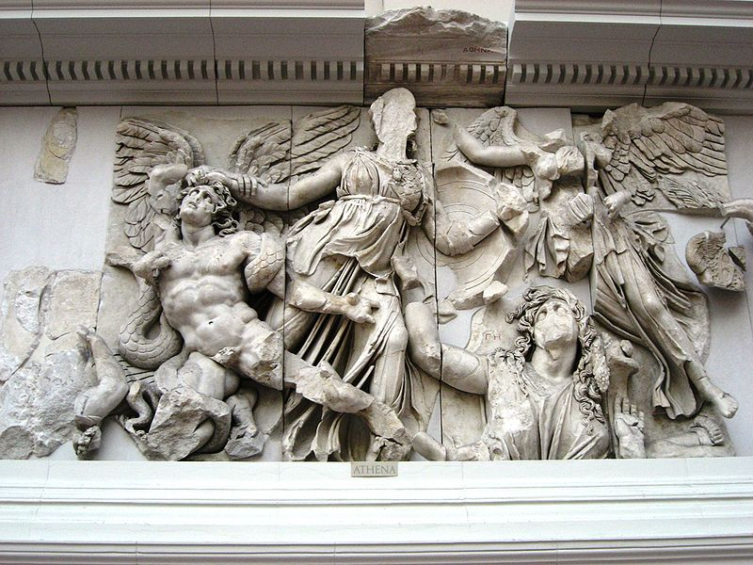  Great Altar of Zeus and Athena at Pergamon. Asia Minor (present day Turkey). Hellenistic Greek. c. 75 B.C.E. Marble (architecture and sculpture)  Athenatpergamon.jpeg | The altar symbolizes power and depicts godly events, especially surrounding Zeus and Athena.  The work describes the battle between gods and the giants; the giants, as helpless tools, were dragged up to worship the gods.  The gods' victory over the giants offers a parallel to Alexander the Great's defeat of the Persians.  The deeply carved figures overlap one another and display a masterful handling of spatial illusion.  The work exhibits a dramatic intensity of figures and movement.  (http://www.cram.com/user/jsalka)
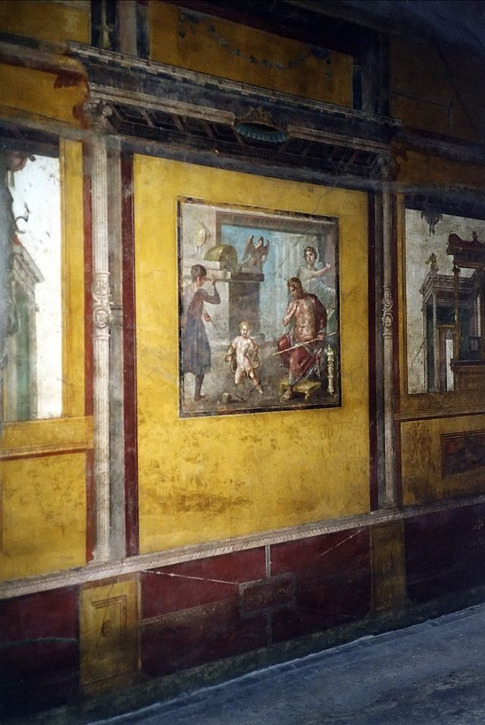  House of Vettii. Pompeii, Italy. Imperial Roman. c. second century B.C.E.; rebuilt c. 62 – 79 C.E. Cut stone and fresco.  Houseofthevettii.jpeg | Content:  This was a private house (a domus) that was built with an atrium, an impluvium (basin for collecting water), and several cubicula (small bedrooms).  Elaborate frescos are painted through out the house.  In the Ixion Room, the mythological scenes were Hercules strangling the snakes, the punishment of Dirce, and Pentheus being torn apart. In the triclinium, there was Daedalus and Pasiphae, the punishment of Ixion, and Bacchus watching Ariadne as she lies sleeping, abandoned by Theseus.  Style:  The fresco in this image indicative of the fourth style of Roman fresco paintings.  The fourth style has illusionistic architectural frames and central panels, for the most part painted with mythological scenes.  The images were generally copies of celebrated Greek originals, and therefore were seen as authentic art collections.  Contextual Analysis:  This house is so well preserved because of the ash from Vesuvius.  Most art historians point to the house’s decorative scheme as being between the Third and Fourth styles of Pompeian wall painting.  Some scholars consider it among the finest examples of the Fourth Style at Pompeii.  (http://www.cram.com/user/jsalka)
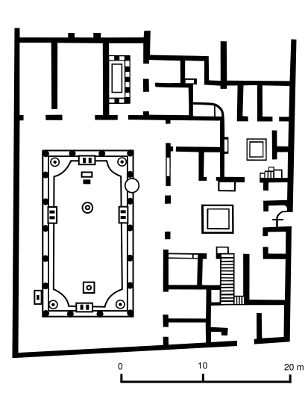  House of Vettii. Pompeii, Italy. Imperial Roman. c. second century B.C.E.; rebuilt c. 62 – 79 C.E. Cut stone and fresco.  Vettiiplan.png | Content:  This was a private house (a domus) that was built like a complex with rented markets, an atrium, an impluvium (basin for collecting water), and several cubicula (small bedrooms).  Style:  The house was also full of architectural advances and domestic engineering.  In the atrium, there was an opening in the ceiling to let natural light in and also collect water for the entire house. The markets and businesses lay separated from the living quarters and everything was centered on the atrium.  Most of the house was also decorated with elaborate frescos that employed painting techniques to make the rooms seem bigger.  Context:  A house like this was meant for display rather than the needs of its inhabitants. The atrium, a semi-public greeting space and the central part of the house, was important because guests and clients were received there.  Shops and other ventures would pay the owner of the house to host their business.  The owner would also patronize and support certain artisans and clients. House owners would also entertain and involve themselves in political debates in their atriums.  The Ixion room in House of Vettii is the one room with the elaborate frescos, they were painted to reflect and exaggerate the wealth and importance of the family.  (http://www.cram.com/flashcards/unit-two-ancient-mediterranean-5048998)
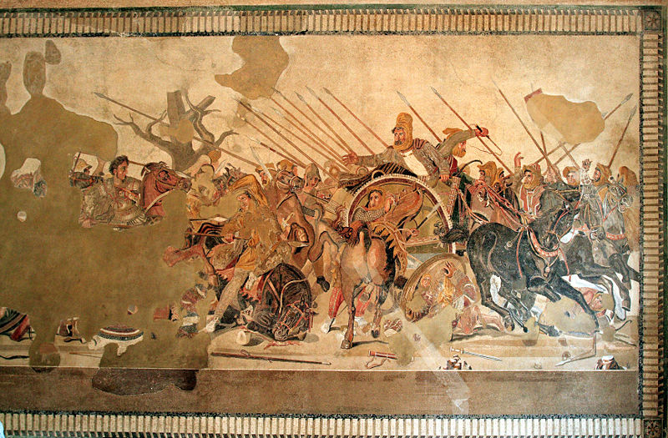  Alexander Mosaic from the House of the Faun, Pompeii. Republican Rome. c. 100 B.C.E. Mosaic  Alexandermosiac.jpeg | Content:  This is a mosaic of the Battle of Issus that was fought between Alexander the Great and the Persian king, Darius.  The work measured 19 feet by 10 feet, and was made piece was made out of roughly 4 million tesserae.  The work is a mosaic decorating the floor in a home in Pompeii, Italy. Although parts of the mosaic are missing, Alexander can be seen riding in on the right on a single steed, and Darius turning and fleeing on the left in his chariot.  The rest of the battle ensues around them, with fighting and falling soldiers, horses, and weapons.  Style:  The work is made of tiny tiles of stone and glass called tesserae. It includes naturalistic depth, reflections, and some twisted perspectives and proportions, like the twisted perspective of the horse near Darius's chariot.  The movement in the piece also moves from left to right.  The most dramatic element is the chilling, direct eye contact that is held between Alexander and Darius and serves as the focal point of the work.  Context:  In general, mosaics were intended to assert the status and wealth of the owner of the house.  This mosaic was a form of Roman propaganda that was used in order to better publicize and worship the achievements of Roman's emperor. To be seen as a new “Alexander the Great” or make a claim to be a great war leader against the East like Alexander, would give credit to Rome's military power and conquest over its enemies.  Alexander is depicted with attractive features and hair, and is heroically riding on his own horse. Darius, who depends on his chariot, is fleeing in fear.  The movement of the piece from left to right suggests that Darius's forces are in a full fledged retreat, moving away from the attacks of Alexander the Great and his men.  The mosaic is just one scene of the battle, bit it suggests that victory is already in the hands of Alexander.  (http://www.cram.com/flashcards/unit-two-ancient-mediterranean-5048998)
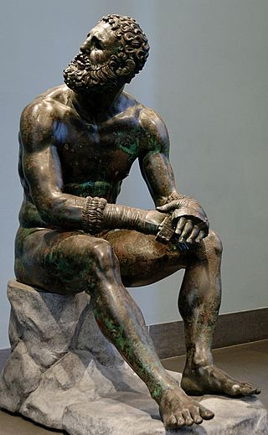  Seated Boxer. Hellenistic Greek. c. 100 B.C.E. Bronze.  Seatedboxer.jpeg | Content:  The sculpture is a bronze statue of a Roman style fighter that probably fought for the entertainment of Roman citizens.  The fighter looks bruised and battered.  His boxing gloves are still on his hands, but he looks away as if he was defeated.  Style:  The sculpture is move away from idealistic into expressionism.  This sculpture is very Hellenistic, with accurate realism mixed with emotional posture and expression.  Some of the most striking characteristics of this boxer are his broken nose, swollen ears, torn gloves and disquieted expression.  Contextual Analysis:  Expressionism is huge in this statue. In the Hellenistic period, they focus on all aspects of life, not solely the beautiful parts. This statue in particular shows this aspect of Hellenistic art as it is communicating defeat. Using art to show the common people is a huge leap in art history.  In Greece, boxing was known as "Pyx", a form of the fighting style where victory was achieved through submission or a knockout. The matches were mainly fought with punches and with no clothing except for the gloves. The fact that a lowly, beaten entertainer was selected to be the subject of this sculpture speaks to the Greek's want to celebrate the life of the everyday man.  (http://www.cram.com/user/jsalka)
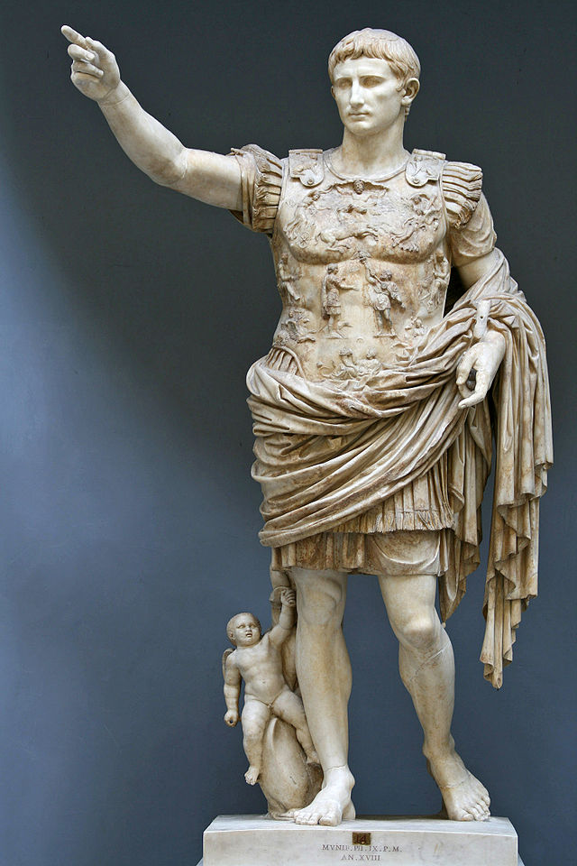  Augustus of Prima Porta. Imperial Roman. Early first century C.E. Marble.  Augustusofprimaporta.jpeg | Content:  This is a statue of one of the Caesar Rulers of Imperial Rome, Augustus. The emperor is pictured in his military uniform.  He has a little cupid at his feet.  Style:  The style of this statue takes a step back into idealism from the verism of the Republican period  Augustus is pictured with flawless features that he may or may have not actually possessed.  His clothes are also not practical, but ceremonial and dramatically sculpted. He is shown raising and pointing in a stance of power.  Context:  This sculpture was Roman propaganda. It was designed mostly to support the ruling family of the Caesars.  Statues of rulers like this once would be copied and placed around the ruler's territory to elevate their status and popularity among their people. The little cupid at his feet represented that Augustus was descended form Venus.  The bare feet on the soldier/king symbolized the endorsement of the gods as to his power.  These statues communicate power through the position of the model.  http://www.cram.com/user/jsalka
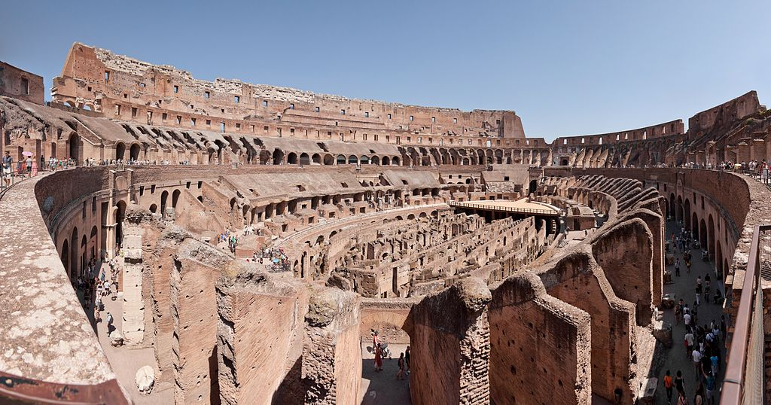  Colosseum (Flavian Amphitheater). Rome, Italy. Imperial Roman. 70 – 80 C.E. Stone and concrete.  Colosseum.jpeg | Content:  This is a concrete and stone amphitheater that for gladiatorial combat.  The structure contained walkways, thousands of seating stands, a platform for fights and entertainment, and sub level dungeons and tunnels.  Style:  The structure was built with three tiers, with each in the style of the three orders of architecture. The lower has Doric characteristics, the middle had Iconic and the top has Corinthian.  The facade of the Colosseum is also primarily constructed using arches, an architectural style hardly used until the Roman empire. The arches are seen in series and each has engaged columns and entablature.  There were once statues of the gods in each arch on the upper levels and flags lining the top.  The construction of the arches included strong, basic post and lintel construction in top of which sat carefully cut stones called springers that held the arch.  The arch was then built with more stones of varying cuts (voussoirs) to create the shape and then a keystone to top the arch and keep it stable. The arches are then extended to create tunnel arches that were uses and entrances and exits for the Colosseum.  A roof made of extendable cloth supported by wood rods was extended to block the light.  It was built in a circular shape so it could be entered or exited at any point and people could also sit and watch from any point.  Contextual Analysis:  The arches are very characteristic of Roman buildings, such as the Colosseum.  The Colosseum was constructed under Flavian as a way of propaganda. The Colosseum's purpose was to entertain the general public and appease them, thus in return favoring Flavian.  This shows Flavian's utilitarian intention of maximizing the use of the Colosseum to all citizens.  Since the Roman empire stretched too much of Africa, they would bring back exotic animals and native Africans to show off to the other Romans and put into the Colosseum to battle for entertainment.  (http://www.cram.com/user/jsalka)
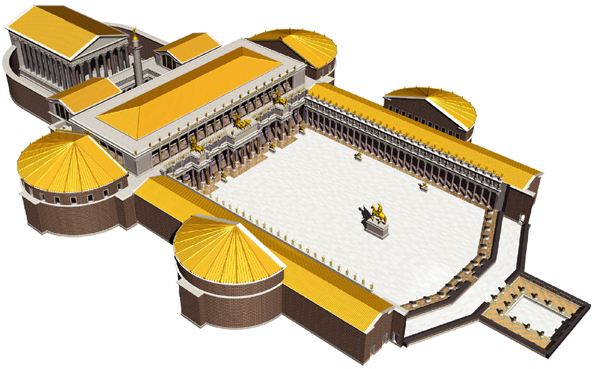  Forum of Trajan. Roman, Italy. Apollodorus of Damascus. Forum and markets: 106 -112 C.E.; column completed 113 C.E. Brick and concrete (architecture); marble (column).  Forumoftrajanplan.jpeg | Content:  This is a complex that served as a commemoration of Emperor Trajan that he commissioned.  It included a center area, main gate, statues, markets, a basilica, and a column dedicated to Trajan's life story.  The main entrance is a huge triumphal arch, which signifies the gateway into something monumental.  It contained a large courtyard, surrounded by colonnades.  In the middle of courtyard is an equestrian statue of the emperor.  The basilica is the central meeting area for politics.  Further back was the Basilica, then the temple of Trajan with markets and libraries, and finally the column of Trajan in the back of the complex, similar to the obelisks of the ancient Egyptians.  Trajan’s column honors Trajan's military campaigns in Germany.  Style:  The layout of this complex was different than any other in Greek and Roman times. It would later become the model that many Christian churches would follow.  Contextual Analysis:  Trajan built this for both himself and the public. The large courtyard was a significant part of this structure because it allowed for a central place for all people to meet. The basilica is another important aspect as it gave Roman society a central meeting place for politics and houses the governing center. In ancient Rome, markets surrounded this forum because it was the central hub of society.  (http://www.cram.com/flashcards/unit-two-ancient-mediterranean-5048998)
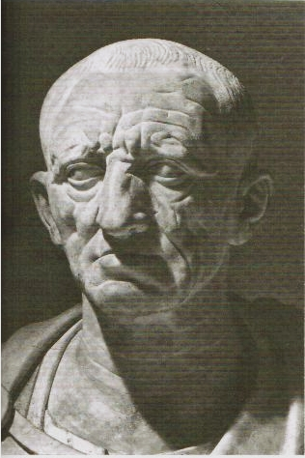  Head of the Roman patrician. Republican Roman. c. 75 – 50 B.C.E. Marble.  Headofaromanpatrician.jpeg | Content:  This is a carved, marble bust of a wealthy, elderly patron of the arts who was honored after his death with the bust.  It depicts old man with details in wrinkles of skin.  Style:  The bust has incredible realism. This extreme realism is called verism. There was no idealism used to make the patrician look younger or more handsome than he was.  The intent was accuracy in this subtractive portrait bust.  The eyes might have once been painted to create further life-like detail.  Contextual Analysis:  Deceased family members or wealthy members of society were always honored in Roman culture with a bust of their likeness that was placed in a room and sometimes held up and paraded about in funeral processions. The ideas of blood lines and family ancestry were very important in Rome, as social status was based on the family tree.  If the busts were made accurately, families could look back and recall the exact look of their ancestors
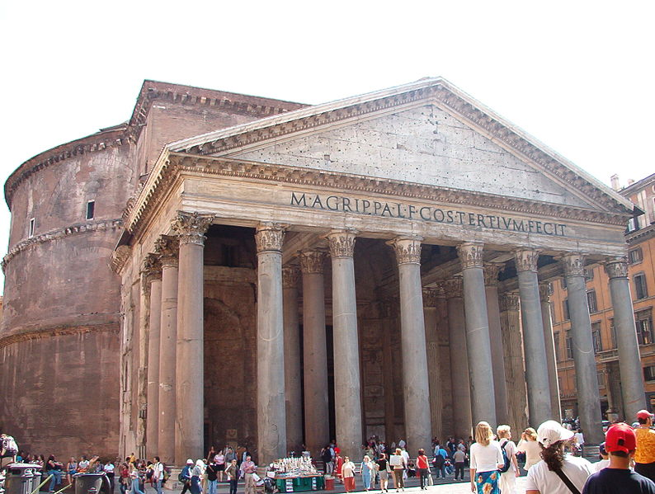  Pantheon. Imperial Roman. 118 -125 C.E. Concrete with stone facing.  Pantheon.jpeg | Content:  The Pantheon is a Roman temple dedicated "to all gods."  It has the front of a traditional Greek temple while the back is a Roman dome set on a drum.  Style:  The front of the temple is a portico with a colonnade and pediment, while the back is a resurrection of the ancient architectural shape: the dome.  The structure is built of stone and concrete.  Arches are embedded in the drum for strength.  The ceiling is coffered - covered in indented, ornate, and polished squares panels that require less concrete and expand the size of the dome. The coffered squares also eliminate weight of the dome.  There is also an oculus (eye) at the very top of the dome that lets in light and eliminates the pressure on the point of the dome.  Contextual Analysis:  Emperor Hadrian built this temple.  The Pantheon represents the assimilation of Greek ideas and the addition of new Roman ones.  The front half of the temple keeps with Greek themes while the back is new, innovative Roman techniques.  The Pantheon is one of the most influential designs in architecture, and it is one of the first major domes seen in history. The Pantheon also shows the full potential of concrete.  (http://www.cram.com/flashcards/unit-two-ancient-mediterranean-5048998)
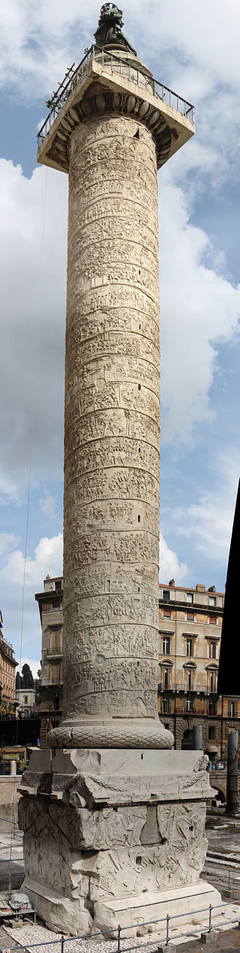  Forum of Trajan. Roman, Italy. Apollodorus of Damascus. column completed 113 C.E. marble (column).  Trajanscolumn.jpeg | Content:  This is a carved column that stands near the back of the Forum of Trajan.  The column itself stood 100 feet tall.  It was supported by a massive rectangular base and topped with a gilded statue of Trajan seated on a horse.  The entire column was covered in friezes depicting Trajan's victory in the Dacian wars.  This relief band is approximately 600 feet in length. Its width at the bottom is two feet and is about four feet at the top.  The wars are shown as a series of vignettes which each illustrate specific events.  His ashes were placed at the column’s base. In 1587, his statue was removed and replaced with a St. Peter statue.  Style:  The inscribed stories of Trajan are carved into the column with low relief. The column is incredibly large but really has no other decoration.  The figures in the carvings (over 2,000 appear) are about 2/3 life size, and they are so detailed that they cannot be easily viewed from the ground.  The reliefs had not always been white, but had originally been gilded and brightly colored, like so many other ancient Roman monuments at that time.  Context:  The Roman tradition is for emperors to leave an architectural monument to themselves. It is important to commemorate their rule, power, and authority.
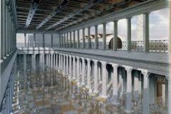  Forum of Trajan. Roman, Italy. Apollodorus of Damascus. Basilica Ulpia. 106 -112 C.E.  basilicaulpia.jpeg | Content:  Although the magnitude of the Basilica Ulpia can only now be seen through reconstructive illustrations like this one, it was an elaborate area of the Forum of Trajan. The area was a reserved space for the politics of Rome.  Style:  The Basilica Ulpia was composed of a great central nave with four side aisles with clerestory windows to let light into the space divided by rows of columns and two semicircular apses.  The apses were located on each end with the entry to the basilica located on the longitudinal side.  The roof was covered with bronze tiles.  The basilica also included high polished and decorative floors and ceilings.  Context:  This part of the forum mostly served a utilitarianism purpose for Trajan and the public. It was a place for politics and since Trajan had gifted the public a place for their political debates and appeals to the emperor, they were inclined to respect Trajan and his accomplishments.  The basilica was also built in a sort of grandeur to further imply the power and authority of Trajan.
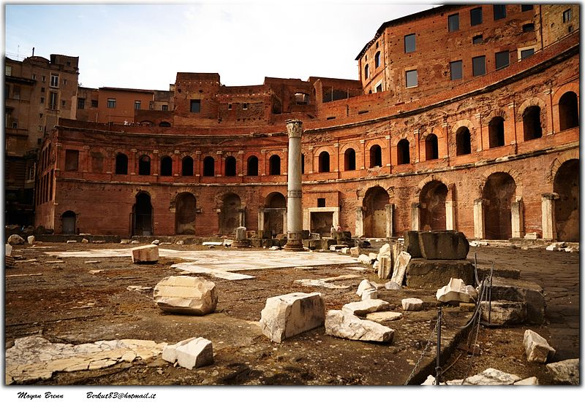  Forum of Trajan. Roman, Italy. Apollodorus of Damascus. Trajan’s Market. 106 -112 C.E.  trajansmarket.jpeg | Content:  The other parts of the forum were filled with markets and libraries.  The vaulted halls provided rooms for administrative offices, shops, and perhaps even apartments.  Style:  The design for these sections was less grand and open than most of the forum.  Context:  The markets of Trajan involved and flourished through public involvement. The people would be drawn to the Forum of Trajan and consequently take in the propaganda of the place.  Thought to be the world's oldest shopping mall, the arcades in Trajan's Market are now believed by many to be administrative offices for Emperor Trajan. The shops and apartments were built in a multi-level structure, and it is still possible to visit several of the levels.

