Battle of the Romans and Barbarians
Ludovisi Battle sarcophagus
Preconneus Marble
Content: The sarcophagus was originally painted.
Context: Roman empire was unstable, and the less traditional, more complex style emerged.
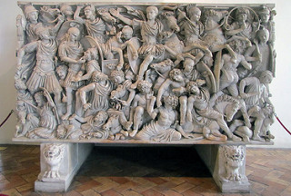
150 cm high
Content: This preconneous marble piece is 150 cm high.
Form: This piece is carved in high relief.
Context: Someone wealthy and powerful would have paid for this sarcophagus, most likely Abdalonymos, the king of Sidon established by Alexander.
Form: An alternation of light and darkness of the hair and faces of the Goths contrasts with the smooth surface of the Romans, who are not carved as deeply.
Content: The Goths are carved more undesirably than the Romans (large nose, puffy cheeks)
Form: Shields of the warriors create frames of parts of the carving which creates depth.
Content: The Roman hero in the center looks calm in the center of the chaotic carving.
Function: This piece is funerary and is a large marble tomb.

