Learning Object Script

Course Name and Number: AP Art History

Module Name: Module Five

SME Name: Denease McCullough

DS Name: Courtney Perrin

Title of Learning Object: Vienna Genesis, Rebecca at the Well

Purpose of Learning Object: Review

Narration Needed (Yes or No): No

Content for Learning Object (including answers):

This review needs links to hotspots that provide close-ups of images and text. (Hopefully you can do this.)

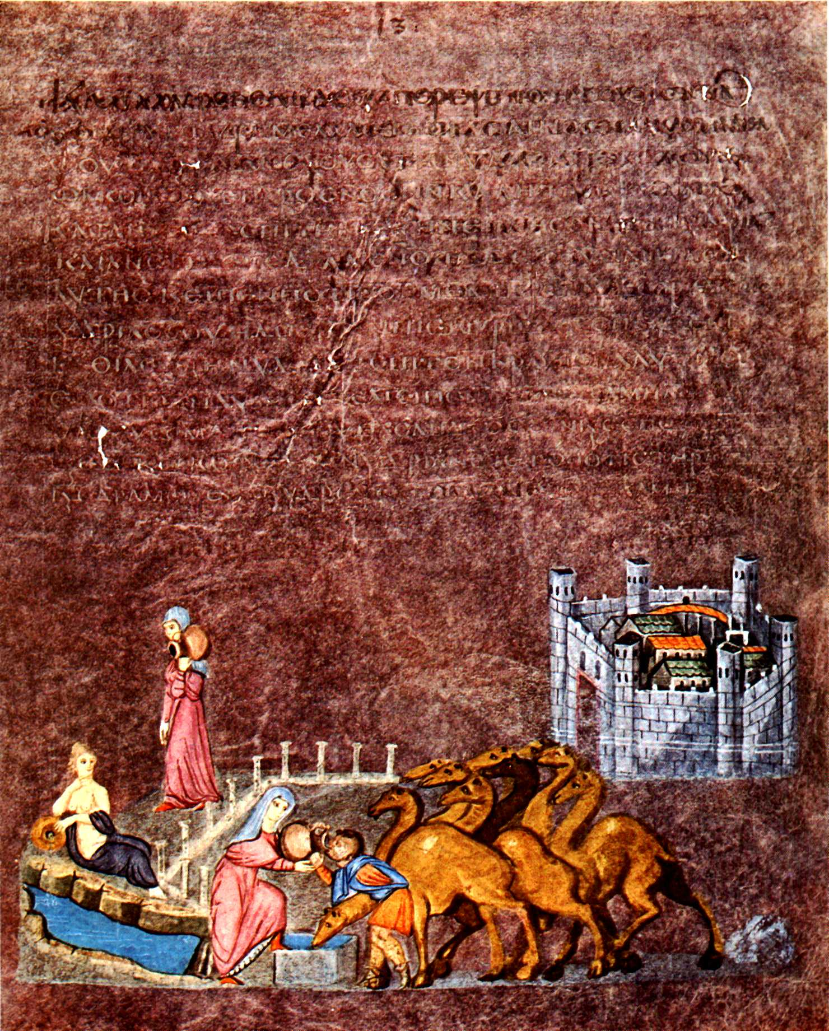

1

3

2
4

5

By en:User:Dsmdgold (English wikipedia) [Public domain], via Wikimedia Commons
ViennaGenesisRebeccaEliezer.jpeg

1. Genesis 24: 3- 21 New International Version (NIV)
Isaac and Rebekah
24 ³ I want you to swear by the Lord, the God of heaven and the God of earth, that you will not get a wife for my son from the daughters of the Canaanites, among whom I am living, ⁴ but will go to my country and my own relatives and get a wife for my son Isaac.”
⁵ The servant asked him, “What if the woman is unwilling to come back with me to this land? Shall I then take your son back to the country you came from?”
⁶ “Make sure that you do not take my son back there,” Abraham said. ⁷ “The Lord, the God of heaven, who brought me out of my father’s household and my native land and who spoke to me and promised me on oath, saying, ‘To your offspring I will give this land’—he will send his angel before you so that you can get a wife for my son from there. ⁸ If the woman is unwilling to come back with you, then you will be released from this oath of mine. Only do not take my son back there.” ⁹ So the servant put his hand under the thigh of his master Abraham and swore an oath to him concerning this matter.
¹⁰ Then the servant left, taking with him ten of his master’s camels loaded with all kinds of good things from his master. He set out for Aram Naharaim and made his way to the town of Nahor. ¹¹ He had the camels kneel down near the well outside the town; it was toward evening, the time the women go out to draw water.
¹² Then he prayed, “Lord, God of my master Abraham, make me successful today, and show kindness to my master Abraham. ¹³ See, I am standing beside this spring, and the daughters of the townspeople are coming out to draw water. ¹⁴ May it be that when I say to a young woman, ‘Please let down your jar that I may have a drink,’ and she says, ‘Drink, and I’ll water your camels too’—let her be the one you have chosen for your servant Isaac. By this I will know that you have shown kindness to my master.”
¹⁵ Before he had finished praying, Rebekah came out with her jar on her shoulder. She was the daughter of Bethuel son of Milkah, who was the wife of Abraham’s brother Nahor. ¹⁶ The woman was very beautiful, a virgin; no man had ever slept with her. She went down to the spring, filled her jar and came up again.
¹⁷ The servant hurried to meet her and said, “Please give me a little water from your jar.”
¹⁸ “Drink, my lord,” she said, and quickly lowered the jar to her hands and gave him a drink.
¹⁹ After she had given him a drink, she said, “I’ll draw water for your camels too, until they have had enough to drink.” ²⁰ So she quickly emptied her jar into the trough, ran back to the well to draw more water, and drew enough for all his camels. ²¹ Without saying a word, the man watched her closely to learn whether or not the Lord had made his journey successful.

.
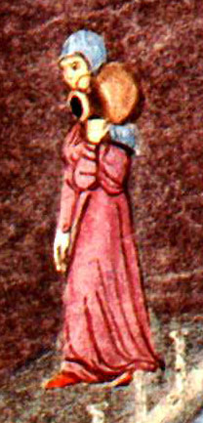

image3well.jpeg

- Rebecca leaves the city of Nahor to fetch water from the well in the first scene.
Rebecca walks to the well along a colonaded avenue of a Roman city.

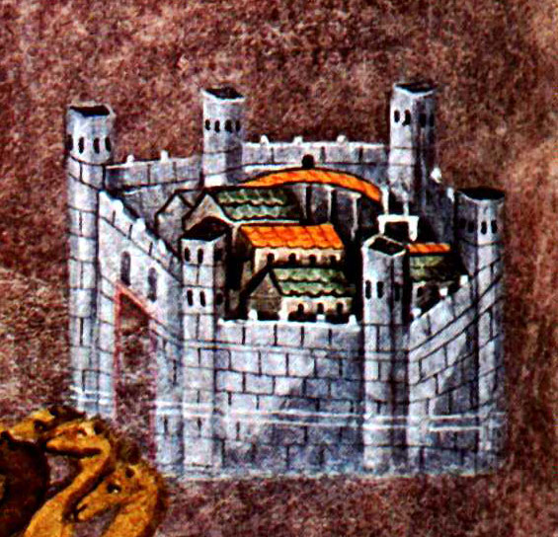

image1well.jpeg

3. Nahor is represented as a walled city seen from above, in the same way as the cityscapes on the Column of Trajan and the mosaics of Santa Maria Maggiore which incorporated Roman pictorial conventions.

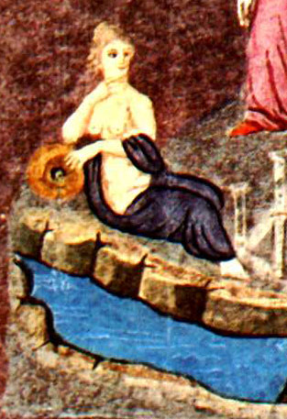

image5well.jpeg

4. The spring, the source of the well, is personified by a seminude female,—a reminder of the persistence of classical motifs

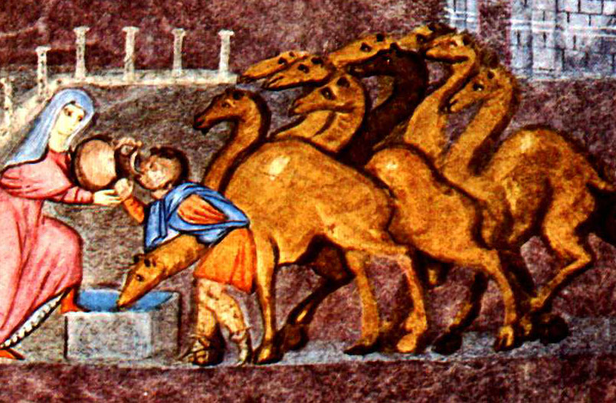

image2well.jpeg

5. Rebecca gives water to Eliezer and his camels. Rebecca braces her foot on the well as she tips the jug towards Eliezer. On camel is already drinking.

Standards associated with Learning Object (to the element – list with commas, no spaces):

Learning Objective 3.1: Students identify a work of art.

Learning Objective 3.3: Students analyze how contextual variables lead to different interpretations of a work of art.

Keywords for Learning Object:

Other files associated with Learning Object (images, etc.):

ViennaGenesisRebeccaEliezer.jpeg ( the master images from which the others were cropped)
image3well.jpeg
image1well.jpeg
image5well.jpeg
image2well.jpeg

Citations: (these are in order)

"Bible Gateway Passage: Genesis 24 - New International Version." Bible Gateway. Web. 26 Nov. 2014. <https://www.biblegateway.com/passage/?search=Genesis 24>.

