Learning Object Script

Course Name and Number: AP Art History

Module Name: Module Five

SME Name: Denease McCullough

DS Name: Courtney Perrin

Title of Learning Object: Vienna Genesis, Jacob Wrestling the Angel

Purpose of Learning Object: Review

Narration Needed (Yes or No): No

Content for Learning Object (including answers):

This review needs links to hotspots that provide close-ups of images and text. (Hopefully you can do this.)

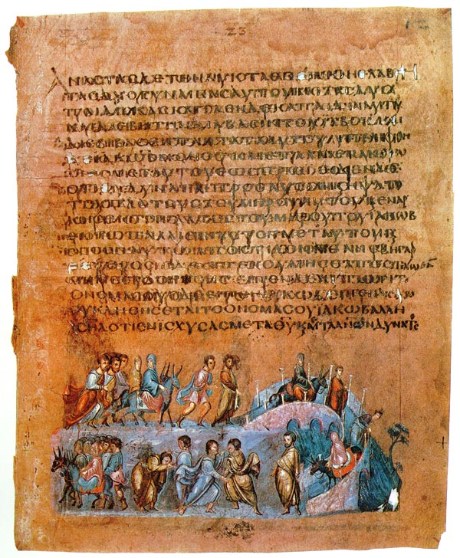
6
5
4
3
2
1
Jacob.jpeg

1. Genesis 32:22-32 English Standard Version (ESV)
Jacob Wrestles with God
²² The same night he arose and took his two wives, his two female servants, and his eleven children, and crossed the ford of the Jabbok. ²³ He took them and sent them across the stream, and everything else that he had. ²⁴ And Jacob was left alone. And a man wrestled with him until the breaking of the day. ²⁵ When the man saw that he did not prevail against Jacob, he touched his hip socket, and Jacob's hip was put out of joint as he wrestled with him. ²⁶ Then he said, “Let me go, for the day has broken.” But Jacob said, “I will not let you go unless you bless me.” ²⁷ And he said to him, “What is your name?” And he said, “Jacob.” ²⁸ Then he said, “Your name shall no longer be called Jacob, but Israel, for you have striven with God and with men, and have prevailed.” ²⁹ Then Jacob asked him, “Please tell me your name.” But he said, “Why is it that you ask my name?” And there he blessed him.³⁰ So Jacob called the name of the place Peniel, saying, “For I have seen God face to face, and yet my life has been delivered.” ³¹ The sun rose upon him as he passed Penuel, limping because of his hip. ³² Therefore to this day the people of Israel do not eat the sinew of the thigh that is on the hip socket, because he touched the socket of Jacob's hip on the sinew of the thigh.

- Jacob travels to meet Esau.

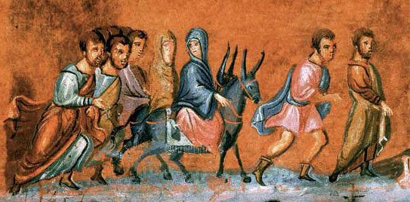
Imageone.jpeg

3. Jacob travels over the Jabbok brook.

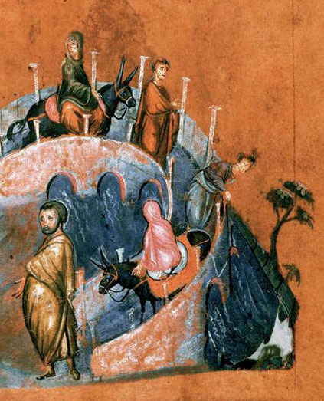

Image2.jpeg

4. Jacob wrestles with the Angel.
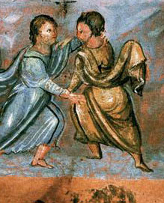

image3.jpeg

5. Jacob blessed by the Angel.

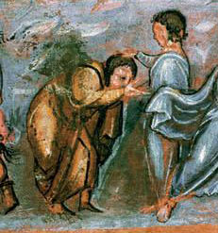

image4.jpeg

6. Jacob’s 11 sons.
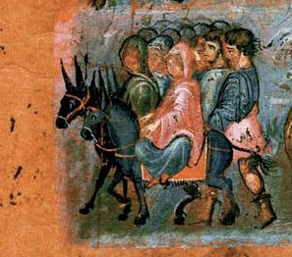

image5.jpeg

Standards associated with Learning Object (to the element – list with commas, no spaces):

Learning Objective 3.1: Students identify a work of art.

Learning Objective 3.3: Students analyze how contextual variables lead to different interpretations of a work of art.

Keywords for Learning Object:

Other files associated with Learning Object (images, etc.):
Jacob.jpeg
imageone.jpeg
image2.jpeg
image3.jpeg
image4.jpeg
image5.jpeg

Citations: (these are in order)

Genesis 32. Web. 26 Nov. 2014. <https://www.biblegateway.com/passage/?search=Genesis 32:22-32&version=ESV>.

Jacob Wrestling The Angel. Wikipedia. Web. 26 Nov. 2014. <http://upload.wikimedia.org/wikipedia/commons/a/a0/ViennGenFol12vJacob.jpg>.

