Learning Object Script

Course Name and Number: AP Art History

Module Name: Module Thirteen

SME Name: Denease McCullough

DS Name: Courtney Perrin

Title of Learning Object: Churning of the Oceans

Purpose of Learning Object: Review

Narration Needed (Yes or No): No

Content for Learning Object (including answers):

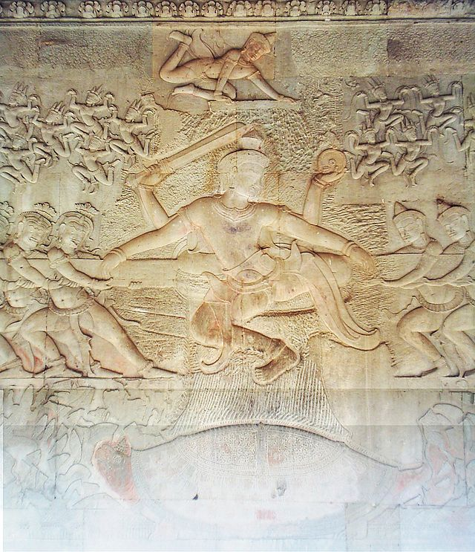
4.
2.
1.

7.
3.

5.

6.

1.
Every culture has its legends of the origin of the species. The Hindu creation myth Churning the Sea of Milk is shown in the bas-relief panel at the East gallery of Angkor Wat. The myth of the Churning was very popular in the Angkor era. It is depicted at temples in Angkor and all over Cambodia.

2.
At the beginning of the world, the gods (devas) and demons (asuras) were engaged in a thousand year battle to secure amrita, an elixir that would render them immortal and incorruptible. After some time, when they became tired and still had not achieved their goal, they asked the help of Vishnu. He appeared and ordered to work together, not against each other. Working together, they then commenced the churning of the Ocean of Milk by using Mount Mandara as the pivot and the five-headed naga Vasuki as the rope.
However, the mountain suddenly began to sink. Vishnu incarnated as the tortoise Kurma to support the pivoting mountain on his back. Many gods also assisted, including Indra, by keeping the pivot in position. The spinning of Mount Mandara created such a violent whirlpool that the that the creatures and fish around it were torn to pieces,
The Ocean of Milk was churned another thousand years before producing the much-desired elixir and other treasures, amongst which are the goddess Lakshmi (Sri Devi) [the spouse of Vishnu] , the elephant Airavata, the horse Ucchaihsravas, a whishing tree (Parijata), and the apsara.
The naga Vasuki vomited floods of black venom due to his mishandling by teh devas and asuras during the churning. This would have been enough to poison everybody had it not been for Shiva, who drank it all; as a result, his mouth remaining stained forever with a black line. (Angkor Guide)

3.
At the center of the relief, Vishnu appears in two forms: below, as Kurma, the tortoise upon which the mountain/pivot is set; and above, in four-armed form, holding sword and chakra with two hands and the snake with the other two, as the one who directs the operation.

4.
The figure above the pivot (closeup) is either Indra, the king of the gods, or Vishnu again (this depends on which version of the myth one is following).

5.
Lord Vishnu cajoles demons (asuras) and gods (devas) into working together to produce an elixir of immortality they both covet. They churn the waters of the cosmic ocean using
a sacred mountain as a pivot and a supernatural, five-headed snake as a rope. Lined up on either side, asuras and devas take turns pulling, causing the mountain to swivel back
and forth, stirring the waters. When the mountain suddenly begins to sink, Lord Vishnu keeps it afloat till their churning produces the elixir.

6.
Innumerable fish and aquatic creatures, torn to pieces as they swim close to powerful air currents near the churning stick, represent the Sea of Milk, or the Ocean of Immortality.

7.
The churning releases a fluid that creates a divine ambrosia, amrita, the essence of life and immortality. Many other treasures are also created. Born of this action are apsaras, or celestial dancers, a purely Khmer innovation. The seductive apsaras promise a joyful existence for those who attain the ultimate incarnation

Citation:
"The Churning of the Sea of Milk." — Angkorguide.net. Web. 29 Mar. 2015. <http://www.angkorguide.net/en/temples/temples-in-angkor/angkor_wat/the-churning-of-the-sea-of-milk.html>.

Keywords for Learning Object:

Other files associated with Learning Object (images, etc.):

Image titles are under the pictures.

Citations:
http://www.angkorguide.net/en/temples/temples-in-angkor/angkor_wat/the-churning-of-the-sea-of-milk.html

