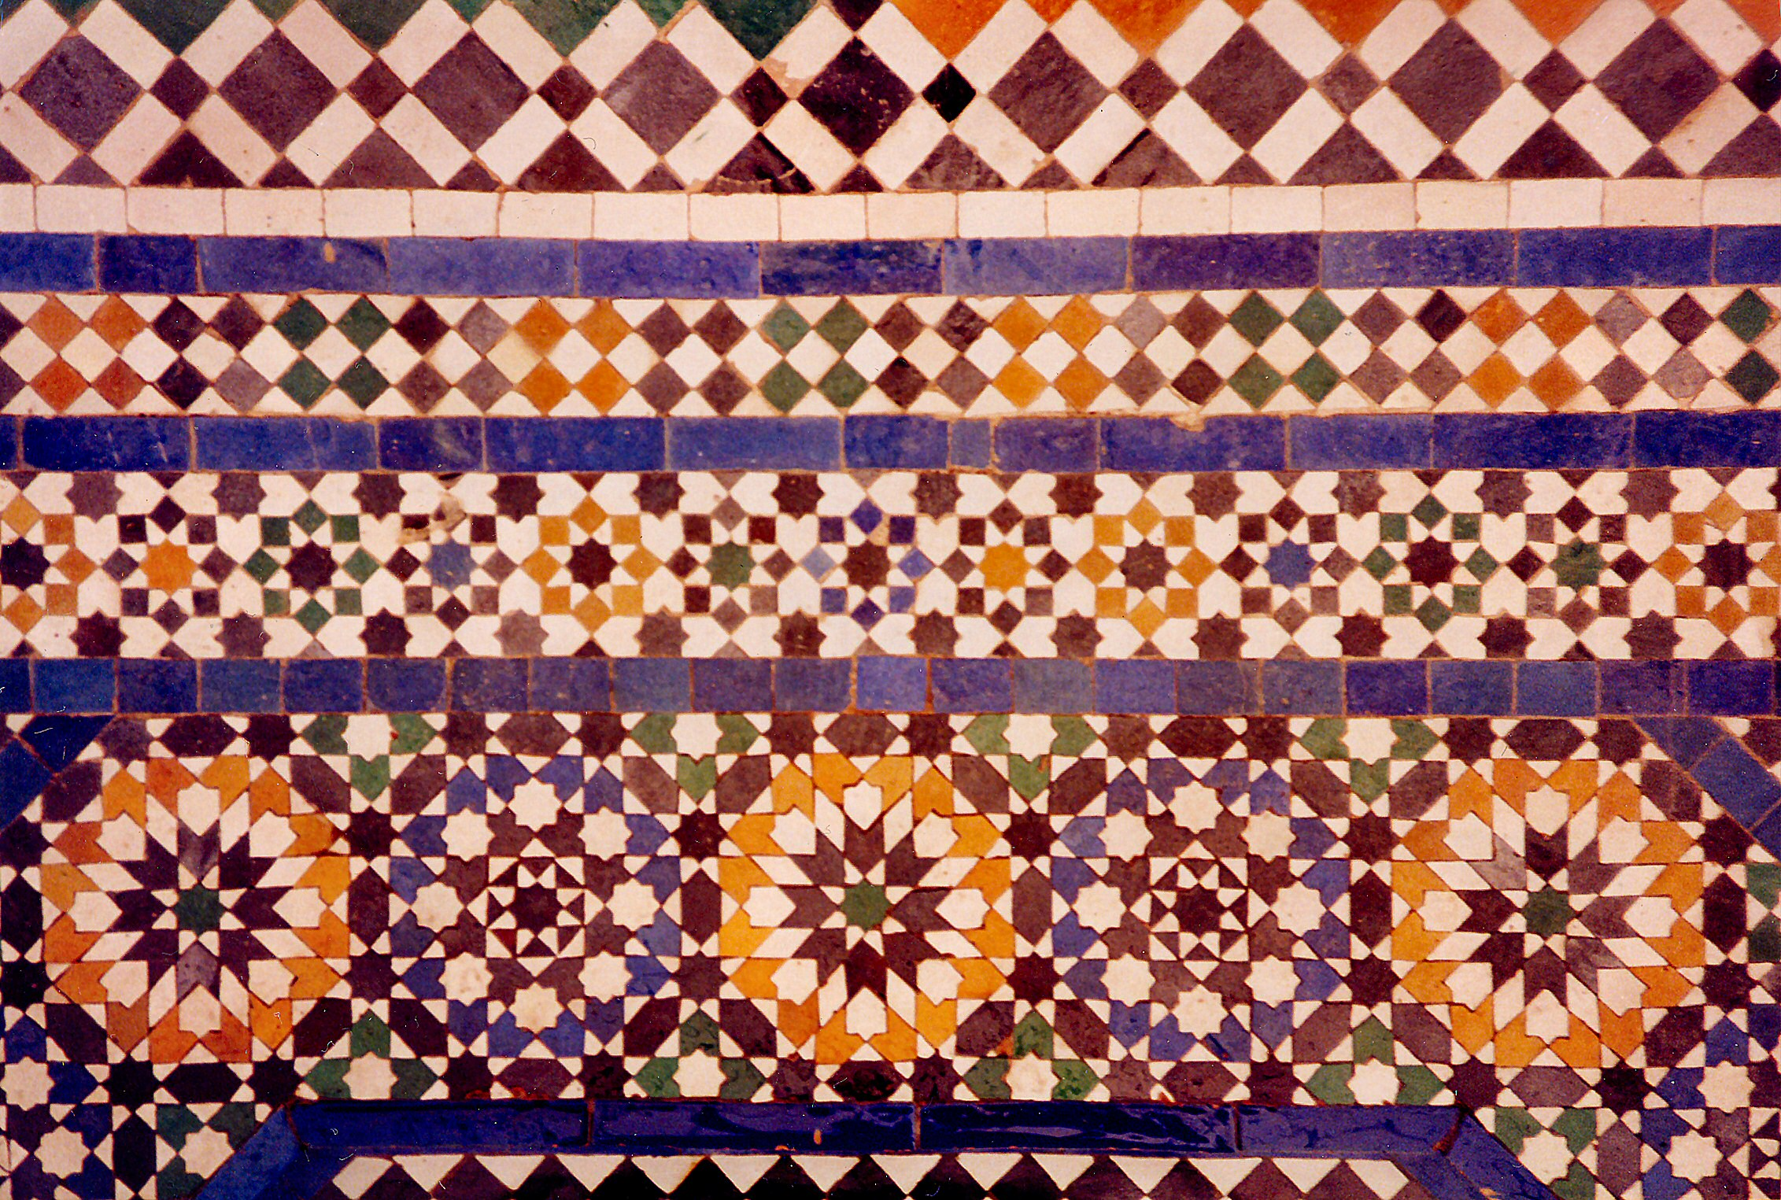

West and Central Asia Module

Jowo Rinpoche, enshrined in the Jokhang Temple. Lhasa, Tibet. Yarlung Dynasty.
Believed to have been brought to Tibet in 641 C.E. Gilt metals with semiprecious
stones, pearls, and paint; various offerings.

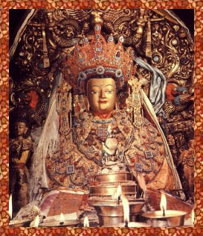

Image Citation: Flickr/ sakyamuni/4297438556/

The Jokhang Temple ("House of the Lord") is a four-story timber complex with a gilt roof . It is located in central Lhasa and is the holiest site in Tibetan Buddhism. The temple is the place where the ceremonies of initiation for the Dalai Lama and Panchen Llamas are held. Every Tibetan looks to Lhasa city as the most sacred place of pilgrimage and the Jokhang Temple is the chief destination to visit. The Jokhang Temple attracts pilgrims from all over Tibet (and the world) who come to offer devotion to an image of the Buddha known as the Jowo Rinpoche.
The first ruler of a unified Tibet, King Songtsen Gampo, constructed the temple in 647. Its purpose was to house a sacred image of the Buddha, the Jowo Rinpoche, which was brought to Lhasa by Queen Wengcheng, the second wife of the King from China, as a dowry. This statue is still enshrined within the temple and is the holiest object in Tibet.
The Chapel of Jowo Shakyamuni is the most important shrine in Tibet. It houses a 1.5m sitting image of Shakyamuni at the age of twelve. It is said to be one of three made during his lifetime. The statue was a gift from the Chinese Princess Wencheng to her husband King Songtsen Gampo. The Jowo sits on a majestic large three-tiered stone platform. Two silver-plated dragons, presented by the Chinese emperor, interweave the ornate pillars that support a double canopy over the Jowo. An ornate crown of coral, turquoise, diamonds, rubies, and other precious gems, sits on the Jowo’s head.
It was believed that whatever prayer one offers in front of Jowo Rinpoche never goes unsatisfied. That is why Tibetans call Jowo Rinpoche, "Joshak-Yishin Norbu" the wish-fulfilling gem. The diadem, cape, and decorative straps worn by the image of the young Buddha are studded with pearls, agates, turquoises, corals and dzi beads. Dzi are a black and white (or dark brown) bead of etched or treated agate that is revered in Tibet. The bead is considered to provide positive spiritual benefit. The most precious are the three pieces of nine-eyed dzi on the diadem. At present, the image is housed and worshipped in the Jokhang Monastery.

Citations:

“Dzi Bead." Wikipedia. Wikimedia Foundation. Web. 14 Mar. 2015. <http://en.wikipedia.org/wiki/Dzi_bead>.

"Meaningsofdzi2232 - Dzidzi888." Meaningsofdzi2232 - Dzidzi888. Web. 14 Mar. 2015. <https://sites.google.com/site/dzidzi888/meaningsofdzi2232>.

