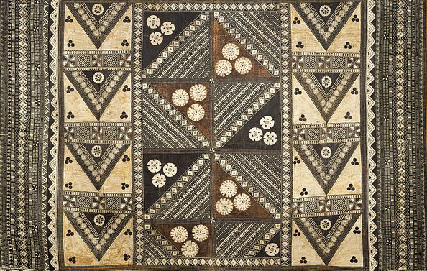

Pacific Arts

Hiapo (tapa). Niue. c. 1850–1900 C.E. Tapa or bark cloth, freehand painting.

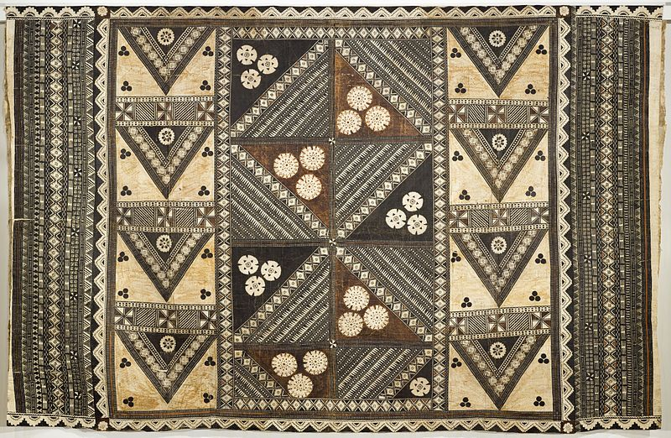

This is not the same image in the image set.

Photo Citation: "Wedding Tapa (Gatu Vakaviti) LACMA M.2010.160" by Image: http://collections.lacma.org/sites/default/files/remote_images/piction/ma-34603986-O3.jpgGallery: http://collections.lacma.org/node/222475. Licensed under Public Domain via Wikimedia Commons -

On the island of Niue, hiapo is the term for bark cloth. The art form is made from the bark of the paper mulberry tree. Samoan missionaries are thought to have brought hiapo with them in 1830. Although the hiapo may have originated in Samoa, the quality of the tapa in Niue is different. Layers are felted into a single sheet like the way it’s done in the Cook Islands. Felting is the process of layering pieces of tapa cloth together. No one knows what it is made for, since the size seems to be too small for clothing or blankets.
The Niuens decorated their hiapo with freehand painting that is similar to the Samoan style. Rectangular or circular design compositions are drawn with fine black lines, in a grid formation. The subject matter is usually abstract forms and plant forms. People, stars, and fish are occasionally painted into the design.

Citations:
"Tapa in Niue." Kapa Kulture. 2 Oct. 2013. Web. 12 Apr. 2015. <https://kapakulture.wordpress.com/2013/10/02/tapa-in-niue/>

Citation:

