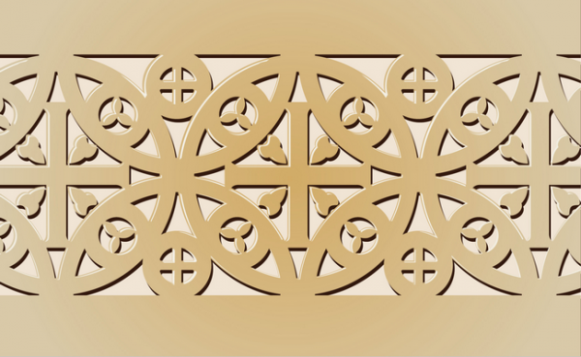
Early Europe and Colonial Americas Module
PART II
The Golden Haggadah is one of the finest of the surviving Haggadah manuscripts from medieval Spain. The Haggadah, which means 'narration', is a collection of Jewish prayers and readings written to accompany the Passover 'seder', a ritual meal eaten on the eve of Passover. The book was intended for use at home and its main aim was to educate the young.
The Golden Haggadah was probably made near Barcelona in about 1320. In addition to the Haggadah text itself the manuscript contains liturgical Passover poems according to the Spanish rite. The text is preceded by a series of full-page miniatures depicting scenes mainly from the Book of Exodus. These sumptuous illuminations set against gold-tooled backgrounds earned the manuscript its name and were executed by two artists in the northern French Gothic style. The 17th-century Italian binding has an elaborate border on each cover. Hebrew is written from right to left, so the Golden Haggadah opens from the right. (British Library)
Only the richer Jews, who, especially in Spain, were employed by princes or their courtiers and were therefore better acquainted with beautifully illuminated codices, would have the means to attempt the imitation of the fashion for such objects by commissioning the illumination of Hebrew books. Such commissions would present the artist with the problem of a subject matter, which was new to him, and the problem was met by the fusion of traditional Jewish themes, motifs, and iconography, with the more fashionable styles and layout of contemporary Christian illumination, according to the style of the artist and the taste of his patron. (British Library)
The style of the miniatures and the text illustrations suggest that it was executed in Barcelona in the first quarter of the 14th century. It is based on the northern French gothic style of the late 13th century. Two artists executed the full-page miniatures, divided into four compartments each painted on a burnished gold background. (British Library)

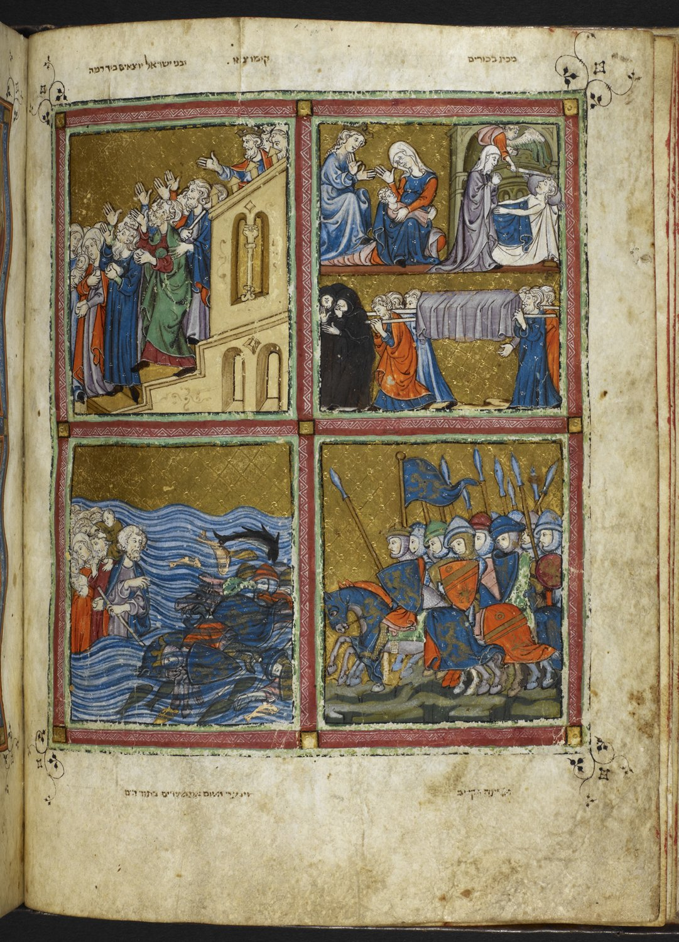

Scenes of Liberation
By The Education Center of the National Library of Israel (The National Library of Israel Collections) [CC BY-SA 3.0 (http://creativecommons.org/licenses/by-sa/3.0)], via Wikimedia Commons

“The Pharaoh refused to free the Israelite slaves. So God, brought about one last plague, which was so terrible that it was certain to persuade Pharaoh to let his slaves go. That night, God sent the angel of death to kill the firstborn sons of the Egyptians. God told Moses to order the Israelite families to sacrifice a lamb and smear the blood on the door of their houses. In this way the angel would know to 'pass over' the houses of the Israelites. This is why the festival commemorating the escape from Egypt is known as Passover. This image shows several scenes from Passover. On the right in a domed room, the angel of death is swinging his sword at a man in bed. On the left the Pharaoh and Queen are mourning the death of their first-born son. Below is a funeral scene with six men carrying a firstborn's coffin.” (British Museum)

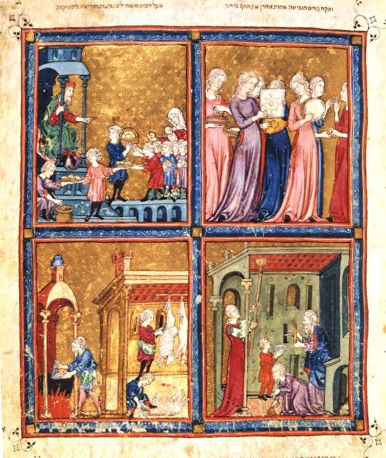

Passover Scene
[Public domain], via Wikimedia Commons

Image is in the image set.

The Plagues of Egypt

Because Pharaoh refused to set the Israelites free, God decided to punish him, sending ten plagues on to Egypt. These included:

- Blood- All the water was changed to blood
- Frogs- An infestation of frogs sprang up in Egypt
- Lice- The Egyptians were infested with lice.
- Wild animals- An infestation of wild animals (some say flies) sprang up in Egypt.
- Pestilence- A plague killed off the Egyptian livestock
- Boils- An epidemic of skin boils afflicted the Egyptians
- Hail- Hail rained from the sky
- Locusts- Locusts swarmed over Egypt and ate crops.
- Darkness- Egypt was covered in darkness
- Killing of the first born- All the first-born sons of the Egyptians were killed by God.

Citations:
"Golden Haggadah - Introduction." Virtual Books: Images Only. Web. 13 Dec. 2014. <http://www.bl.uk/onlinegallery/ttp/hagadah/accessible/introduction.html>.

For more information:

Flip through the Golden Haggadah virtually
http://www.bl.uk/turning-the-pages/?id=47111807-4e9a-43de-be65-96f49c3d623c&type=book

