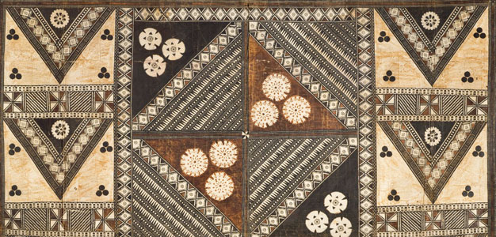
African Art Module

Aka elephant mask. Bamileke (Cameroon, western grassfields region). c. 19th to 20thcentury C.E. Wood, woven raffia, cloth, and beads.
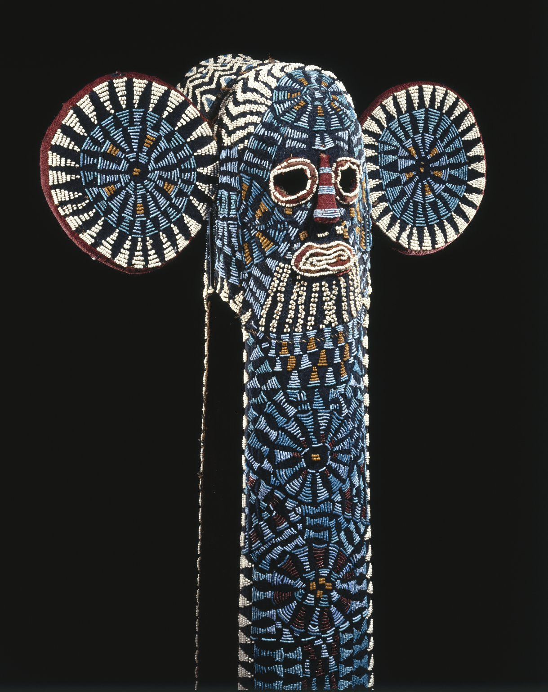

Image Citation: http://upload.wikimedia.org/wikipedia/commons/1/10/Brooklyn_Museum_81.170_Kuosi_Society_Elephant_Mask.jp

The masquerade is performance art. The works on view here were not meant to be seen as isolated sculptural forms but were part of a whole that included costume, music, songs, food, audience interaction, and, above all, movement. Masked performances have a variety of purposes. Both of the masks displayed here were performed to support political authority, but in different contexts.
The Bamileke masquerade is an assertive but controlled and dignified performance worthy of a royal court. The elite Kuosi masking society controls the right to own and wear elephant masks, since both elephants and beadwork are symbols of political power in the kingdoms of the Cameroon grasslands. The Kuosi society assists the king, or fon, in his role as preserver and enforcer of a rigid sociopolitical hierarchy (Arts of Africa).
“Maskers dance barefoot in these colorful costumes to a drum and gong, moving slowly as they wave poles with blue and white beaded tips trimmed with horsehair. They whistle "mysteriously and tunelessly," brandishing spears and horsetails. Chiefs and princesses, parading by an elaborate tent in which high-ranking men sit to observe, later join masked dancers. A mask wearer hurls his horsetail to the chief, the crowd cheers, and the celebration continues with various feats performed primarily by younger maskers (Randafrica).”

Citations:
"Bamileke Elephant Masks - RAND AFRICAN ART." Bamileke Elephant Masks - RAND AFRICAN ART. Web. 2 Mar. 2015. <http://www.randafricanart.com/Bamileke_elephant_mask_cowrie_shells.html>.

"Collections: Arts of Africa: Kuosi Society Elephant Mask." Brooklyn Museum: Arts of Africa: Kuosi Society Elephant Mask. Web. 2 Mar. 2015. <http://www.brooklynmuseum.org/opencollection/objects/4852/Kuosi_Society_Elephant_Mask>.

