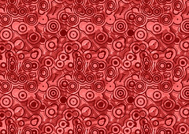
Global Contemporary

Earth’s Creation. Emily Kame Kngwarreye. 1994 C.E. Synthetic polymer paint on
canvas.
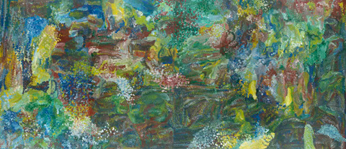
Photo Citation: https://www.khanacademy.org/humanities/global-culture/identity-body/identity-body-united-states/a/jaune-quick-to-see-smith-trade-gifts-for-trading-land-with-white-people

Earth's Creation is a painting by the Australian Aboriginal artist Emily Kame Kngwarreye. It was painted in 1994 at Utopia, north east of Alice Springs. Emily Kame Kngwarreye is recognized as one of Australia’s most important Aboriginal artists. She began painting late in life when she was in her 70s.
Earth's Creation is described as part of her "high-colorist" phase. It's dubbed a rich vibrant masterpiece of swirling blues, greens and yellows, from what Kngwarreye called the "green time", after the rains came and the bush erupted in new life. She painted with a 'dump dot' technique, also known as ‘dump dump’ using her shaving brush to pound the acrylic paint onto the canvas and create layers of color and movement. (Wikipedia)
Kngwarreye's vibrant images evoke the characteristics and stories of the land of her origins. Although the artist knew very few English words, Kngwarreye was asked in 1990 to explain what she painted. She told the interviewer that she painted her country, in all its aspects:

"...Whole lot, that's whole lot, Awelye (my dreaming), Arlatyeye (pencil yam), Arkerrthe (mountain devil lizard), Ntange (grass seed), Tingu (a dream-time pup), Ankerre (emu), Intekwe (a favourite food of emus, a small plant), Atnwerle (green bean), and Kame (yam seed). That's what I paint: whole lot...."

As an elder and leader of women's ceremony, Kngwarreye was required to pass on her knowledge and the stories of the land. For Kngwarreye, painting was not some separate aesthetic exercise but another component of the Dreaming ceremonies. To paint was a spiritual act.
“The Aboriginal Dreamings or myths about creation, the development of the earth and cosmos, are presented as the outcome of journeys and activities of supernatural ancestral beings. The dreamtime stories, which outline definite customs and social laws, are also related to different regions. The Aboriginal people who reside in these areas are regarded as the custodians of these myths. Their responsibility is to pass them on through ceremony, ritual, song and dance, and to preserve and protect the land with its sacred sites. By enacting a dreamtime story Aboriginal people believe that they are activating the powers of ancestral beings, who will nourish and renew the land and all its inhabitants. (WSWS)”
Emily Kame Kngwarreye’s work become immediately popular and was likened to the work of the modernist or the great abstract expressionist painters such as Jackson Pollock. Art critics and collectors have wondered at how this elderly woman painted such extraordinary modern artworks when she was never exposed to it. Artistic expression however was not new to Emily as she had enjoyed a lifetime of ritual and artistic activity with the women drawing in sand and making batiks, the desert earth and painting their bodies for dance and song ceremonies. Her achievements have made one of Australia’s most important Aboriginal artists.

Citation:
"Earth's Creation." Wikipedia. Wikimedia Foundation. Web. 28 Apr. 2015. <http://en.wikipedia.org/wiki/Earth's_Creation>.

"World Socialist Web Site." The Art of the "Dreaming" -. Web. 28 Apr. 2015. <https://www.wsws.org/en/articles/1999/05/kng-m07.html>.

