Camila Strohmeyer
The Code of Hammurabi. Babylon. 1792-1750 BCE, Basalt. 7 feet tall.
Source for picture: http://www.pbslearningmedia.org/resource/8ad4b452-e171-4647-8c39-820e774d61a8/code-of-hammurabi-state-department/
Content: By being given the scepter and ring, it means the God(s) have “destined” him to be king.
Function: Tells the people what the punishments are for doing something against the law.
Function: Keeps Hammurabi’s people in line for the most part by scaring/threatening them.

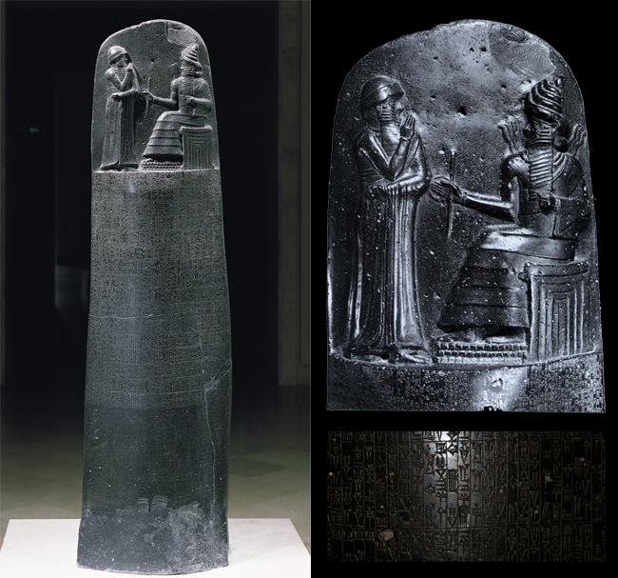
Content: Contains about 300 laws that Hammurabi set & although most are fair, punishments sometimes vary depending on class.
Context: He’s not saying he is a God, but is only in the presence of one.
Context: Tells and shows how he became king.
Form: Has movement because people read left to right, up to down.
Form: Code was inscribed on a 7-foot tall, basalt stele.
Context: Shows power of authority by what the “narrative” at the top represents.
Content: The laws inscribed on the lower part of the monument are written in cuneiform.

