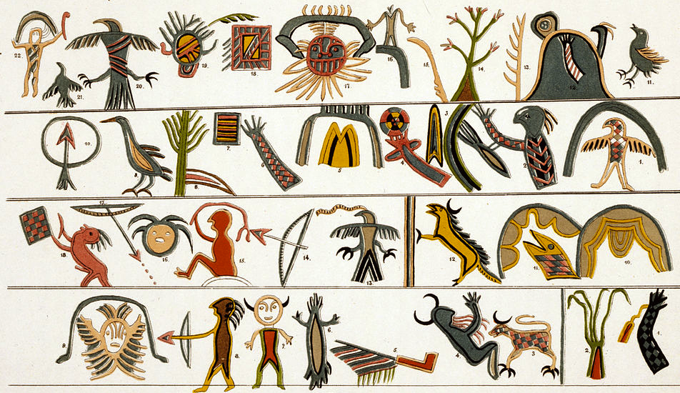
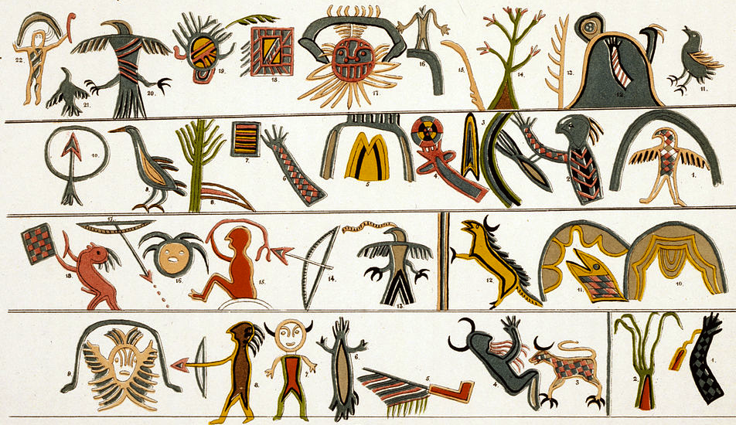
Indigenous Americas Module

City of Cusco.Walls at Saqsa Waman (Sacsayhuaman). Central highlands, Peru. Inca. c. 1440 C.E. Sandstone.
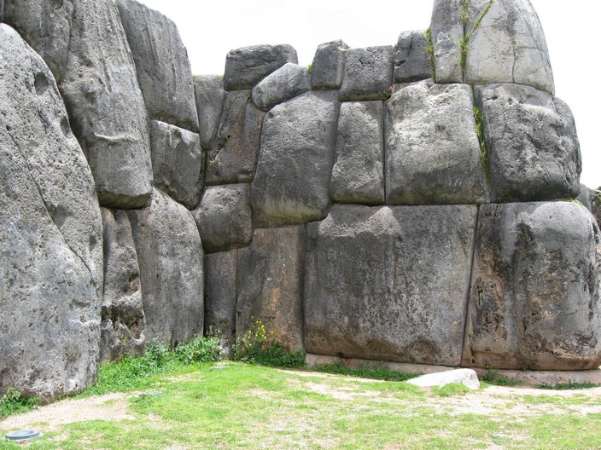

By Leon Petrosyan (Own work) [CC-BY-SA-3.0 (http://creativecommons.org/licenses/by-sa/3.0)], via Wikimedia Commons

The capital of the Inca empire was a grand city called Cusco, which was built in the shape of a puma. The imperial city Cusco, meaning ‘navel of the earth,’ was laid out in the form of a puma, the animal that symbolized the Inca dynasty. The belly of the puma was the main plaza, the river Tullumayo formed its spine, and the hill of Sacsayhuaman its head.
Garcilaso de la Vega wrote the following:
"The largest and most magnificent work which they ordered built to demonstrate their power and majesty was the fortress of Cuzco, the magnitude of which is incredible to those who have not seen it, and those who have seen and looked with attention it makes them imagine and even believe that it its greatness is made by way of enchantment and was made by devils and not men, because the multitude of so many stones of such great size, such as those placed in three terraces (which are more so than stones), cause admiration in imagining how they could be cut from the quarries from which they were taken...
"...many of them are so fitted that the joint hardly shows, and to think how they could fit stones so immense so well that you can scarcely insert the point of a knife between them..." (World Mysteries)

Sacsayhuaman is known today for its majesty and resilience. Its construction took over seven decades and required the work of approximately 20,000 men to lay the foundations after transporting materials and carving. Hewn stones could have been located 20 kilometers away from Cusco. Some of its external walls exceed the 9 meters of height and 350 tons of weight (AP Chuquicamata).
The spectacular structure built with huge carved rocks jointed with absolute accuracy, this astounding sample of the Incan military architecture proves the organizational capacity of the empire and its powerful logistic system capable of mobilizing such a work. The Incas at the time possessed only primitive tools, and had not discovered the wheel, making the placement of the massive stones nearly impossible. In 1535, Spanish explorer Pizarro laid siege to the fortress, destroying much of the complex with cannons and eventually won the battle, with much of the fortress lying in ruins. Today only the foundations of the towers are visible, but the great wall still stands untouched by Spanish artillery.

Citation:
"AP Chuquicamata, San Martin De Los Andes, Sascahuaman." Ravenseniors -. Web. 16 Feb. 2015. <http://ravenseniors.wikispaces.com/AP Chuquicamata, San Martin de los Andes, Sascahuaman>.

"MYSTIC PLACES: Sacsayhuaman." World Mysteries. Web. 16 Feb. 2015. <http://www.world-mysteries.com/mpl_9.htm>.

