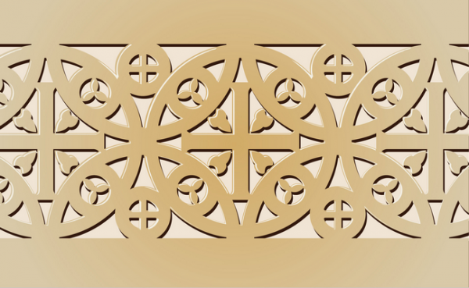
Church of Sainte-Foy. Conques, France. Church: c 1050-1130 C.E.; Reliquary of Saint Foy: ninth century C.E., with later additions. Stone (architecture); stone and paint (tympanum); gold, silver, gemstones, and enamel over wood (reliquary).
Early Europe and Colonial Americas Module ONE

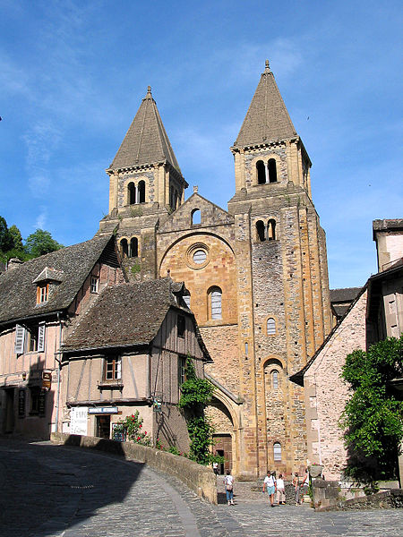
During the Romanesque Period in Europe, there was a very large interest in religion. Large numbers of people traveled on pilgrimages to visit sites of saints and martyrs. People believed that holy relics had the power to do miracles. The most popular destination was Santiago de Compostela in northwest Spain. Pilgrimages were big business: certainly on a par with modern day tourism. In the thirteenth century, many as 60% of the people with any significant wealth went on pilgrimages. Many churches were built along the pilgrimage routes and many were specially designed to cope with vast numbers of people
The routes to the more famous holy places, such as Santiago, became very well traveled and required larger buildings to hold the large crowds. The basilica style church could not hold the large crowds, which were coming. They began to build churches in the shape of the Latin cross. The pilgrim would enter the church through the nave. They would then come to the area known as the crossing, which was under a groin vault, where the vaults of the nave and the transepts would intersect. The relics of the church would be held and displayed in the area of the high alter. The pilgrims would be allowed to view the relics from the ambulatory, which allowed for a good traffic pattern for these large crowds. The more famous the relics a church held, the larger the crowds it would attract.

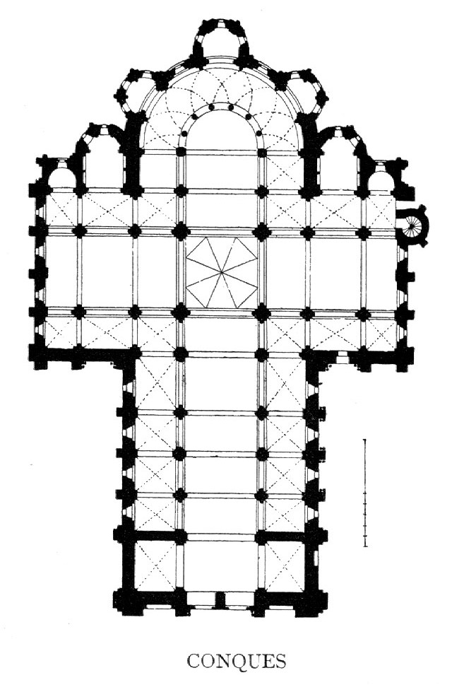
Sainte Foy has a cruciform plan, includes a three-aisled nave with a central vessel and two side aisles on each side. A strongly projecting transept is also aisled with two chapels off the eastern side of each arm. To the east of the transept is the choir that includes an ambulatory and three radiating chapels. The aisles in the nave, transept, and choir (ambulatory) permit the pilgrim to circumambulate the entire church without entering the central altarspace.

The eastern portions of the choir are constructed above a crypt. Because of the more complex arrangement of spaces, the portion east of the transept in the Romanesque period is referred to as the choir rather than apse, the term used to describe the semicircular space east of an Early Christian or Byzantine transept or nave.

The transept crossing piers and western nave piers are enlarged to support towers.
Regular rectangular bays form the length of the nave, transept and choir and the plan proportions (the square bays of the aisles and the rectangular bays of the central vessel) are based on square schematism derived from the square of the transept crossing. Square schematism results in great regularity and harmony of spatial proportions. (Note: In a good ground plan dotted or broken lines usually indicated groin vaults whereas a solid line indicates ribbed vaults). Each nave bay measures ½ of crossing/ aisles are ¼ the size of crossing.
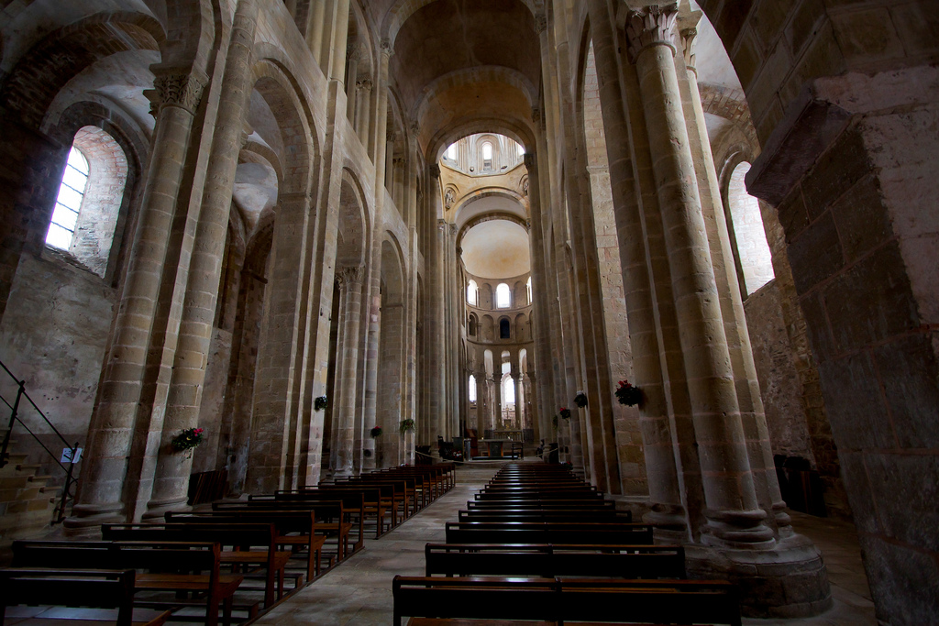
The architects also wanted to get away from using wood for the ceilings. They began to use stone ceilings on the new type of churches. Barrel or groin vaults were used in the ceiling. The stone was supported in the middle by the arch construction but was very heavy. The weight of the ceilings would tend to buckle the walls outward. This pressure outward is known as outward thrust. To support the walls, large piles of stone would be stacked along the wall in intervals to buttress (or support) the walls from pushing.
Due to the weight of the stone ceiling, the wall of the church had to be very thick. Windows had to be small to keep the strength of the wall strong. Because of this, the churches interior was dim. This was not solved till the gothic church design was used.

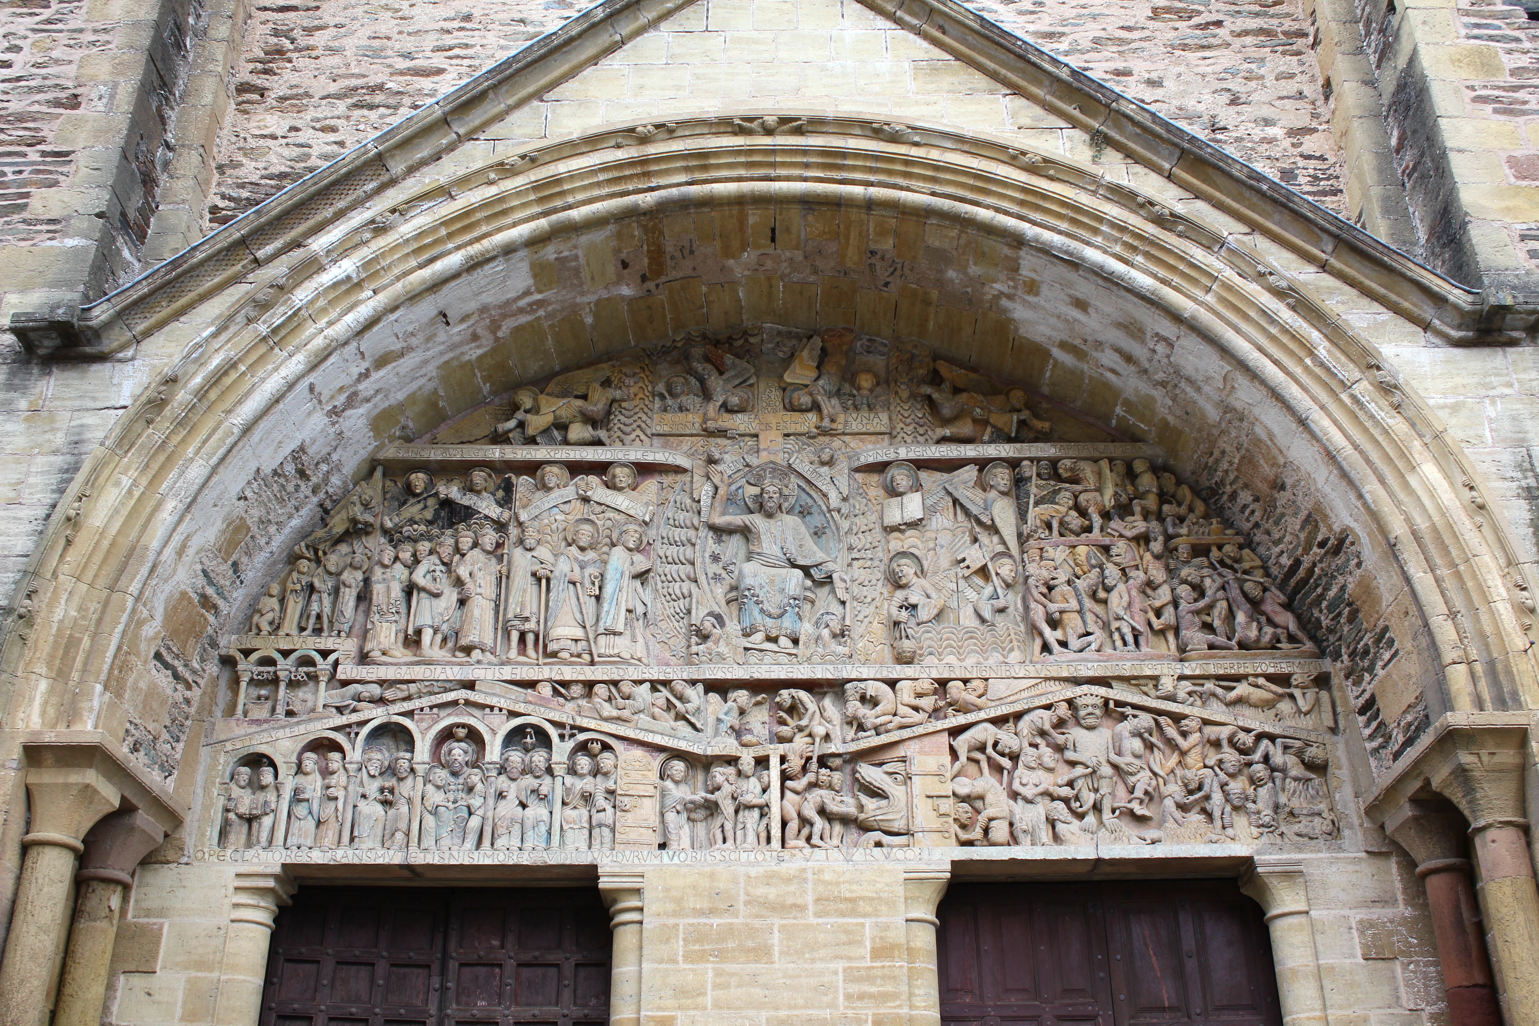
When a pilgrim arrived at Conques, they would probably head for the church to receive blessing. Yet before they got inside, an important message awaited them on the portals: the Last Judgment. This scene is depicted on the tympanum, the central semi-circular relief carving above the central portal.
This scene would have served as a reminder to those entering the Church of Saint-Foy about the joys of heaven and torments of hell.

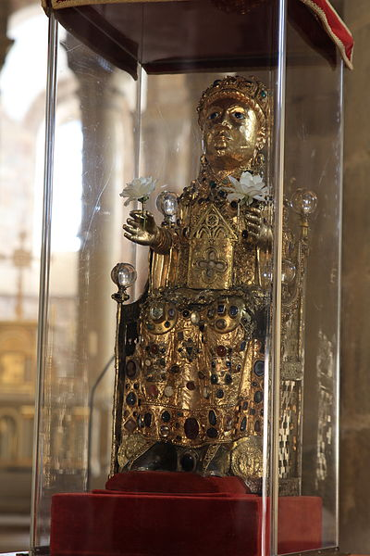
Saint Foy or "Saint Faith of Conques” is a saint who is said to have been a girl or young woman of Agen in Aquitaine. Her legend recounts how she was arrested during persecution of Christians by the Roman Empire and refused to make pagan sacrifices even under torture. Saint Faith was tortured to death with a red-hot brazier, a hot griddle.

The center of her veneration was transferred to the Abbey of Sainte-Foy, Conques, where her relics arrived in the ninth century, stolen from Agen by a monk from the Abbey nearby at Conques. In the same year the abbey was founded, the relics of St. James were discovered at Compostela in Spain. The pilgrimage routes passed through smaller shrines along the way, which soon became rich from pilgrim gifts and religious tourism. For the monks at Conques, the lure of fame and riches soon proved too much to bear, and they conspired to steal some relics to attract pilgrims. A Conques brother acted as a faithful monk at Agen for 10 years at until he was able to steal the relics, which he brought back to Conques. Streams of pilgrims soon began to make their way to the shrine.

The saint’s relics are still held in the golden reliquary, dating back at least to 1010, designed in the shape of a woman. The manly face of the reliquary has actually caused some debate, but regardless, it is one big, golden statue. It is also the last remaining example of its type, once common in the Middle Ages. The monastery at Conques remains an important stop on the pilgrimage route of the Camino de Santiago, where pilgrims stop to visit the relics of St. Foy to ask for her blessings of safe travel.

Citations:

"Sacred Destinations." Conques Abbey. Web. 26 Nov. 2014. <http://www.sacred-destinations.com/france/conques-abbey>.

Web. 26 Nov. 2014. <https://www.khanacademy.org/humanities/medieval-world/latin-western-europe/ romanesque1/a/church-and-reliquary-of-saintefoy-france>.

Image:

By Daniel Villafruela. (Own work.) [GFDL (http://www.gnu.org/copyleft/fdl.html) or CC-BY-SA-3.0-2.5-2.0-1.0 (http://creativecommons.org/licenses/by-sa/3.0)], via Wikimedia Commons

By Jean-Pol GRANDMONT (Own work) [CC-BY-2.0 (http://creativecommons.org/licenses/by/2.0)], via Wikimedia Commons

Par Christophe.Finot (Travail personnel) [CC-BY-SA-2.5 (http://creativecommons.org/licenses/by-sa/2.5)], via Wikimedia Commons

By Titanet (Own work) [CC-BY-SA-3.0 (http://creativecommons.org/licenses/by-sa/3.0)], via Wikimedia Commons

