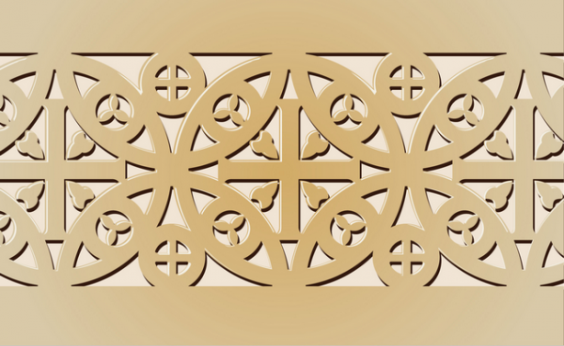
Early Europe and Colonial Americas Module
Bayeux Tapestry. Romanesque Europe ( English or Norman). c. 1066-1080 C.E. Embroidery on linen

The Bayeux Tapestry is a long embroidered cloth, which describes the events before and during the Norman conquest of England (1066). The two combatants were the Anglo-Saxon English, led by Harold Godwinson, and the Normans, led by William the Conqueror.

The Bayeux Tapestry is embroidered in wool thread on a linen ground. The linen is assembled in panels and has been patched in numerous places. It is about 70 meters (230 ft.) long. The Bayeux Tapestry was probably made in England, having been commissioned by William I’s half-brother, Bishop Odo. It was discovered in the 18th century hanging in Bayeux Cathedral.
Wool yarn, colored by vegetable dyes, was used for the embroidery and the work is divided into fifty panels.

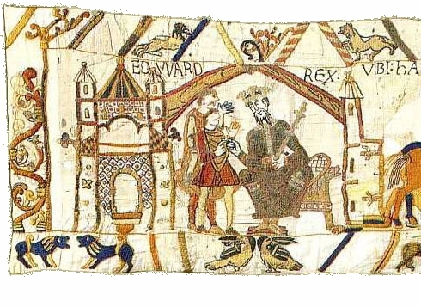 | King Edward the Confessor talking to his brother-in-law Harold, Earl of Wessex in 1064.
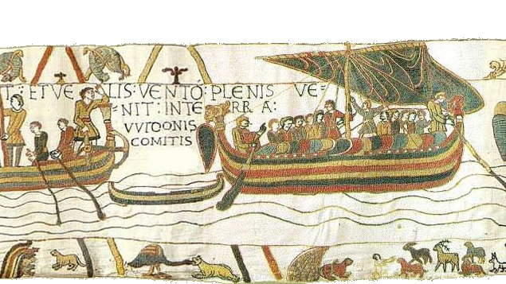 | Harold Godwinson's Journey To Normandy.
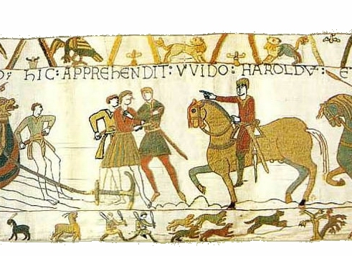 | Harold is taken prisoner by the Normans.
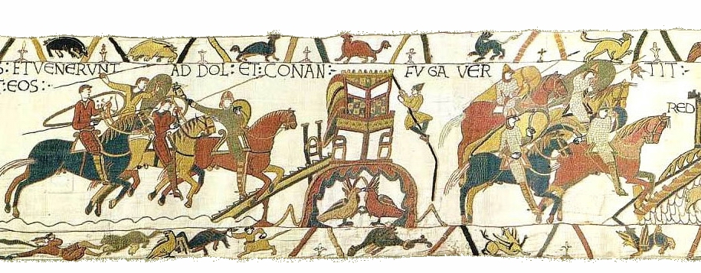 | William and Harold and the Norman soldiers are allies as they travel fight Duke Conan of Brittany.
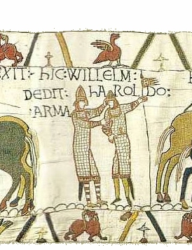 | William honors Harold Godwinson with a gift of arms.
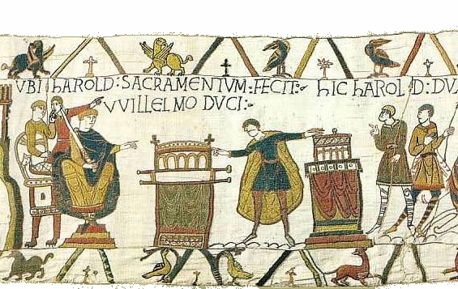 | Harold is depicted as swearing an oath to William.
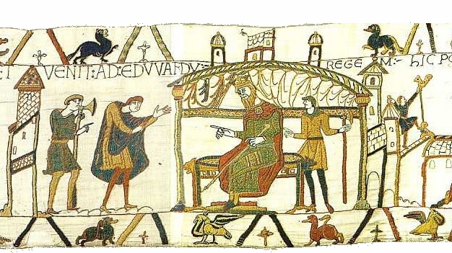 | Harold returns to England and talks to King Edward the Confessor.
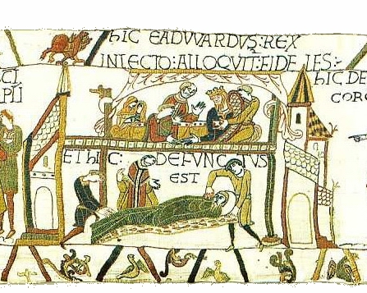 | The death of King Edward the Confessor
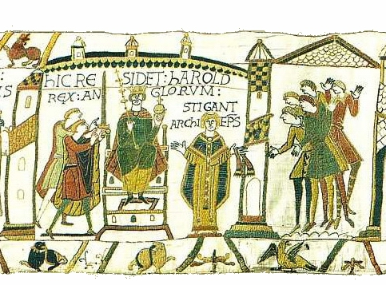 | Harold Godwinson is crowned King of England on 6th January 1066.
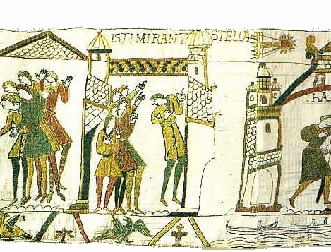 | Haley’s Comet
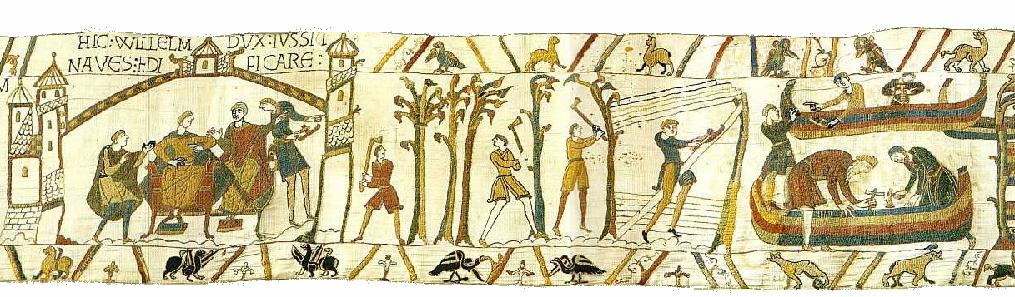 | Duke William who believes he should be King of England plans the Norman invasion with his half brother Bishop Odo of Bayeux.
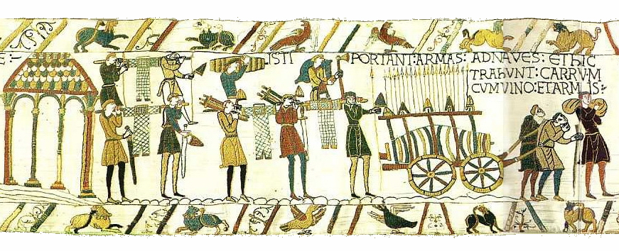 | The next Bayeux tapestry scenes show preparations of the invasion fleet. The ships are loaded with weapons. armor, food and drink.
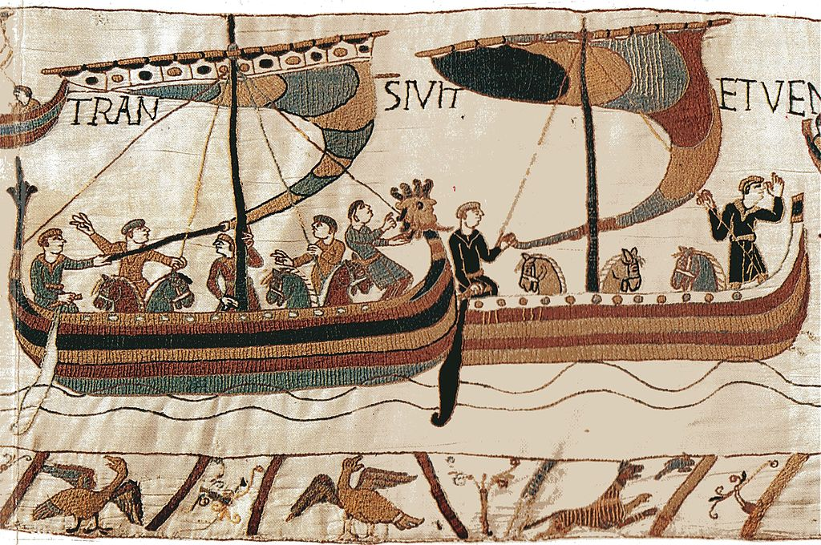 | The next Bayeux tapestry scenes show the invasion fleet, led by Duke William, crossing the channel. Horses, weapons and soldiers are illustrated. Pre-built wooden castles are also loaded on the ships.
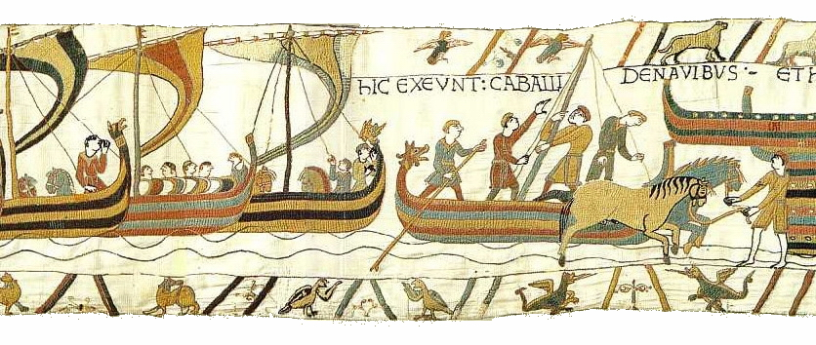 | On 28th September 1066 the fleet lands at Pevensey in England.
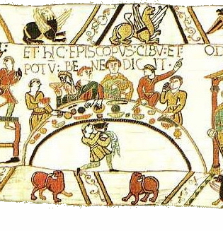 | A feast is prepared attended by Duke William and his nobles Bishop Odo is shown saying grace.
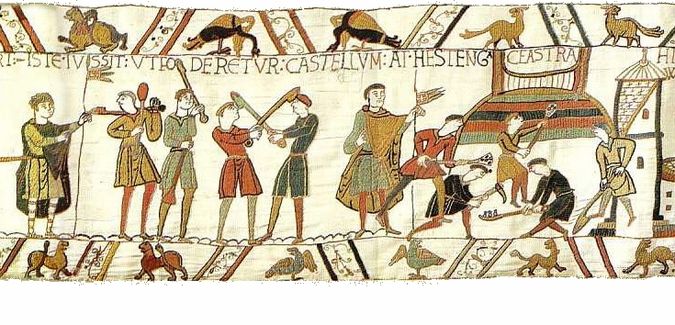 | A Motte and Bailey castle is built at Hastings.
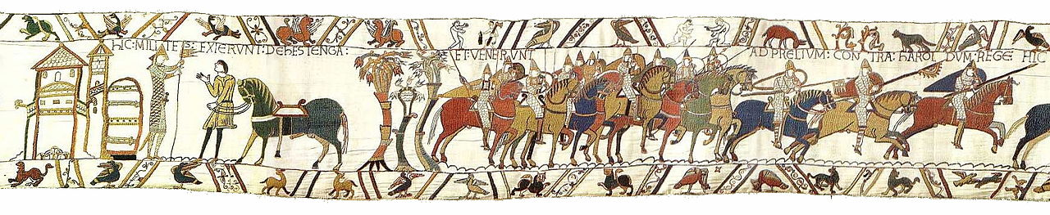 | On 14th October 1066 Duke William is depicted in full armor, about to mount his horse. The Norman cavalry rides off to fight the English led by King Harold.
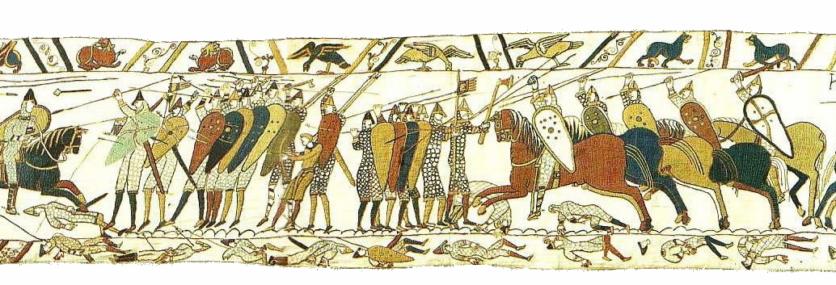 | The battle of Hastings begins and the Bayeux tapestry scenes show the English and Norman soldiers with their armor and weapons fighting, some lay dead.
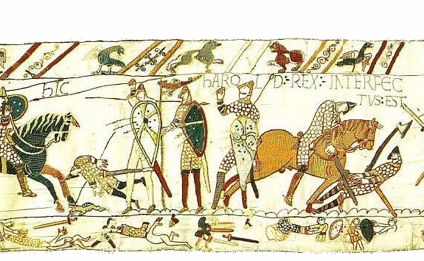 | The Normans are shown killing King Harold who is first shot with an arrow in his eye and then hacked to death by Norman soldiers.
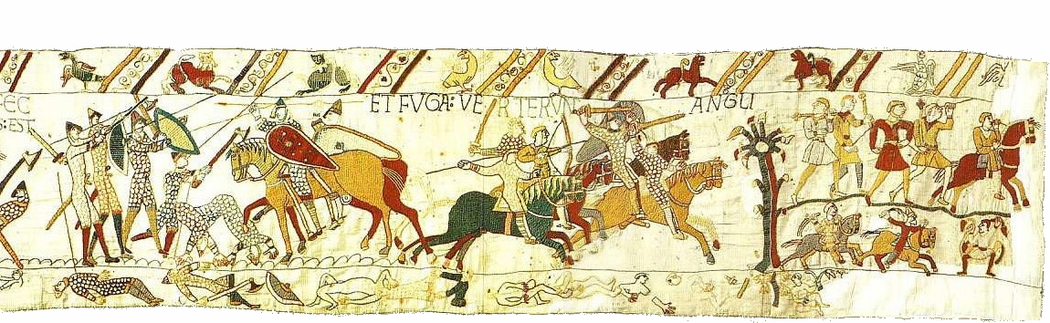 | The Normans win victory over the English at the Battle of Hastings.

Citation:

"Bayeux Tapestry Tituli." Wikipedia. Wikimedia Foundation, 27 Nov. 2014. Web. 29 Nov. 2014. <http://en.wikipedia.org/wiki/Bayeux_Tapestry_tituli>.

