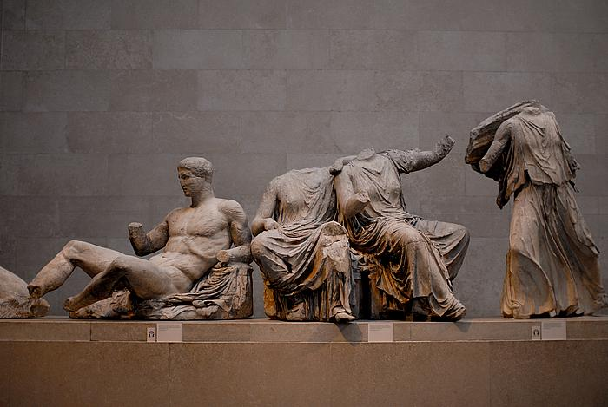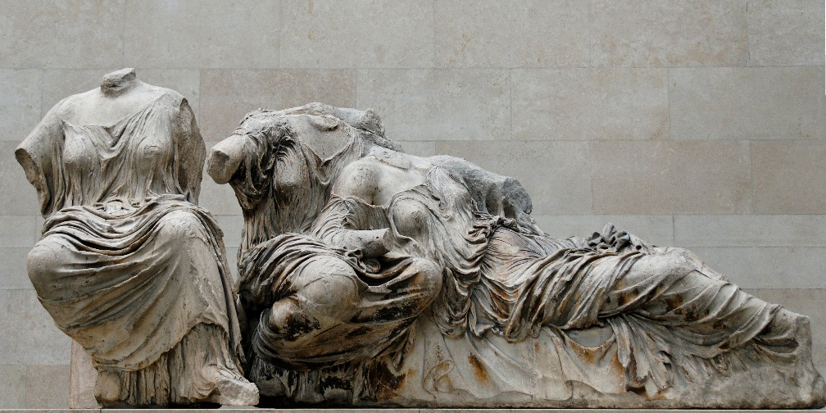Angelo Passarelli MB Honors Humanities

The eastern Pediment was used to tell a story. The Parthenon was created for the espect of worship of their patron Athena.

The location of this would make it above the people because they were gods and were considered to be in a different place they are. This is shown because the figures seem like they are at their own place and world and the people below aren’t even there.

This was a relief sculpture because it was carved out of the Parthenon. This type of relief was deep because of how much the figures popped out to show their whole bodies. Also the figures had precise detail on the human figure and the way clothing flowed on it.

Helios, Horses, Dionysus (Hercules?) east pediment, is on the Parthenon. It was created around 448-432 B.C.E., and was created by Iktinos and Kallikrates in Athens, Greece. It was created with marble. These figures are actually larger than scale.

Today the center piece doesn’t exist because it was destroyed but part of it is still on the Parthenon, while other pieces like these pictures are at the British Museum in London.

Its purpose was a religious tribune to the goddess Athena, and was created to show her birth because it was her beginning in which was important to them.

It was on t Parthenon because it represented the birth of the goddess of their city, Athena. Also it was on the eastern side of the Parthenon

The triangular shape of the pediment was introduced by the Doric introduction in Greece.

At the beginning of the pediment it shows horse heads represents the rise of the sun, which begins the story. These statue symbolizes the birth of Athena. During this moment the story behind it was that Zeus said he was suffering from a migraine so he asked Hephaestus the god of blacksmiths to help him. Hephaestus hit him in the head with a hammer which cracked it open and Athena popped out fully grown and had armor on ready to battle. The other gods around them seem to be watching this occur.

Athens belived art was a very important factor to have in their culture. It was a source of pride for the Athenian people. They would focus on making their city as beautiful as they could, with breath taking art and architecture. Also the government would normally fund it.