Global Contemporary

En la Barberia no se Llora (No Crying Allowed in the Barbershop). Pepon Osorio.
1994 C.E. Mixed-media installation.
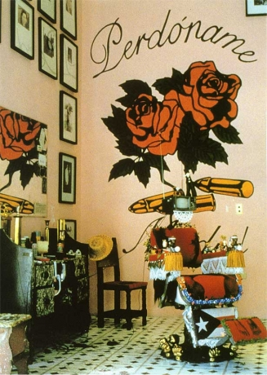
.

Photo Citation: Flickr/ https://flic.kr/p/971mZQ

"'No Crying Allowed in the Barber Shop'...it’s about recreating my memory. When I was five years old my father took me to get my first haircut right around the neighborhood. And what was meant to be a celebration became disastrous event. I was crying a lot, I was scared...What traumatized me wasn’t so much the haircut itself but the way that this barber dealt with my kind of hair...That experience was a combination of race and a right of passage into becoming a little man."
Pepon Osorio

For En la barbería no se llora (No crying in the barbershop), 1994, the artist addressed the reproduction of masculinity and machismo in the context of a faux barbershop complete with ornate, thematically decorated barber’s chairs, video images of grown men crying, and free haircuts for visitors off the street. Osario takes direct aim at machismo by dealing with the repression of feelings -- big boys don't cry.
Osorio emigrated from his native Puerto Rico to the United States when only eighteen years of age, and became a social worker. He uses his life acquired experience, –that of black, Puerto Rican, immigrant, artist and social worker as a source of for his work.
En la barbería no se llora originates from a childhood memory –when his father took him for the first time, to cut his hair. Wanting to emphasize the essentially macho community. Osorio designed a space complete with velvet-covered seats, the roof covered with a screen printed design of enlarged sperm photographs, monitors with men crying while telling their life story, and pictures of muscular torsos. “This installation calls for reflection regarding the Latin stereotype of masculinity, based on physical strength, sexual prowess and economic power, while the aesthetic overloaded with household decorations and “feminine touches”, presents alternative models of masculinity where men may cry.” (Revistasexcelencias.com)
Pepón Osorio is an internationally recognized artist whose richly ornate installations challenge the stereotypes and misconceptions that shape our view of social institutions and human relationships. Osorio draws on his Puerto Rican background and the immigrant experience for inspiration to bridge geographical barriers and class divides.

Citation:

""En La Barbaria No Se Llora (No Crying Allowed in the Babershop)," Detail (1994) | ART21." "En La Barbaria No Se Llora (No Crying Allowed in the Babershop)," Detail (1994) | ART21. Web. 30 Apr. 2015. <http://www.art21.org/images/pepón-osorio/en-la-barbaria-no-se-llora-no-crying-allowed-in-the-babershop-detail-1994>.

"Memory as an Artistic Pre-text. The Symbolic Dimension of Materials in Pepón Osorio's Work | Revistas Excelencias." Memory as an Artistic Pre-text. The Symbolic Dimension of Materials in Pepón Osorio's Work | Revistas Excelencias. Web. 30 Apr. 2015. <http://www.revistasexcelencias.com/en/arte-por-excelencias/editorial-13/resenas/memory-artistic-pre-text-symbolic-dimension-materials-pepo>.

