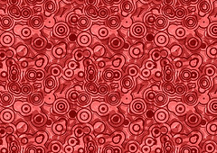
Global Contemporary

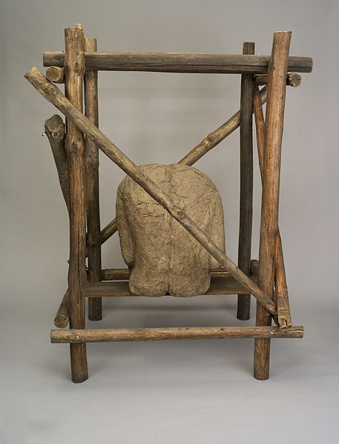
Androgyne III. Magdalena Abakanowicz. 1985 C.E. Burlap, resin, wood, nails, string.

Photo Citation: Magdalena Abakanowicz [Public domain or CC BY-SA 3.0

This image is not Androgyne III, but a very similar work called Cage. The copyright on the work does not permit the use of the image in the course. You may access the image at this site. http://www.metmuseum.org/collection/the-collection-online/search/484422

The Polish artist Magdalena is known for her fragmented human figures-faces without skulls, bodies without heads, and torsos without legs-placed in a setting alone or in groups.. These body parts look like hollow shells because they are actually fiber casts made from plaster molds. The works are intended to be seen in the round, but the hollow interior is as integral to the piece as the molded exterior. The hardened-fiber surface assumes organic characteristics like the cellular composition of human skin due to the creases, ridges, and veins made by the burlap and resin. (MetMuseum)
Androgyn III uses the same molded-torso shell that the artist used in her Back series begun. Unlike the earlier pieces that sat directly on the floor, the Androgyn torsos sit on low wooden stretchers. The long poles fill in for the missing legs. “Through these provocative images, the artist expresses the physical and spiritual condition of mankind. As she says, they are "about existence in general." (MetMuseum)
"The face can lie. The back cannot," artist Magdalena Abakanowicz says of her longtime fascination with the human back. But if her sculptural backs tell the truth--or at least talk straight about an aspect of the human condition--she isn't inclined to translate the body language. "Nothing is literal in my art; it is fully metaphoric," she says. "To try to explain it away (LA Times.)”

Citation:
"Magdalena Abakanowicz | Androgyne III." Magdalena Abakanowicz. Web. 30 Apr. 2015. <http://www.metmuseum.org/collection/the-collection-online/search/484422>.

25, March. "She's Turned Her Backs on the World." Los Angeles Times. Los Angeles Times, 25 Mar. 2001. Web. 30 Apr. 2015. <http://articles.latimes.com/2001/mar/25/entertainment/ca-42311>.

