Bushel with Ibex Motifs
Bushel with Ibex Motifs, Susa, Iran. 4200 – 3500 B.C.E. Painted terra cotta.
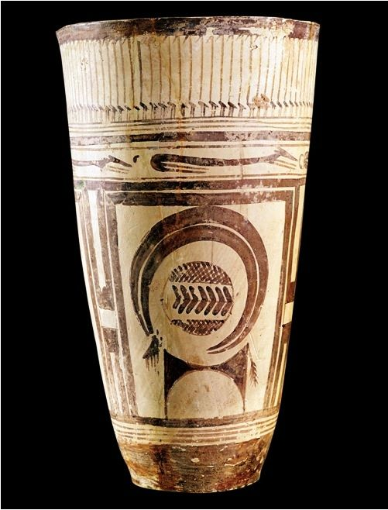
Content: This vase is very geometric, with lots of straight lines and shapes making up the animals.
Context: The people of Susa became more aware of nature when they realized that they could heat clay to a certain temperature and harden it.
Context: All vases from this time are all very similar but each vase has a stamp of an individual craftsman.
Content: Pots and Vases were buried with people in their burial place along with a few metal objects.
Content: In the center of the panels is a geometric figure of a mountain goat. This may serve the purpose of identification for the family that owns this.
Content: This vase is hand thrown and is decorated with a synthesis of the environment of the first agricultural community.
Content: The main part of this bushel has large panels that may show the settlement of land and the borders of agriculture fields.
Content: At the top of the vase there is a frieze of water birds with long necks to create rhythm. Below that are long skinny dogs.
Content: This vessel was found at a funerary site, showing that death was important in their society.
Purpose: The people of Susa could’ve used this to store items, which shows us that this is a more advanced/stable community.

