Focus on Literary Forms: Wisdom Literature

Defining Wisdom Literature
Wisdom literature consists of oral and written works that focus on the search for understanding, meaning, and enlightenment. This type of literature is concerned with profound questions about human existence. More specifically, it tends to focus on human conduct and morality: how we should live and how we should treat others.
A wise man hears one word and understands two. — Yiddish Proverb

Types of Wisdom Literature
Wisdom literature encompasses a wide range of forms, many of which overlap. Some works are part of the oral tradition—moral and spiritual insights that were originally handed down by word of mouth. Others are attributed to a specific author or philosophical teacher, whose words may have been written down by a follower. Some works are considered sacred texts that are the foundation of a religion. The chart below lists some of the most important types of wisdom literature.
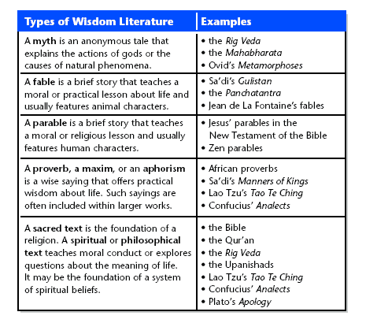

Features of Wisdom Literature
- Wisdom literature often uses an aphoristic style. An aphorism is a brief, memorable, and often witty saying that expresses a truth about life—as in a proverb or the moral at the end of a fable. Many philosophical writers and spiritual teachers, such as Sa'di, Lao Tzu and Confucius use concise, aphoristic statements to express their beliefs about how people should live.
- Wisdom literature often uses figurative language and symbolism to express meaning. Figurative language is language that is not meant to be understood literally. Instead, it expresses an imaginative connection. A symbol is an object, a person, an animal, a place, or an image that represents both itself and something larger in meaning—usually an abstract idea. For example, in the African proverb “The zebra cannot do away with his stripes,” the zebra stands for unchangeable human nature.
- Sometimes the symbolism of wisdom literature rises to the level of allegory. An allegory is a literary work with two levels of meaning. Every element has both a literal and a symbolic meaning, with specific characters standing for abstract qualities. Fables and parables are considered types of allegory. Dante's Divine Comedy is a famous example of a book-length allegory in which a literal journey represents a man's struggle for redemption.
- Wisdom literature is usually didactic in its purpose—that is, it is meant to teach a moral or ethical lesson about life. This lesson may be taught directly, as in a fable, or indirectly, as in a parable, in which the moral is not explicitly stated. Although wisdom literature may use wit and even humor to convey its message, its purpose is nevertheless to instruct rather than simply to entertain.

Strategies for Reading Wisdom Literature
Use these strategies as you read wisdom literature.
Read the Text Aloud Because wisdom literature often developed within the oral tradition, reading the work aloud will usually deepen your appreciation of its beauty and meaning. As you read, consider how the sound of the language affects you on an emotional or even spiritual level.
Read Between the Lines Sometimes, the wisdom in a work of wisdom literature is directly stated. In other texts, however, you may need to interpret details to draw inferences about the moral or theme. As you read, consider whether there are characters, images, or statements that are not meant to be understood literally. Then, think about what these elements may represent on a figurative, a symbolic, or even an allegorical level.

