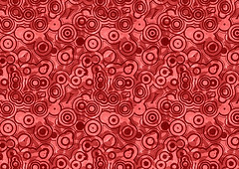
Global Contemporary

Vietnam Veterans Memorial. Washington, D.C., U.S. Maya Lin. 1982 C.E. Granite.
.
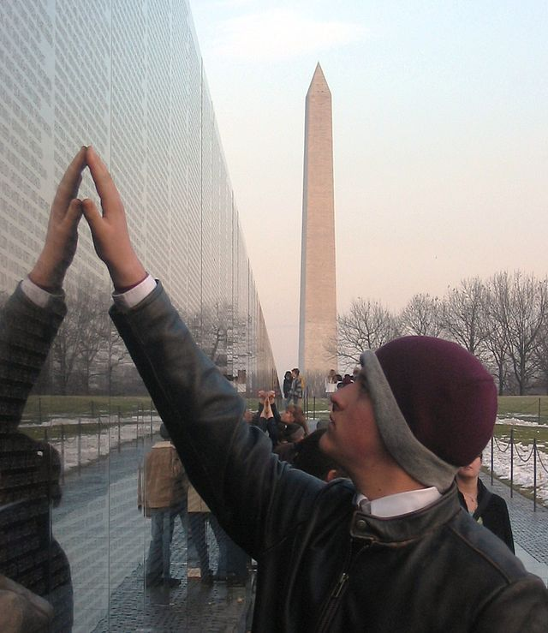
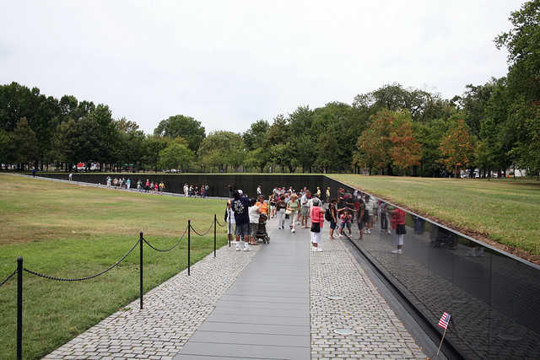

Photo Citation:
"TouchWall" by Original uploader was Skyring at en.wikipedia -
Photo Citation:
https://www.flickr.com/photos/nostri- imago/2912815035/

As a 21-year-old Yale architecture student, Maya Lin designed the Vietnam Veterans Memorial as a class project, and then entered it in the largest design competition in American history. Her proposal was a V-shaped wall of black stone, etched with the names of 58,000 dead soldiers. The design beat out the submissions of 1,420 other entrants. Her unconventional design was selected and created ferocious criticism for the artist. Her name was not even mentioned at the dedication of the memorial in 1982. Her inspiring vision has since become the most-visited memorial in the nation's capital. The families of the fallen leave mementos at the wall, and veterans maintain a constant vigil there ( Sandcreekmemorial)
“In keeping with the competition criteria of sensitivity to the nearby Lincoln Memorial and Washington Monument, the inclusion of the names of all the dead and missing of the war, and the avoidance of political statements about the war, Lin's design was simple. She proposed two two-hundred-foot-long polished black granite walls, which dipped ten feet below grade to meet at an obtuse (greater than 90 degrees) angle of 130 degrees. The two arms were to point towards the Lincoln Memorial and Washington Monument, and they were to be inscribed with the names of the approximately fifty-eight thousand men and women killed or missing in Vietnam. These names were to be listed chronologically, according to the dates killed or reported missing, instead of alphabetically, so that they would read, in Lin's words, "like an epic Greek poem." (en101hvetmem).”

Citation:
"Maya Lin Vietnam War Memorial." Sandcreekmassacrememorial -. Web. 2 May 2015. <http://sandcreekmassacrememorial.wikispaces.com/Maya Lin Vietnam War Memorial>.

"Maya Lin." EN101Hvetmem -. Web. 2 May 2015. <http://en101hvetmem.wikispaces.com/Maya Lin>.

