Early Europe and Colonial Americas Module
PART I
Rebecca and Eliezer at the Well and Jacob Wrestling the Angel, from the Vienna Genesis. Early Byzantine Europe. Early sixth century C.E. Illuminated manuscript (pigments on vellum).

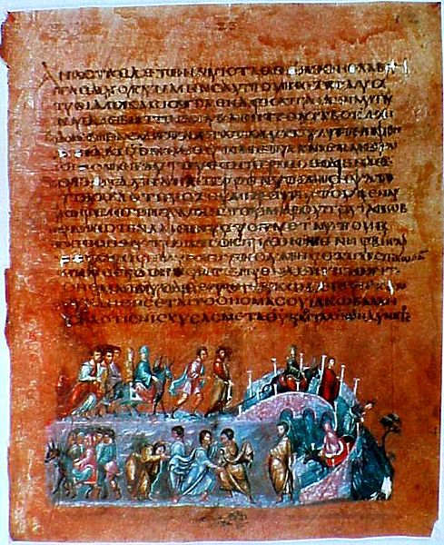
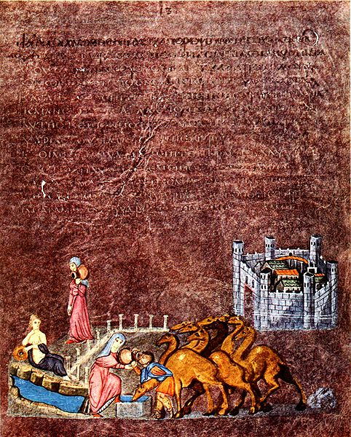
Wikimedia Commons/Public Domain

The earliest well preserved painted manuscript we know of that contains biblical scenes is the Vienna Genesis. The text is a fragment of the book of Genesis in the Greek translation. The text is frequently abbreviated. It is thought that there were originally about ninety-six folios and 192 illustrations. Only 24 have survived. It is written with silver ink on calfskin dyed purple, the same dye used to dye imperial cloth.
The illustrations are done in the style common to Roman painting of the period. The manuscript's illustrations are considered a transition between those found in scrolls and later images found in codices. Each illustration is painted at the bottom of a single page; however, two or more episodes from a story may be included, so that the same person may be represented multiple times within a single illustration. It has the continuity of a frieze in a scroll. In a continuous narrative, two or more scenes of a story are represented within a single frame. This becomes common in medieval art. The illustrations also oddly contain incidents and people not mentioned in the text of Genesis. (Wikipedia/Vienna Genesis)
In the first image, from the book of Genesis (24:15-61), Rebecca leaves the city of Nahor to fetch water from the well in the first episode. In the second, she gives water to Eliezer, the servant of Abraham, and his camels. Nahor is represented as a walled city seen from above. Rebecca is depicted walking to the well along a colonnaded avenue of a Roman city, the source of the well. A seminude female personifies the well. —a reminder of the persistence of classical motifs. Rebecca braces her foot on the well as she tips the jug towards Eliezer. According to the Bible, Rebecca continued to draw water until all the camels were sated, proving her kind and generous nature and her suitability for entering Abraham's household as Isaacs’ wife.
In the second image, a continuous narrative of the story of Jacob is depicted. Jacob is shown falling asleep, getting left behind by his group, and then waking up to a the presence of a man. Jacob wrestles and defeats him only to discover that he is an angel. Jacob demands the angel to give him his blessing. The scenes are all connected with characters appearing multiple times, proving it is a continuous narrative. The landscape is foreshortened, suggesting a three-dimensional feel along with the twisting figures and curved bridge.

For more information:

https://www.khanacademy.org/humanities/medieval-world/early-christian1/v/vienna-genesis

