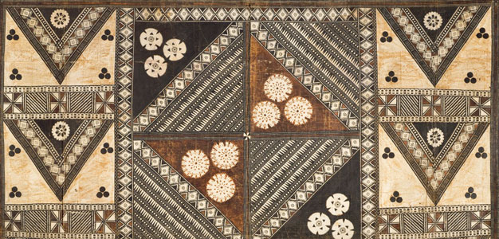
African Art Module
Veranda post of enthroned king and senior wife (Opo Ogoga). Olowe of Ise
(Yoruba peoples). c. 1910–1914 C.E. Wood and pigment
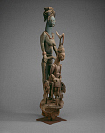

Image Citation: Flickr https://flic.kr/p/6HMSfe/rasMarly

This veranda post is one of four sculpted for the palace at Ikere by the Yoruba artist Olowe of Ise. It is considered among the artist's masterpieces. His work embodies his unique style of including the interrelationship of figures, their exaggerated proportions, and the open space between them. While the king is the emphasis, his depiction suggests a ruler's dependence on others. The stately female figure behind the king represents his senior or first wife. Her size in hierarchal scale and depiction of her with hands on the king's throne, emphasize her importance. She placed the crown on the king's head during his coronation as well as used her political wiles and spiritual knowledge to protect the king's interests during his reign. The small figures at the king's feet represent a junior wife, the flute-playing trickster-god Esu, and a fan bearer, now missing (About this Artwork).
Olowe was born in the Ekiti town of Efon-Alaye, one of the great centers of Yoruba carving at the turn of the century. He moved to Ise, a village to the southeast. There, according to Fagg, Olowe “became a messenger of the arinjale, or king of Ise, and for many years, until his death in 1938, he had great fame in the area as a carver of architectural sculptures such as doors and veranda posts. Surface decorations complement the formal properties of the work. The size and boldness of Olowe’s figures allowed him to carve elaborate hairstyles, and to incise in intricate decorative patterning on the bodies without diverting attention from the sculptural subject (About this Artwork).

Citations:
"About This Artwork." Veranda Post of Enthroned King and Senior Wife (Opo Ogoga). Web. 2 Mar. 2015. <http://www.artic.edu/aic/collections/artwork/102611>.

