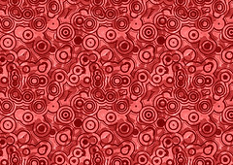
Global Contemporary

Untitled (#228), from the History Portraits series. Cindy Sherman. 1990 C.E. Photograph.
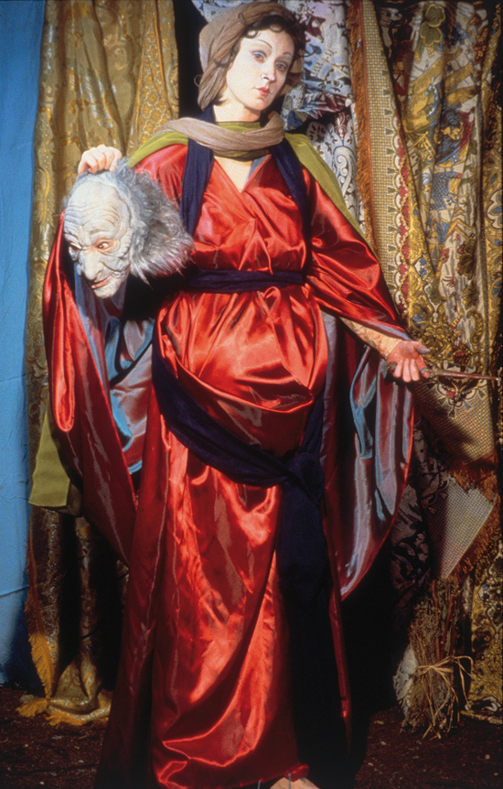

Photo Citation: Flickr/ Cind Sherman/https://www.flickr.com/photos/49359681@N07/4525019663/in/photolist-7TRUGp-gbf5eu-dnjuf2-gboriV-bvWhZL

Cindy Sherman is an American conceptual artist and photographer known for her portraits using herself as the model. In her History Portraits collection, Sherman photographed herself in costumes and props to depict famous artistic figures. Cindy Sherman uses photography to challenge images in popular culture and the mass media. Her work concentrates on examining the way women are viewed by society.
The images in the “History” series either relate directly to images in classical European painting, or relate to types found during those periods. She’s been quoted as saying,

When I was doing those history pictures I was living in Rome but never went to the churches and museums there. I worked out of books, with reproductions. It’s an aspect of photography I appreciate conceptually: the idea that images can be reproduced and seen anytime, anywhere, by anyone.

That said, the photos remain original conceptions, loosely based upon—but not duplicates of—original works.
Sherman served as model, set-creator, and photographer for her “History Portraits.” Drawing from different art styles and periods, including the Renaissance, Baroque, Rococo, and Neoclassical, she used costumes and settings to change herself into the historical-looking male and female figures. Full of fake body parts, bad wigs, and theater makeup, the photographic images are intended to look fake. “By revealing her disguise, she demonstrates that her pictures are constructs; through them, she draws attention to the staged and often mannered nature of historical portrait paintings, while also playfully mocking the discipline of art history.” (MOMA)
Among these pictures is Untitled, Number 228. It is a full-length portrait of the artist as the biblical heroine Judith. The heroine, Judith, rescued the Israelites from the invading Assyrian general Holofernes by seducing and beheading him. This story is part of the Apocrypha. The subject of Judith was a popular and frequently depicted subject in numerous Renaissance and Baroque artists. In keeping with the large scale and visual impact of some Baroque paintings, the photograph is nearly seven feet high by four feet wide and filled with richly patterned and colorful fabrics. The fabrics, purchased at secondhand stores, seem so richer in the photo. As the artist described: “I would go to a Salvation Army and look for certain kinds of costume-y things. But so much of it was junky stuff.” (MOMA)
“Sherman shows Judith standing against a backdrop of brocaded cloth, dressed in an iridescent, voluminous crimson robe and holding the masklike head of Holofernes in one hand, a blood-smeared knife in the other. Her feet, planted firmly on the dirt ground, are slightly spread and appear incongruously large and thick. With her head slightly cocked, she stares ahead with a placid face, her expression open to many different speculations about her mental and emotional state in the aftermath of the violent act—and in keeping with the ambiguity that the artist builds into all of her work (MOMA).”
As a woman she takes on not just the role of the subject but also the role of the old master. Since Sherman was more fascinated with reproductions of paintings than seeing the originals, her work is about a removal from the original reference. Her work becomes a “reproduction of a reproduction.” (MOMA)

Citation:
"MoMA Learning." MoMA. Web. 27 Apr. 2015. <http://www.moma.org/learn/moma_learning/cindy-sherman-untitled-number-228-1990>

