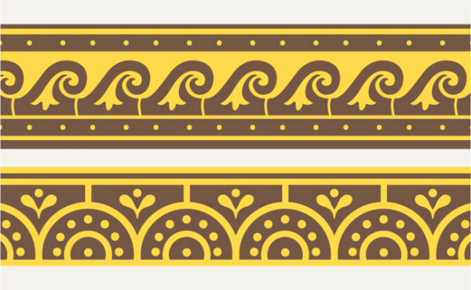

ANCIENT MEDITERRANEAN
MODULE/PART II

Tomb of the Triclinium. Tarquinia, Italy. Etruscan. c. 480 -470 B.C.E. Tufa and fresco.
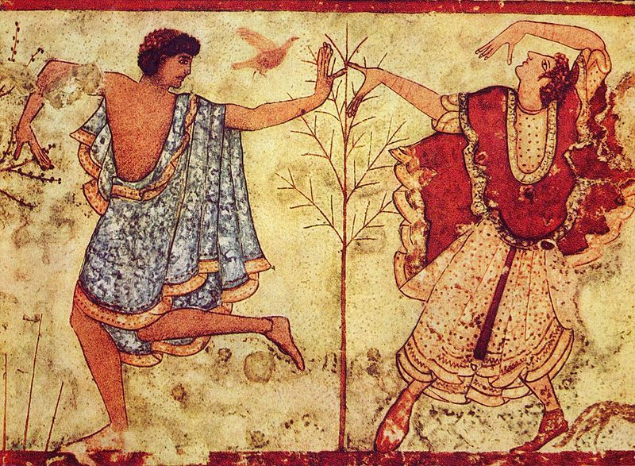
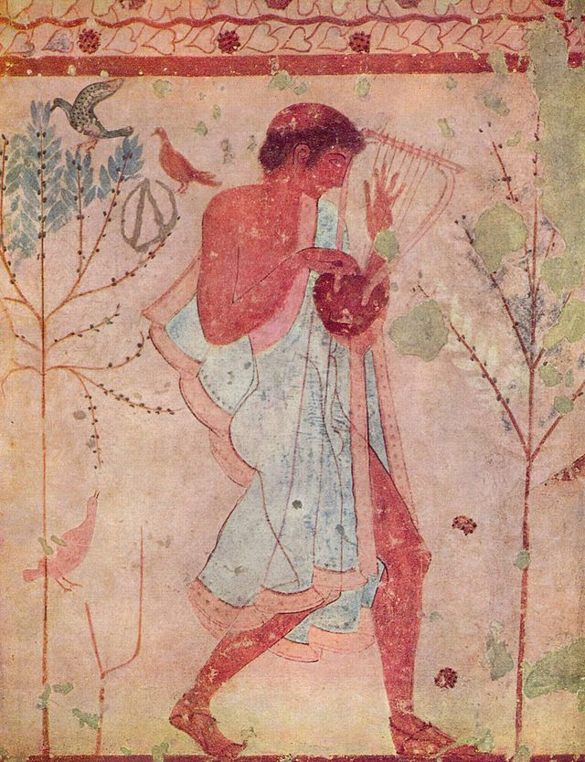

By Deutsch: Unbekannt English: Unknown Français : Inconnue [Public domain], via Wikimedia Commons

Licensed under Public domain via Wikimedia Commons - http://commons.wikimedia.org/wiki/File:Etruskischer_Meister_001.jpg#mediaviewer/File:Etruskischer_Meister_001.jpg

The Tomb of the Triclinium is an Etruscan tomb in the necropolis near Tarquinia, Italy. The Etruscan tomb is named after a triclinium, the formal dining room of the ancient Greco-Roman culture, which appears in the frescoes of the tomb. Chamber tombs are subterranean rock-cut chambers accessed by an approach way. The tombs are intended to contain the remains of the deceased but their grave goods as well. TheTomb of the Triclinium is composed of a one room with wall decorations painted in fresco.
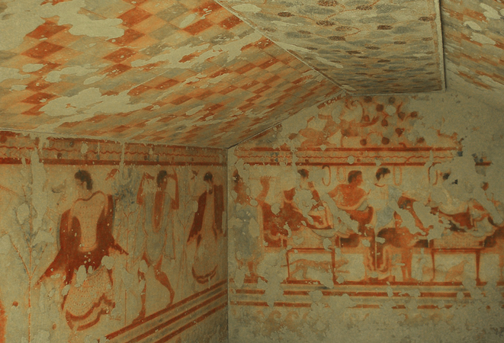

Citation: https://www.khanacademy.org/humanities/ancient-art-civilizations/etruscan/a/tomb-of-the-triclinium
The fresco on the back wall shows a banquet scene. The banqueteers recline on three couches, while under the table, a cat prowls towards a rooster and a partridge. Two attendants attend to the needs of the diners. On the left wall, three female dancers, one male dancer and a male musician with are depicted. They are painted between small trees filled with birds. Common painterly conventions of gender tare employed—the skin of females is painted light in color while male skin is painted a darker tone of orange-brown. A similar scene is shown on the right wall. The tomb’s ceiling is painted in a checkered scheme of alternating colors. This design may have been designed to suggest the fabric tents that were used near the tomb for the actual celebration of the funeral banquet. The dancers and musicians are a common theme in tombs and funerals. The festive theme of the Tomb of the Triclinium is indicative of Etruscan funeral rites. Funerals were not somber but celebratory. The funeral practice was to share a final meal with the deceased as the deceased journeyed to the afterlife. The feast also reinforced the social status of the deceased person and his or her family. A large “party” would remind the community of the status of the family and reinforce their position in society (Khan Academy).
Citation:
"Khan Academy." Tomb of the Triclinium. Khan Academy. Web. 25 Oct. 2014. <https://www.khanacademy.org/humanities/ancient-art-civilizations/etruscan/a/tomb-of-the-triclinium>.

