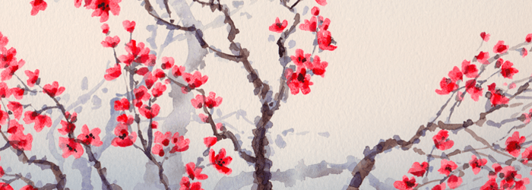
South, East, and Southeast Asia II

Forbidden City. Beijing, China. Ming Dynasty. 15th century C.E. and later. Stone
masonry, marble, brick, wood, and ceramic tile

Citation:

