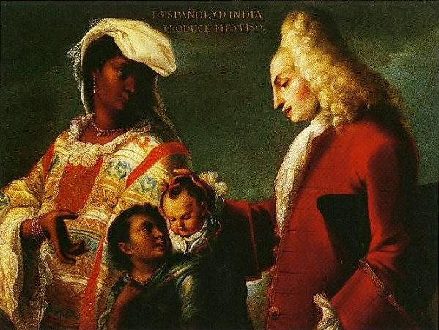
Spaniard and Indian Produce a Mestizo. Attributed to Juan Rodríguez Juárez. c. 1715 C.E. Oil on canvas.

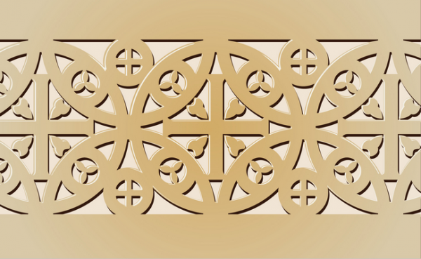
Early Europe and Colonial Americas Module III

Citations: https://www.khanacademy.org/humanities/art-americas/new-spain/viceroyalty-new- spain/a/spaniard-and-indian-produce-a-mestizo-attributed-to-juan-rodriguez

The painting displays a Spanish father and Indigenous mother with their son. This genre of painting known as caste paintings are a part of a larger series of works that seek to document the ethnic mixing occurring in New Spain among Europeans, indigenous peoples, Africans, and the mixed-race population.
The painting displays a simple composition- a mother and father with two children. One of the children is a servant carrying the couple’s baby. The indigenous mother is dressed in a beautiful traditional garment worn in central Mexico. She turns to look at her husband as she gestures towards her child. Her husband, wearing a French-style suit including a powdered wig, looks down at the children with his hand on the back of his child. The family appears calm and happy.
But who commissioned these genre of art and why? The existing evidence leads historians to believe that the Viceroys, or the stand-ins for the Spanish King commissioned them. Casta paintings reflect the increasing social anxieties about inter-ethnic mixing. (Khan Academy)

Citation:

"Khan Academy." Khan Academy. Web. 1 Jan. 2015. <https://www.khanacademy.org/humanities/monarchy-enlightenment/Colonial-Americas/a/spaniard-and-indian-produce-a-mestizo-attributed-to-juan-rodriguez>.

