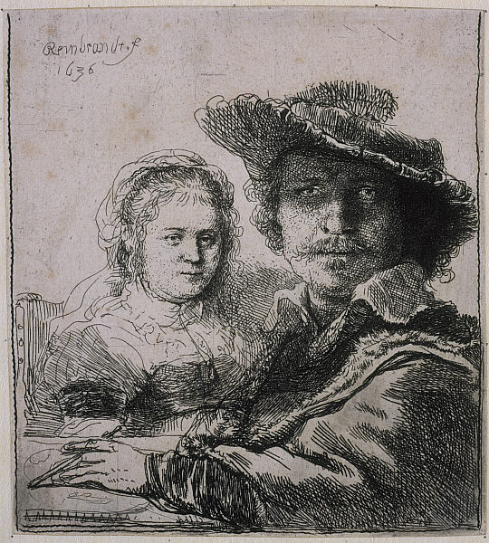
Self-Portrait with Saskia. Rembrandt van Rijn. 1636 C.E. Etching.
.

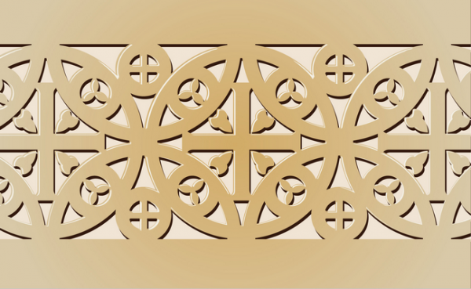
Early Europe and Colonial Americas Module III

Photo Citation:Rembrandt [Public domain], via Wikimedia Commons

In this1636 etching, Self-Portrait with Saskia, Rembrandt and his wife are shown wearing vintage historical clothing. Known for his self-portraits, preferred to show himself in a variety of imagined roles. This work may be more than a self-portrait. This etching can also be regarded as a marriage portrait. The young woman shown seated at the table with Rembrandt is his wife, Saskia van Uylenburgh.
The two figures are depicted seated around a table before an empty background. Rembrandt, largely in the foreground, dominates the image with a serious expression on his face. Saskia, rendered on a smaller scale and appearing contemplative, sits behind him. Rembrandt's hand is too small for his own figure though in scale with his wife’s.
The scene is simple one. It may reflect one from their daily life.
This etching is the first time that Rembrandt has presented himself as an artist at work. In his left hand, Rembrandt holds a porte-crayon (a chalk holder) and appears to have been drawing. A paper lies on the table before him. Rembrandt was an excellent draughtsman, and he draws attention to his mastery. (Khan Academy)
Rembrandt became a master of etching in his 20s after three years of training. He was a right-handed artist. This print shows his left hand with a drawing tool, while his right hand was probably at rest. This image indicates that he used a mirror to portray himself and Saskia at the same time. When he created this painting, however, he may have held a drawing tool in his left hand since the image of the etching on the plate reverses when printed on paper. He seemed to care about light and spatial quality more than accuracy. For example, the lines used to depict Rembrandt are darker than those used for Saskia to show she sat further away within the pictorial space.

Citations:

"Khan Academy." Khan Academy. Web. 1 Jan. 2015. <https://www.khanacademy.org/humanities/monarchy-enlightenment/baroque-art1/holland/a/rembrandt-self-portrait-with-saskia>.

