Seated Scribes
Saqqara, Egypt. Old Kingdom, Fourth Dynasty. C.2620- 2500
B.c.e Painted Limestone
Materials: it was made from limestone
Function: Negative space making him not look eternal like other Egyptians statues
Content: Realism, lower hierarchy than Pharaoh

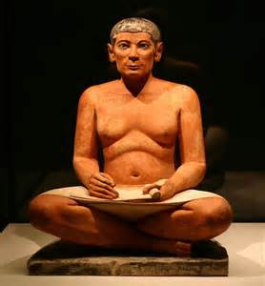
Function: He is important because he can read and write
Content: was more relaxed and was in realism
Themes: It was placed in the tombs. They wrote scribes, and stood for a symbol of scribe for Pharaoh
Themes: It served as a Ka statue to help the person in afterlife
Content: His eyes are off centered in an informal pose.
Purpose: Wrote scribes for the Pharaoh
CONTENT: Secondary sons after Pharaoh

