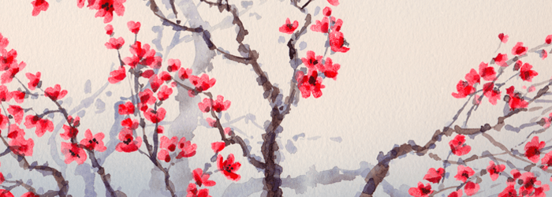
South, East, and Southeast Asia

Portrait of Sin Sukju (1417–1475). Imperial Bureau of Painting. c. 15th century C.E. Hanging scroll (ink and color on silk).

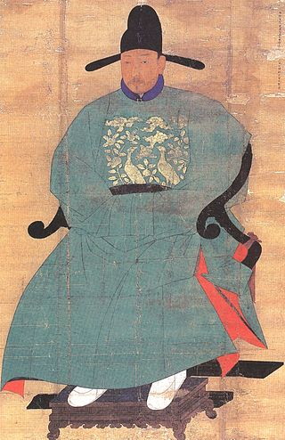

Citation: By Anonymous in the Joseon period [Public domain], via Wikimedia Commons" href="http://commons.wikimedia.org/wiki/File%3AJoseon-Portrait_of_Shin_Sukju.jpg"><img width="256" alt="Joseon-Portrait of Shin Sukju" src="//upload.wikimedia.org/wikipedia/commons/7/76/Joseon-Portrait_of_Shin_Sukju.jpg"/></a>

The Joseon dynasty was a period of decisive authoritative rule by leaders of Korea. Sin Sukju was one of the politicians who ruled during this period. During this rule, this propagandistic portrait of Sin Sukju was created. The painting was placed at the Imperial Bureau of Painting. This shows the works importance as well as the sitter.
Silk was one of Asia's main trade goods during the time, and the popularity of the material led to its trade and the formation of the Silk Road. The demand and value of this material indicates the great value of this artwork. Traditionally, Asian art featured silk like that of a stretched canvas. Sin Sukju is a powerful leader during this time period, and this painting is evidence of his authority.
A renowned writer, Sin Sukju was also a key political figure of his time. He rose to the position of Prime Minister. Following the artistic conventions of Joseon portraiture, this painting depicts the sitter in a three-quarter pose facing his right. He is dressed in an official robe and black silk hat. The garment has an ornamental, gold-embroidered green rank badge, which feature peacocks. The portrait is life-like. The artist was trying to capture the physical as well as his character.
It was common for the Joseon to make portraits of important ancestors, particularly praiseworthy subjects. These portraits, believed to embody the spirit of their subjects, were worshiped in various family shrines (yeongdang).

Citation:
"Traditional Paintings." Korea Art History. Web. 29 Mar. 2015. <http://koreaarthistory.weebly.com/traditional-paintings.html>

