Pantheon.
Roma, Italy. Imperial Roman. 118-125 C.E. Concrete with stone facing.
Form
Built with a colonnade and drum. A colonnade is a row of columns supporting a roof. Also, the drum is the dome attached to the back of the colonnade.

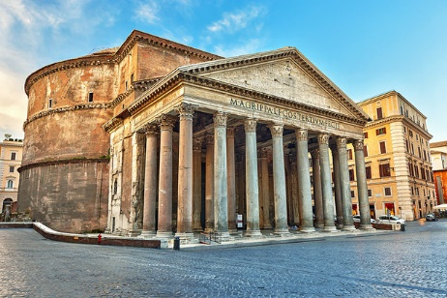
Content
The inside of the dome has a coffered ceiling that is covered in indented elaborate squares. Also, the oculus in the center of the dome was the only source of light in the pantheon. Romans believed it was a way to connect the pantheon to the gods.

Context
The Pantheon was originally built in 80 C.E., but then was struck by lighting and burnt to the ground. It was rebuilt and is now a combination of old Greek ideas and new Roman ones. It is the most preserved building of Ancient Rome and also one of the first major domes in history that shows many influential designs to architecture.
Purpose
This temple is dedicated to all of the gods. It also emphasized power and duty. However, the purpose of the Pantheon is not truly known.
Form
The inside of the dome has a coffered ceiling, meaning that it had indented squares that help to lessen the needed amount of concrete and size of the dome , there is an oculus, meaning “eye,” in the center of the dome, which is basically gigantic a whole in the top of the dome.

Content
This temple is dedicated to all of the gods. In the back, the building takes a round shape called a drum. The front of resembles the traditional Greek style with its pediment and columns.
Patron
Emperor Hadrian built this temple.
Content
In the back, the building takes a round shape called a drum. The front of resembles the traditional Greek style with its pediment and columns.
Pantheon by Charity Williams (Tatum-B)
Works Cited
Image: http://www.planetware.com/photos-large/I/italy-rome-pantheon-exterior-view.jpg
Form, content, and context: Module_four_art_gallery.docx

