ANCIENT MEDITERRANEAN
MODULE/PART II
Niobides Krater. Anonymous vase painter of Classical Greece known as the Niobid Painter. c. 460–450 B.C.E. Clay, red-figure technique (white highlights).
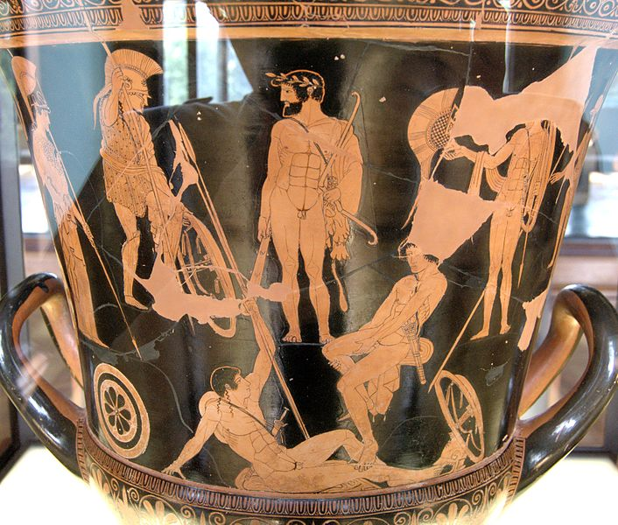
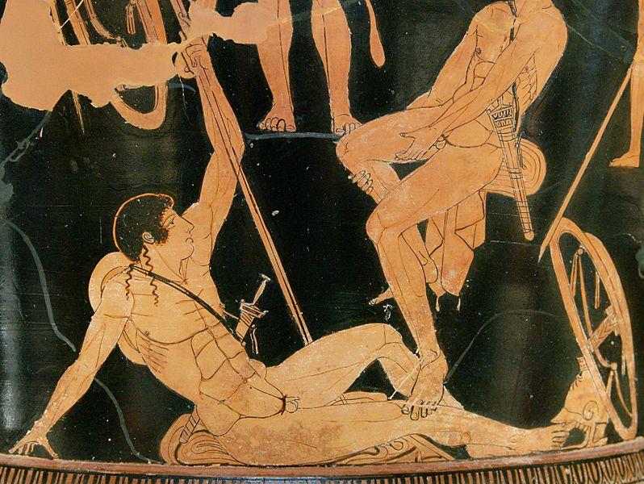

Niobid Vase
By English: Niobid Painter Français : Peintre des Niobides (User:Bibi Saint-Pol, own work, 2007-07-21) [Public domain], via Wikimedia Commons

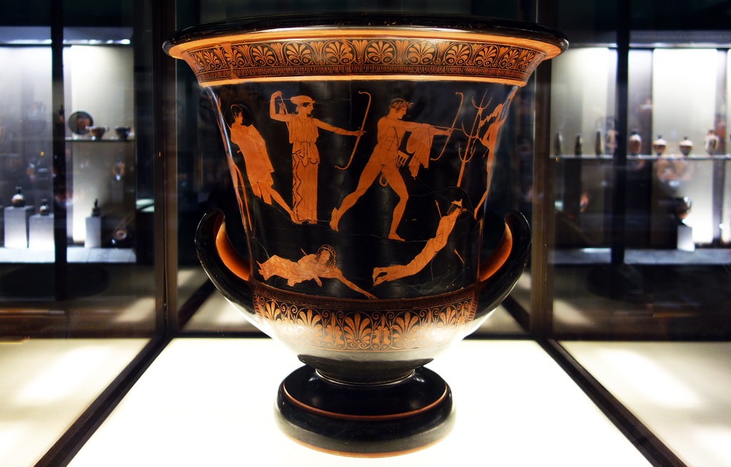

Flicker. Some rights reserved by Professor Steven Zucker.

The Niobid Painter's red figure krater of Artemis and Apollo slaying the children of Niobe, from 460 BCE, is believed to be a composition inspired by a panel painting. The side of the vessel depicting Artemis and Apollo relates to the myth of the twin god and goddess who slew Niobe's fourteen children after she boasted that her ability to birth children acceded Leto, the mother of Apollo and Artemis. The scene is unique for it is one of the first vase painting scenes to show the figures on different ground lines. Apollo and Artemis stand in the center of the vessel as Niobe's children fall to ground around them; one child has even fallen behind a rock in the landscape. There is some speculation as to what is being depicted on the opposite side as none of the figures are labeled. It is generally accepted that it is either the gathering of the Argonauts, the Seven Against Thebes, or Heracles surrounded by Athena and heroes in arms. (http://en.wikipedia.org/wiki/Niobid_Painter) All the figures stand and sit on various ground lines. The figures on both sides are depicted from multiple angles, including three-quarter view, and a profile eye is used for the figures in profile, a first in Greek vase painting. The artist has attempted to create a three-dimensional space, by outlining the foreground, middleground and background. (www.boundless.com)

