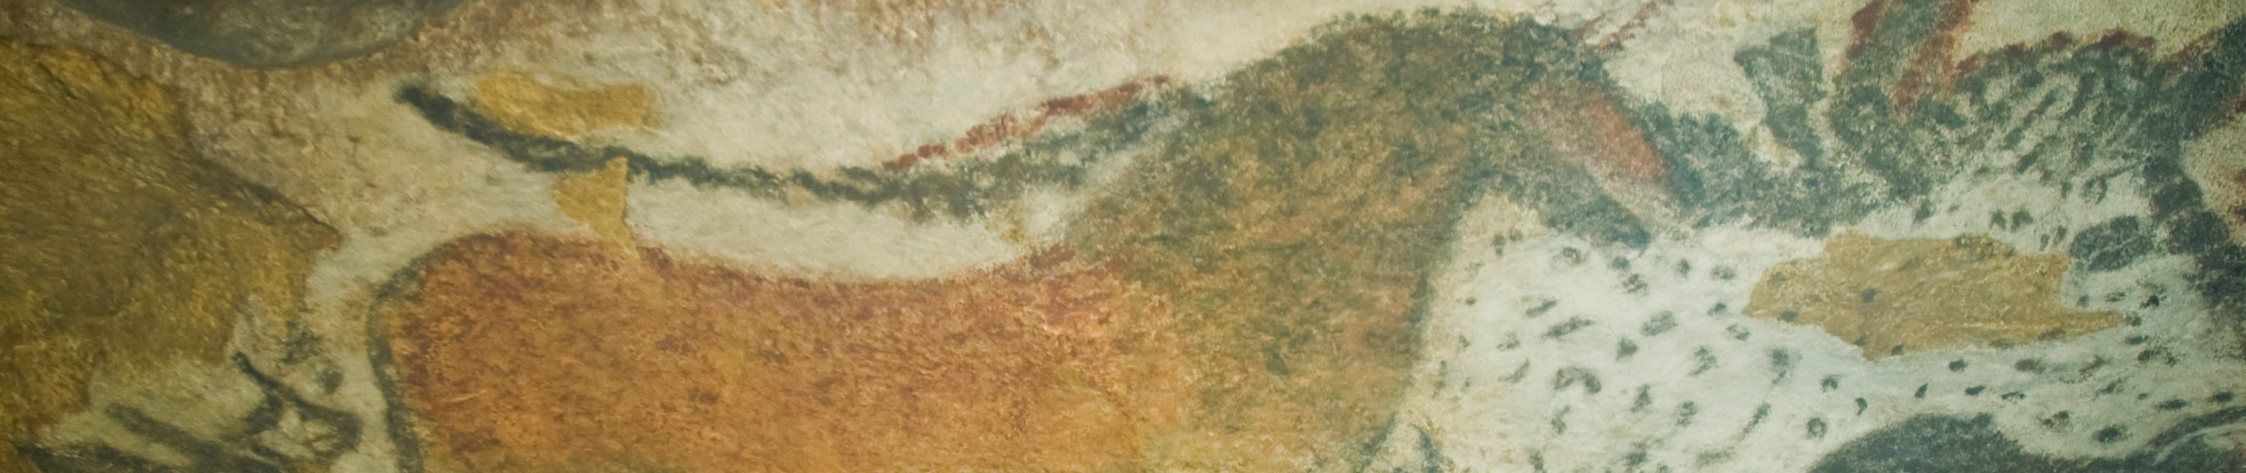

Running horned woman, Algeria. 6000–4000 B.C.E. Pigment on rock.

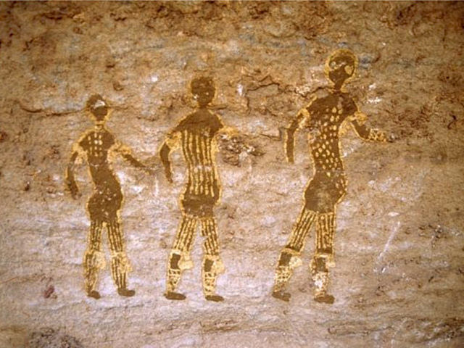

This is not the image in your image set/

Photo Citation: Flickr/baletsociety/ https://www.flickr.com/photos/118908666@N06/12865685214/sizes/z/

The Tassili n’Ajjer range is also noted for its prehistoric rock art and other ancient archeological sites, dating from the Neolithic era. At his time, the local climate was less dry and more like a savannah. The paintings depicted herds of cattle, large wild animals including crocodiles, and human activities such as hunting and dancing. (Wikipedia)
The Running Horned Woman has a defined outline of the human body, and it has more visual detail (such as the dots on the body-shoulders, legs, torso) than the other Paleolithic paintings that we have seen. It also is a cave painting of a human, whereas the earlier Paleolithic paintings were mostly of animals. This early rock painting is thousands of years older than the first African sculptures. The painting represents a running woman with body paint, raffia skirt, and horned headgear, apparently in a ritual or ceremonial context. The painting also shows what might be scarring on her back and drapery. Her breasts are exaggerated, suggesting a fertility aspect.

Citation:
(n.d.). Retrieved September 27, 2014, from http://en.wikipedia.org/wiki/Tassili_n'Ajjer.

More information:

http://www.metmuseum.org/toah/hd/tass/hd_tass.htm
http://whc.unesco.org/en/list/179
VIDEO https://www.youtube.com/watch?v=dEtnJHeocKg

