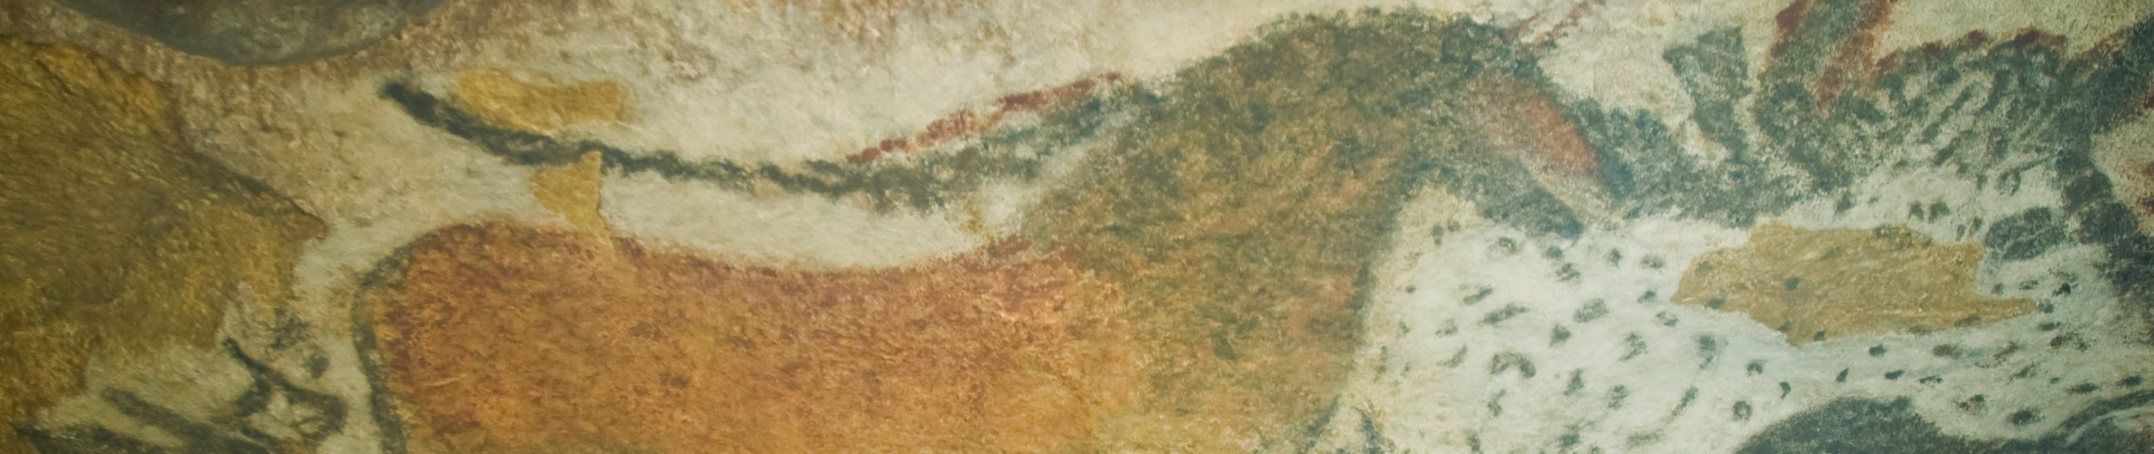
A cong is a form of ancient Chinese jade artifact. The cong is one of the main types of jade artifact of the Liangzhu culture (about 3000-2000 BC) around Lake Tai in Jiangsu province. In form, a cong is a tube with a circular inner section and squarish outer section. The outer surface is divided vertically or horizontally. The outer faces are sometimes decorated with mask-like faces.
Although generally considered to be a ritual object of some sort, the original function and meaning of the cong are unknown. Later writings speak of the cong as symbolizing the earth, while the bi represents the heavens. The square represents the earth and a circle represents the heavens. (Wikipedia)
Half-human, half-animal images with large eyes, flat noses, and rectangular mouths were found carved in low relief. The meaning of the mask like creatures is hard to be determined, but could possibly be a representation of deities or ancestors.
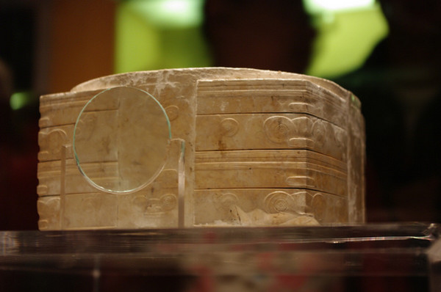
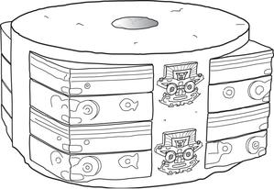
https://bowersarthistory.wikispaces.com/
Greg Kf (http://www.gnu.org/copyleft/fdl.html)], via Wikimedia Commons
Creative Commons Attribution Share-Alike 3.0 License

Be sure to watch the Khan Academy video https://www.youtube.com/watch?v=ld8kHvz1yN4

Additional resource:
http://www.britishmuseum.org/explore/highlights/highlight_objects/asia/j/jade_cong.aspx

Citation:
Jade Cong. (n.d.). Retrieved September 28, 2014, from http://en.wikipedia.org/wiki/Jade_cong)

