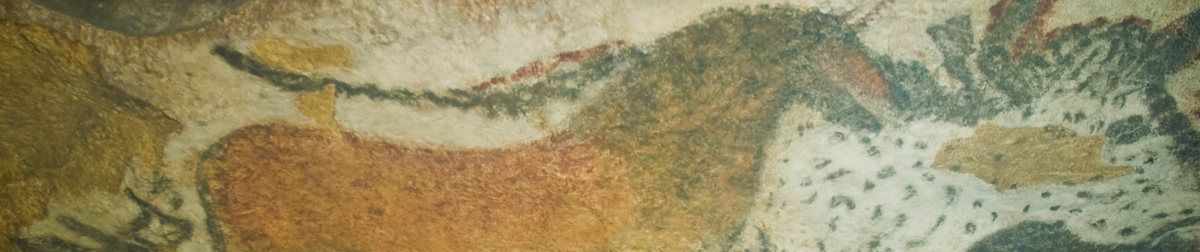
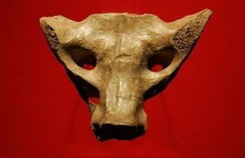

Camelid sacrum in the shape of a canine. Tequixquiac, central Mexico. 14,000–7000 B.C.E. Bone.
By Marrovi (Own work) [Public domain], via Wikimedia Commons

A sacrum bone found in Tequixquiac, Mexico is considered a work of prehistoric art. It is the earliest known art from the region of Mesoamerica. Humans who had crossed the Bering Strait from Asia inhabited the town of Tequixquiac in 35,000 BCE. These people were nomadic, hunting large animals such as mammoths and gathering fruits as evidenced by archaeological evidence found at the site. The carving is the earliest example of true art found in the Americas so far. The true purpose and meaning of the carving, as well as the culture that produced it, remain unknown.
The artwork, which has no known purpose but may reflect the ideological sense of the artist who carved the pelvis of a camelid. A camelid is an extinct ancestor of a camel that lived in the Americas. The Tequixquiac carving is a carving representing the face of a dog, wolf or coyote.
After being lost in the late 19th century, the carved bone was rediscovered in 1956. Recent studies of the specimen tend to demonstrate its authenticity and scientific value. The age of the artifact remains unclear because we do not know whether the carving had been done soon after the animal's death or long after. A survey of all known examples of similar finds in North America suggests that the Tequixquiac bone is probably the only example of true art that has yet been found in Paleo-Indian levels in North and South America. (www.jstor.org)

Citation:

(1965, January 1). Retrieved September 28, 2014, from http://www.jstor.org/discover/10.2307/278808?uid=2&uid=4&sid=21104401140117

