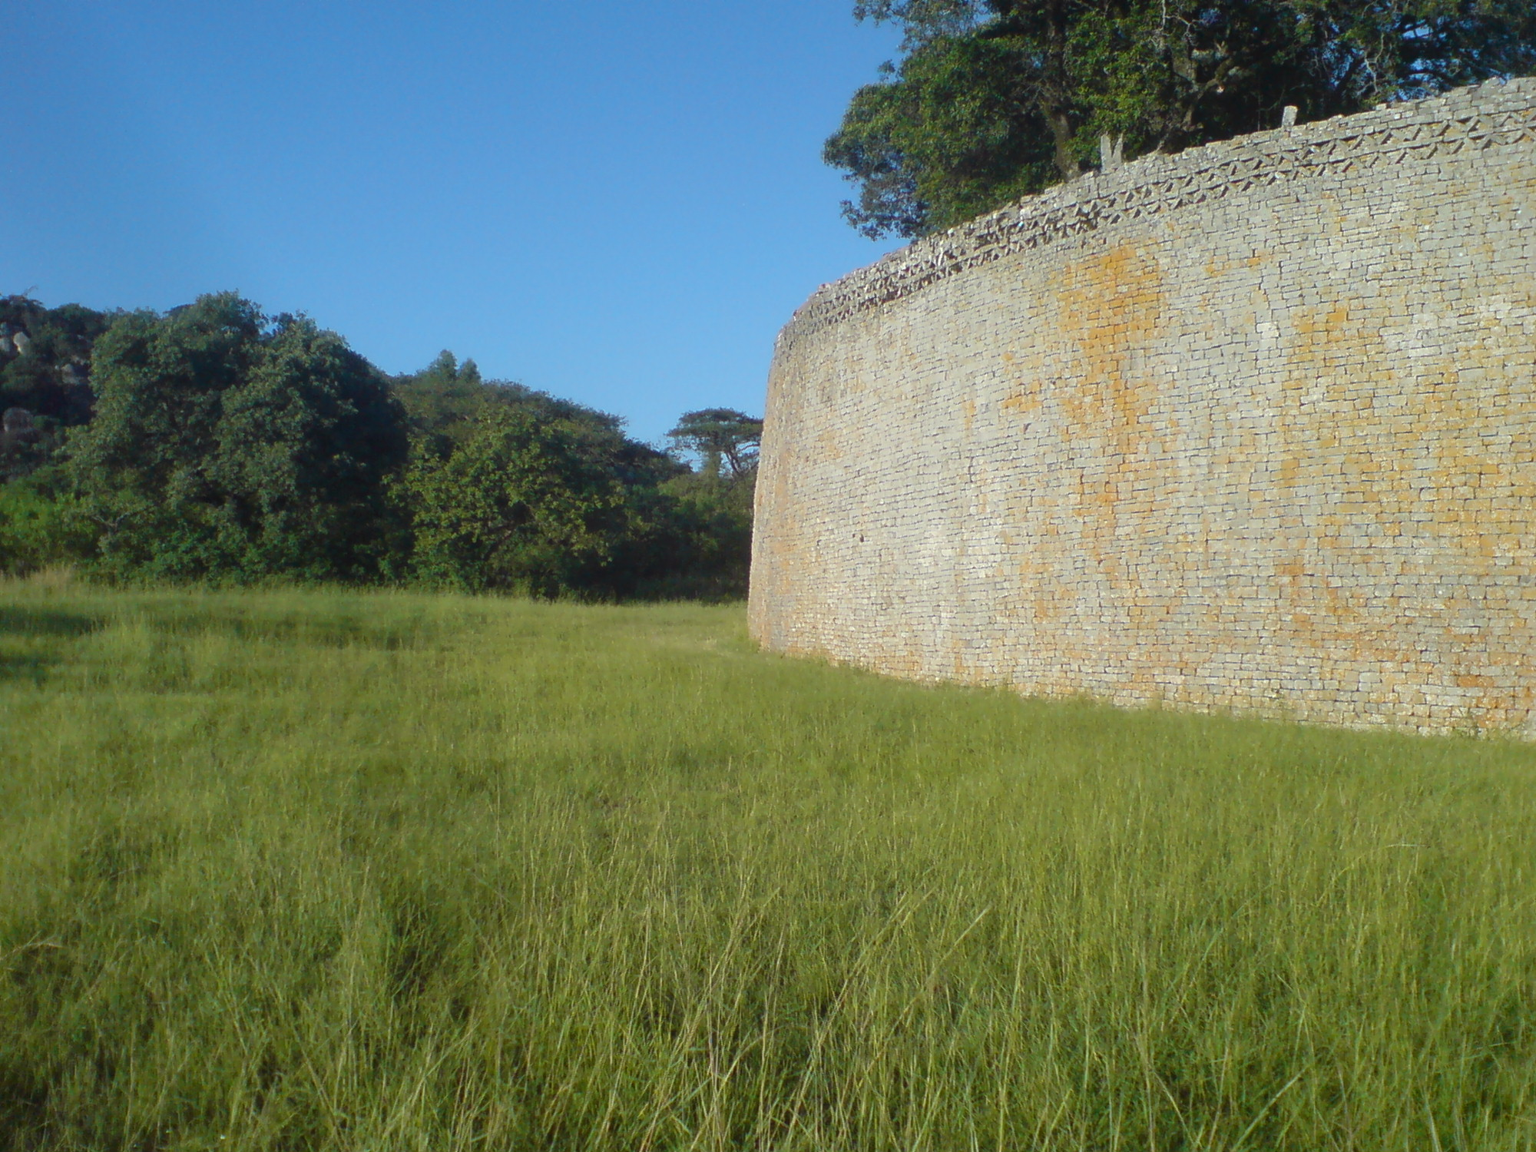  Conical tower and circular wall of Great Zimbabwe. Southeastern Zimbabwe. Shona peoples. c. 1000–1400 C.E. Coursed granite blocks  GreatZimbabwe2.jpg | Content:  Great Zimbabwe is an abandoned city in the southeastern hills of Zimbabwe near Lake Mutirikwe and the town of Masvingo.  Great Zimbabwe served as a royal palace for the Zimbabwean monarch and would have been used as the seat of political power.  One of its most prominent features was the walls, which were over five meters high and which were constructed without mortar.  Style:  These walls were constructed from granite blocks fitted without the use of mortar by laying stones one on top of the other, each layer slightly more recessed than the last to produce a stabilizing inward slope.  Contextual Analysis:  Great Zimbabwe was a prosperous trading center.  The structure is in the shape of an ellipse and contains a series of daga-hut living quarters, a community area, and a narrow passage leading to a high conical tower.  The bricks (daga) were made from a mixture of granitic sand and clay.  Huts were built within the stone enclosure walls generally comprising a kitchen, two living huts and a court.  Each enclosure was made of adobe and defined a family dwelling  The stone enclosure, known as great enclosure, may have been a royal residence.  http://whc.unesco.org/en/list/364
Conical tower and circular wall of Great Zimbabwe. Southeastern Zimbabwe. Shona peoples. c. 1000–1400 C.E. Coursed granite blocks  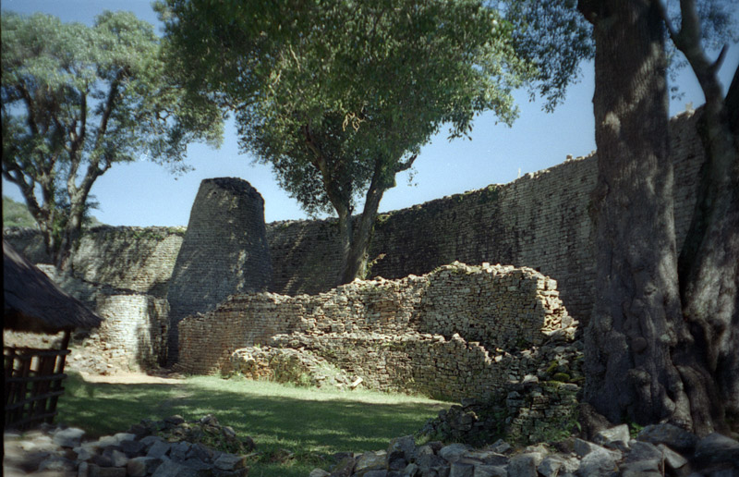  greatzimbabwe.JPG | Content:  The structure is a stone tower that is  built between the old wall and the newer outer wall.  It is decorated around the top with dentelle-patterned frieze and has beautifully regular coursing with a slight batter, giving the slightly irregular conical shape.  Style:  The Conical Tower, one of the last structures to be built in the Great Enclosure, is 33 feet high and 16 feet in diameter at the base, tapering to 6.5 feet at the top where, originally, there were an additional three courses of 'dentelle' decoration.  It is solid, built of granite blocks throughout, and rests directly on the ground with no underlying chamber.  Context:  Its large size and seclusion behind an equally massive enclosure wall, together with the narrow passageway leading to it, indicate that it was an important structure.  Next to it is a smaller tower, and similar examples are also found in other Valley Enclosures.  The purpose of the towers is unknown but as they seem to have had no functional use they were probably symbolic.  Traditionally, the Conical Tower is said to represent a grain bin, symbolizing good harvests and prosperity.  http://www.metmuseum.org/toah/hd/zimb/hd_zimb.htm
Great Mosque of Djenné. Mali. Founded c. 1200 C.E.; rebuilt 1906–1907. Adobe.  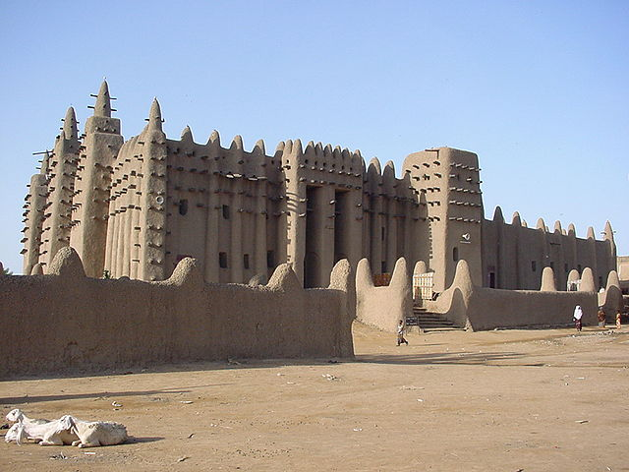  mosqueofjenne.jpg | Content:  The Great Mosque of Djenné is a large banco or adobe building that is considered by many architects to be one of the greatest achievements of the Sudano-Sahelian architectural style. The mosque is located in the city of Djenné, Mali, on the flood plain of the Bani River.  Style:  The plan is hypostyle.  The Sudanese architectural style is characterized by the use of mud bricks and an adobe plaster, with large wooden-log support beams that jut out from the wall face for large buildings such as mosques or palaces.  These beams also act as scaffolding for reworking, which is done at regular intervals, and involves the local community.  Contextual Analysis:  The mosque combines the use of the hypostyle hall with buttressed walls and towers to produce a style common to both monumental and rural buildings.  Construction methods use reinforcing stick scaffolding that remains embedded in the structure.  The mosque incorporates African symbols, such as ancestor pillar fertility symbols and tops covered in ostrich eggs for strength.
Great Mosque of Djenné. Mali. Founded c. 1200 C.E.; rebuilt 1906–1907. Adobe.  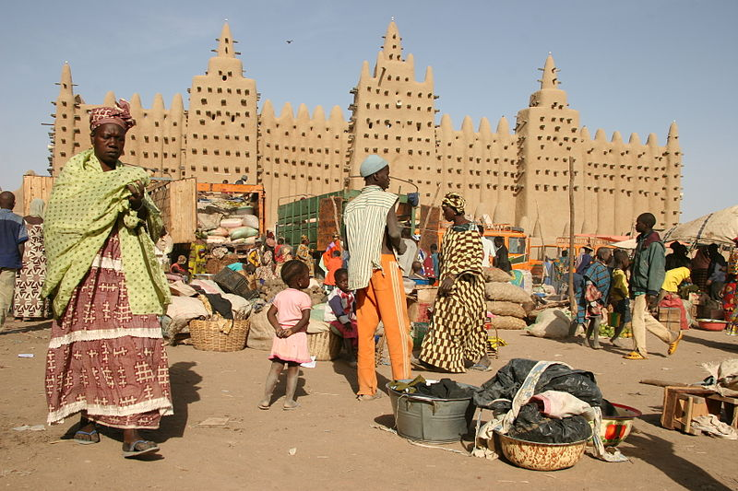  mosqueofjenne2.jpg | Contextual Analysis:  The prayer wall or quibla of the Great Mosque faces east towards Mecca and overlooks the city marketplace.  The most notable days at the Great Mosque of Djenne are market days, when the square in front of the Mosque fills with vendors and shoppers.  People of the various ethnic groups of Mali come together at this weekly market to purchase everything from cattle, meat, fish, vegetables, rice, and all sorts of household goods.
Wall plaque, from Oba’s palace. Edo peoples, Benin (Nigeria). 16th century C.E.  Cast brass.  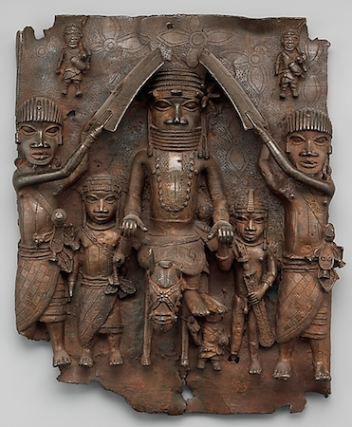  beninplaque.jpg | Content:  The royal palace was covered with 900 brass plaques made using the lost-wax casting process.  Style:  The plaque is cast in the cire perdue process.  It a relief in cast brass.  Contextual Analysis:  The plaques commemorates scenes of the Benin court including scenes of the Oba and court functionaries  The Oba is dressed in ceremonial attire, a leopards tooth necklace, and high coral encrusted collar and headdress.  The figures are sized based on importance (hierarchic scale).  The attendants raise their shields to shield the Oba either from attack or the sun, or as pat of a military celebration.  The work shows the importance of the ruler through the crown, the coral necklaces, size, and the centered composition.  The proportions of the head are too big, which may be a symbol of intelligence.  The work is more concerned with communicating hierarchy and status than capturing individual physical features.  The leopard skins and teeth associates the warrior with the stealth, speed, and ferocity of the leopard.
The Oba. Edo peoples, Benin (Nigeria).  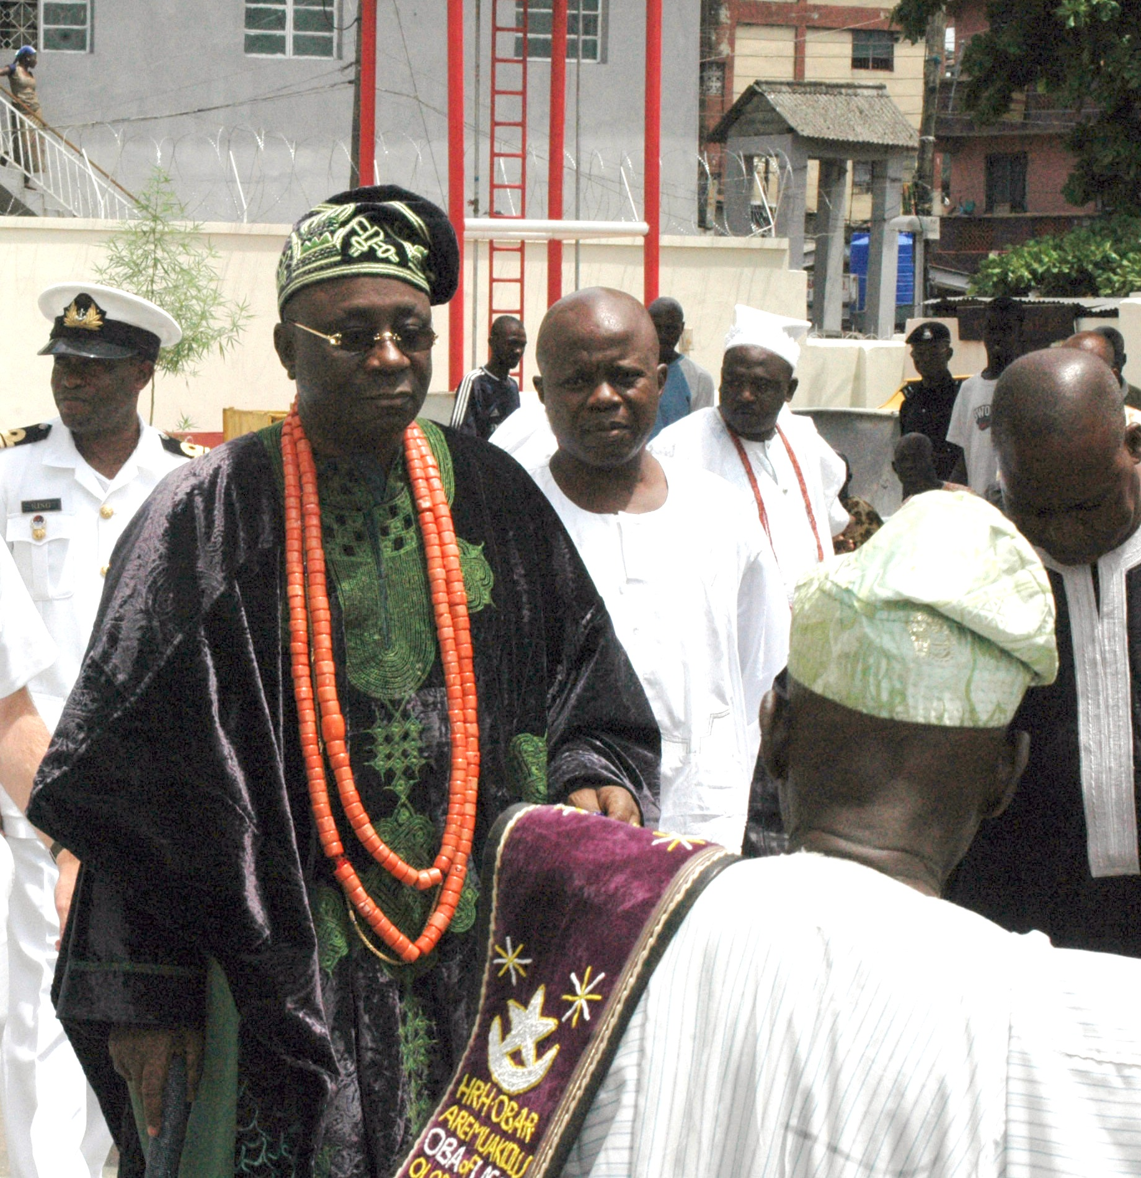  oba.jpg | Contextual Analysis:  The Oba of Benin, or Omo N'Oba, is the traditional ruler of the Edo people and head of the historic Eweka dynasty of the Benin Empire - a West African Empire centered on Benin City, in modern-day Nigeria.  The British overthrew the Oba, but his descendants all preserved their titles and statuses as traditional rulers in modern-day Nigeria.  The present Oba, Erediauwa I, is the 39th Oba of the dynasty.  In this picture, he wars the coral beads of authority.
Sika dwa kofi (Golden Stool). Ashanti peoples (south central Ghana). c. 1700 C.E.  Gold over wood and cast-gold attachments.  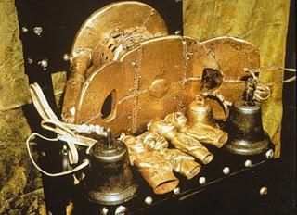  goldenstool.jpg | Content:  The Golden Stool is the royal and divine throne of the Akan people (Ashanti people).  Style:  Each stool is made from a single block of the wood of Alstonia boonei and carved with a crescent-shaped seat, and flat base.  The many designs and symbolic meanings mean that every stool is unique as each has a different meaning for the person whose soul it seats.  The Golden Stool is a curved seat 46 cm high with a platform 61 cm wide and 30 cm deep. Its entire surface is inlaid with gold, and hung with bells to warn the king of impending danger.  Contextual Analysis  According to legend, Okomfo Anokye, High Priest and one of the two chief founders of the Asante Confederacy, caused the stool to descend from the sky and land on the lap of the first Asante king, Osei Tutu.  Such seats were traditionally symbolic of a chieftain's leadership, but the Golden Stool is believed to house the spirit of the Asante nation—living, dead and yet to be born.  The soul was believed to reside in the stool after death  Replicas have been produced for the chiefs and at their funerals are ceremonially blackened with animal blood, a symbol of their power for generations.  Blackened stools of kings and royals are kept in a special shrine called a stool room.  The stool is believed to be alive, was never blackened, and is placed on its own because it still shows succession and power.  http://en.wikipedia.org/wiki/Golden_Stool
Ndop (portrait figure) of King Mishe miShyaang maMbul. Kuba peoples (Democratic Republic of the Congo). c. 1760–1780. C.E. Wood.  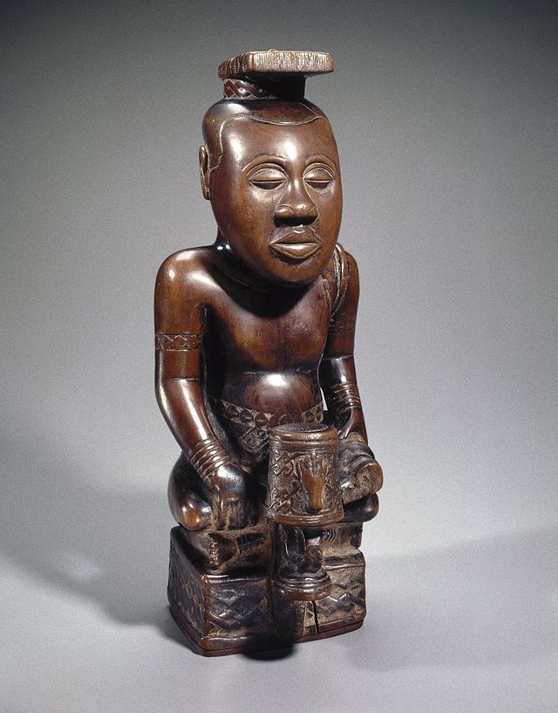  NdopPortraitofKing.jpg | Content:  Ndop figures are idealized portraits of individual Kuba rulers known as nyims. This ndop, considered the oldest in existence, displays the king’s symbol, a drum with a severed hand.  The ruler sits cross-legged on a raised platform.  His face expresses both aloofness and composure.  The short sword in his left hand (held with handle out, indicating the nonaggressive pose of the nyim) and the belts, arm bands, bracelets, shoulder ornaments, and special projecting headdress are all elements of royal regalia.  Style:  It is a subtractive wood carving.  Contextual Analysis:  The works are idealized representations of royalty (statues were created to show the subject at their highest points of life).  They are covered with royal decorations, including the cowrie shell, which was a symbol of wealth.  Ndop figures were believed to represent and honor the spirit of the ruler and serve as a point of contact with his spirit.  The expression on the face, the position of the body, and the regalia were meant to faithfully represent the ideal of a ruler—but not an individual nyim.  All figures are sculpted using a one-to-three proportion—the head of the statue was sculpted to be one-third the size of the total statue because the head was considered to be the seat of intelligence.  The ibol, an emblem and geometric symbol protruding from the base, is symbolic of the king's power and reign. The ibol gives the ndop its particular identity, making it clear whom the sculpture portrays and what specific eign it represents.  https://www.khanacademy.org/humanities/art-africa-oceania-americas/africa-art/kuba/a/ndop-portrait-of-king-mishe-mishyaang-mambul
Power figure (Nkisi n’kondi). Kongo peoples (Democratic Republic of the Congo). c.  late 19th century C.E. Wood and metal.  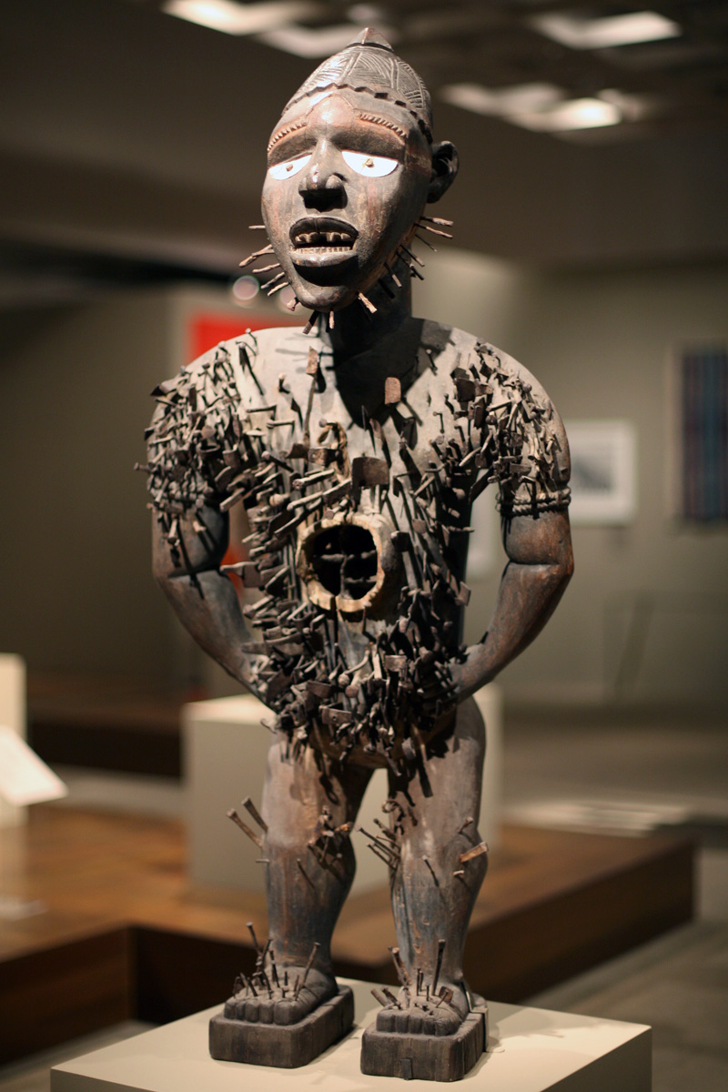  kongopowerfigure.jpg | Content:  Nkisi refers to the spiritual charm of the figure, and nkondi refers to the carved power figure itself.  Generally carved in the shape of human beings minkondi were sacred objects, which contained a powerful spirit that derived their supernatural power from medicinal substances deposited in cavities in the stomach of the figure.  When a problem in the village needed to be resolved, the parties drove a blade, nail, screw, and/or another sharply pointed object into the nkisi nkondi.  Style:  The sculpture is subtractively card wood.  The work has nails driven into it’s form  There is evidence of paint.  Contextual Analysis:  The Kongo peoples live in southwestern Zaire and Angola. In a few traditional Kongo villages a religious specialist, who is also a healer and a legal expert, takes care of the spiritual and physical needs of the villagers with the assistance of a powerful carved figure, called ankisi nkondi.  Popularly known as nail figures, these sculptures were used for a wide variety of purposes, including to protect the village, to prove guilt or innocence, to heal the sick, to end disasters, to bring revenge, and to settle legal disputes.  Among most Kongo peoples, these figures are no longer used.  The sculptures were thought to represent dead spirits, and believed to hold the power of those spirits  The spirits held power over events in the living world.  Banganga used these statues, and they worked as healers/diviners.  Banganga could create medicines to ward off witchcraft or to treat different diseases.  The figures have chest cavities to hold medicine.  The figures could be called upon to right a wrong done to an individual in the village.  Spirits can be called upon to bless or harm others, cause death or give life, and in order to prod/activate the image into action, nails or blades are often inserted into the image or removed from it.  http://www.artsconnected.org/resource/93730/nail-figure-nkisi-nkondi
Female (Pwo) mask. Chokwe peoples (Democratic Republic of the Congo). Late  19th to early 20th century C.E. Wood, fiber, pigment, and metal.  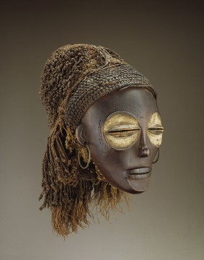  pwo.jpg | Content:  The mask is a carved wood mask of a female face with an elaborate hair style.  The eyes, slender nose, elliptical mouth and ears are delicately carved on a face delineated by a softly modeled forehead and concave chin. The fiber coiffure is composed of a braided headband and a heavy fringe at the rear.  Style:  The mask is made of wood, fiber, pigment, and metal.  The half-closed eyes placed in large, concave sockets are covered with white clay (kaolin).  Contextual Analysis:  The ancestral female/archetype of womanhood represented in the mask.  These representations are especially significant given that the Chokwe trace descent through their mothers' lines.  Pwo's joint performance with her male counterpart, Cihongo, brings fertility (Pwo) and prosperity (Cihongo) to a community.  Females wore the masks to visit neighboring tribes, in order to negotiate and/or exchange agreements of loyalty and protection.  Chokwe masks are also performed at the celebrations that mark the completion of initiation into adulthood.  The mask has symbolic tattoos carved in to the wood on forehead and cheeks.  Chokwe women typically wore a hairstyle entirely coated with red earth and known as tota.  A male dancer is dressed like a woman in a costume of braided fiber that completely covers his body and hides his identity. He wears a loincloth, carries a fan and moves in slow, precise steps to imitate a woman.  When the mask becomes broken or unusable, it is rejected.  When a masquerader dies, the mask is buried with the dancer.  https://africa.si.edu/collections/view/objects/asitem/People@1398/12/title-asc?t:state:flow=3f4e7aac-e96d-451d-b087-b99e9728362b
Portrait mask (Mblo). Baule peoples (Côte d’Ivoire). Early 20th century C.E. Wood  and pigment.  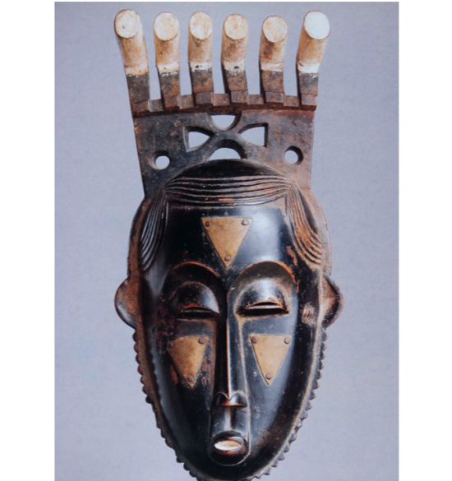  mblo.jpg | Content:  The wood mask with stylized features is pat of a ritual dance practiced by the Baule people of the Ivory Coast.  Style:  The faces are idealized.  Contextual Analysis:  The masks are used in rituals involving dancing.  The masks portray specific individuals.  The broad forehead and downcast eyes reflected Baule ideals and were associated with intelligence.  There were often protrusions depicted on top of the head.  The rituals celebrated the achievements of distinguished members of the community.  The Mblo is danced in skits or by itself. It is meant be similar to an opera, in the way it is performed.  The performances get brought up to date every couple of generations with different skits.  Women can participate in these dances and masks are kept out of sight between dances, stored in the village.  Normally, only gets performed on holidays, at festivals, and to important people within their society.  Overall these masks are important to entertain people within their society but are also used for other purposes as well.  http://hidingbehindthemask.weebly.com/mblo-face-mask.html
Bundu mask. Sande Society, Mende peoples (West African forests of Sierra Leone  and Liberia). 19th to 20th century C.E. Wood, cloth, and fiber.  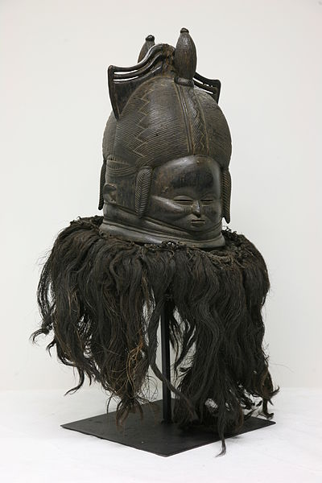 | Content:  The masks are depicted with elaborate hairstyle and attempt to represent feminine beauty, with high foreheads, small, compressed facial features, and voluminous neck-rings, depicting the desirable full-figured woman.  Originally all had a dark raffia collar and were worn with a full, dark costume of raffia on cloth.  Style:  The mask was made of wood, cloth, and fiber.  The surface is smoothed with the leaves of the ficus tree, then dyed black with a recipe made of leaves. Before use, it is covered with palm oil to make it shine. (Modern carvers use black shoe polish.)  Contextual Analysis:  The mask was worn by leader of the Sande, a group of women associations that initiated girls into secret of womanhood.  The leader also had a white scarf to tie her to the initiates.  This mask also contains bands that could represent water as the initiates have a rebirth into adulthood.  The high forehead symbolizes wisdom.  All the initiates were dressed in white and had white makeup apply to their face and had leave their community while going through this process of adulthood.  http://www.randafricanart.com/Mende_mask.html
Bundu mask. Sande Society, Mende peoples (West African forests of Sierra Leone  and Liberia). 19th to 20th century C.E. Wood, cloth, and fiber.  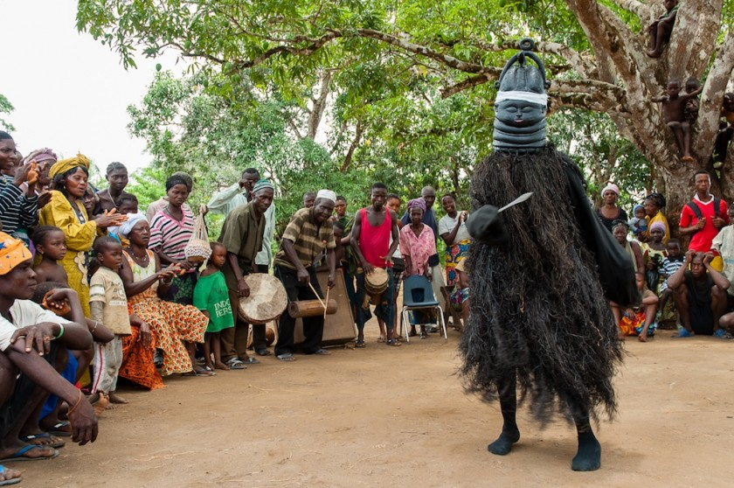  helmetmask.jpg | Contextual Analysis:  The spirit speaks not through words but through the language of dance. The dance may last up to two hours.  These masks are important to the Mende because they tell a lot about the culture, the importance of marriage, and the way lineage is traced. The mask is a piece of art, a communication tool, and it is representative of many of the Mende’s most fundamental values.
Ikenga (shrine figure). Igbo peoples (Nigeria). c. 19th to 20th century C.E. Wood.  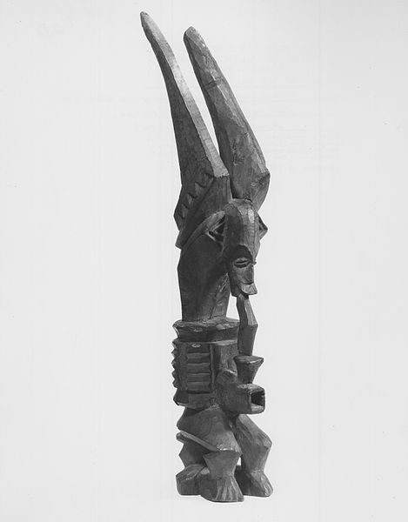  IkengaFigure.jpg | Content:  Ikengas are human figures with sharp horns (horns symbolize power) used in personal shrines of men.  This is sometimes reduced to only a head with horns on a base  Some horns are straight, others are spiral, and others even more elaborate.  Style:  Ikengas are made subtractively of wood.  The body proportions are very stylized.  The figures are generally frontal, symmetrical, and upright, with legs slightly spread.  Contextual Analysis:  Ikenga altars are created by men to symbolize their perfection and strength.  According to tradition, sacrifices to the altars occurred after successes and accomplishments.  The shrine figures form included sharp horns, which are a theme and symbol of power.  Power is further emphasized with the right hand and arm as physical power usually doing something more important with that arm.  Although the one shown here depicts only a horned head above a geometrically abstracted, spool-like body.  The owner regularly offered prayers and sacrifices of gin, egg, and kola nut to the spirit of the ikenga.  http://www.randafricanart.com/Igbo_altar_figure.html
Lukasa (memory board). Mbudye Society, Luba peoples (Democratic Republic of the  Congo). c. 19th to 20th century C.E. Wood, beads, and metal.  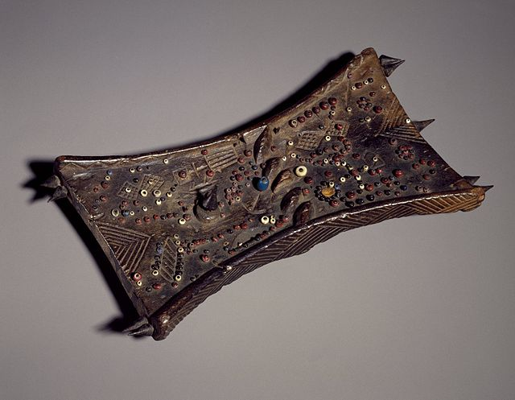  lukasa.jpg | Content:  The work is a wood plank, carved in relief and adorned with beads in very specific patterns used as a mnemonic device--helps a story teller remember important details in a history or other tale.  Style:  The work is a wood plank, carved in relief and adorned with beads in very specific patterns.  Contextual Analysis:  The Lukasa is the highest stage of royal initiation available to king and members of Mdubye.  These members were men of memory considered historians and genealogists, which is why this map contains social maps connected to the Luba's history.  Lukasa memory boards often served as a method of validation of a king's power, a reminder to the public of how a king came to power, or to tell a story of a king's ancestry  This artifact is used as memory aid in ceremonies and to gain the complex bodies of knowledge.  The board is dotted with beads representing the individuals or groups of people, possibly within the map.
Aka elephant mask. Bamileke (Cameroon, western grassfields region). c. 19th to 20thcentury C.E. Wood, woven raffia, cloth, and beads.  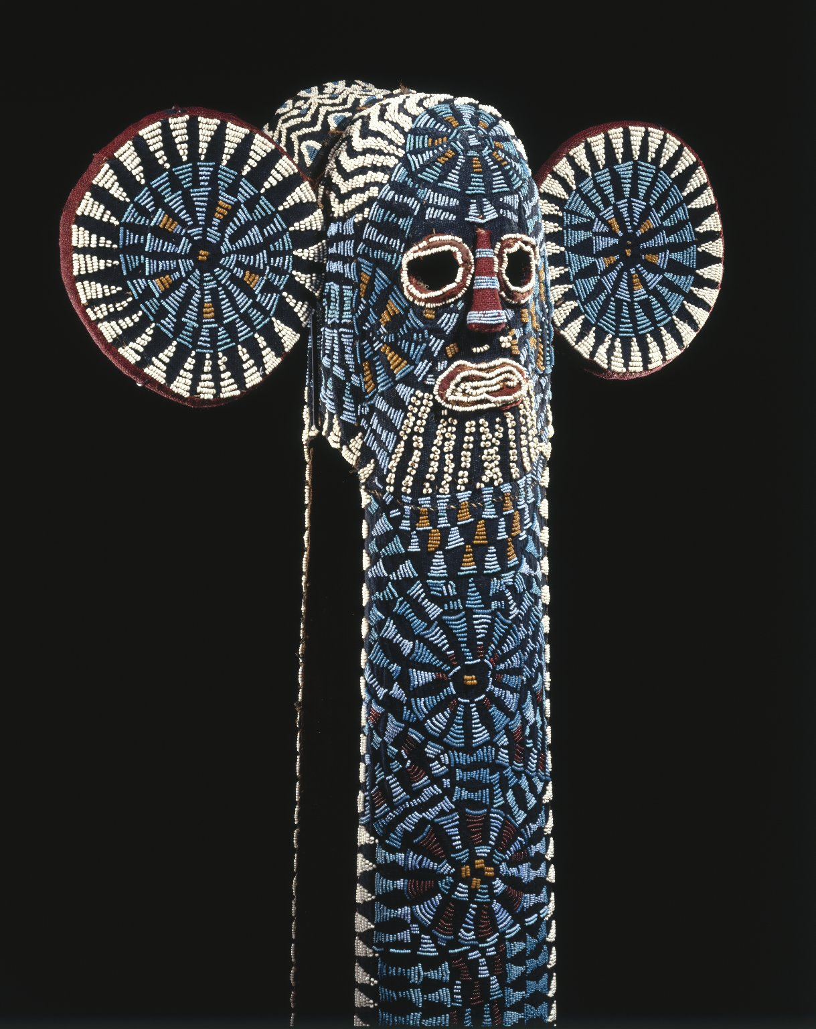  ElephantMask.jpg | Content:  It consisted of long flaps, symbolic of elephant trunks, of cloth cascade over the masquerader's chest and down the back, including beaded sculptural crests as the appearance of leopards on the masks, as elephants and leopards were considered the royal animals.  Style:  Elephant masks comprise cloth panels and hoods woven from plantain fiber over raffia.  On this background multicolored beads are stitched in geometric patterns.  The basic form depicts the features of the elephant—a long trunk and large ears while the face is human.  Contextual Analysis:  Masquerade is performance art.  This mask was not meant to be seen as isolated sculptural forms but were part of a whole that included costume, music, songs, food, audience interaction, and, above all, movement. Masked performances have a variety of purposes.  The Bamileke masquerade is a confident and dignified performance worthy of a royal court. The elite Kuosi masking society controls the right to own and wear elephant masks, since both elephants and beadwork are symbols of political power in the kingdoms of the Cameroon grasslands. The Kuosi society assists the king, or Fon, in his role as preserver of a rigid sociopolitical hierarchy.  The masked dance barefoot in these colorful costumes to a drum and gong, moving slowly as they wave poles with blue and white beaded tips  trimmed with horsehair. As they whistle "mysteriously and tunelessly," brandishing spears and horsetails, the dancers are l joined by chiefs  and princesses. As they observe the dance, a dancer hurls his horsetail to the chief to the delight of the crowd.  http://www.randafricanart.com/Bamileke_elephant_mask_cowrie_shells.html  http://www.brooklynmuseum.org/opencollection/objects/4852/Kuosi_Society_Elephant_Mask
Reliquary figure (byeri)  Fang peoples (southern Cameroon). c. 19th to  20th century C.E. Wood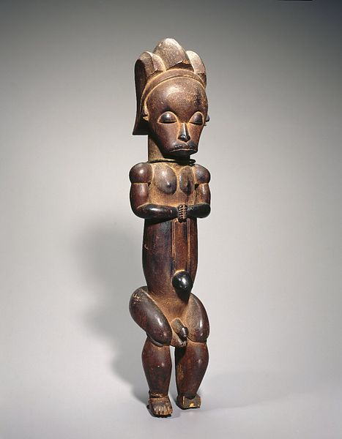  ReliquaryGuardianFigure.jpg | Content:  Bieri are wooden mortuary figure of the Fang tribe of Gabon, Africa that traditionally guarded the skulls of deceased ancestors. These figures were somewhat naturalistic, representing the ancestor whose skull was kept in a small, barrel-shaped bark container to which the figure was traditionally attached.  Style:  The work is a subtractive carved wood.  Contextual Analysis:  Because of the spiritual powers attributed to deceased ancestors, these mortuary figures were originally carved to protect the ancestor’s bones from possession by evil spirits and to shield the tribesmen from unwittingly coming into contact with the skull’s potentially dangerous powers.  The Fang figure has primarily been reduced to a series of basic shapes—cylinders and circles.  The legs and hips are conceived as the intersection of two perpendicular cylinders, echoing the cylindrical reliquary box on which the figure sat.  In the belief that skulls and certain bones of great men retained their supernatural powers after death, the Fang, as well as other peoples venerated and preserved their remains.  "Great men" included the founder of the lineage and successive lineages, clan or family heads, and extraordinary women who were believed to have supernatural abilities or who bore numerous healthy children.  The skull, along with valued beads, strong substances with magical properties (medicine), and other spiritually charged objects were kept in containers made of bark or woven plant fibers.  A post sticking out from a carved guardian figure secured it to the lid of the bark reliquary box.  The sculpted guardians protected the relics from evil spirits and other humans as well as served as link between the ancestors and family members.  https://www.dma.org/collection/artwork/african/reliquary-guardian-figure
Veranda post of enthroned king and senior wife (Opo Ogoga). Olowe of Ise (Yoruba  peoples). c. 1910–1914 C.E. Wood and pigment  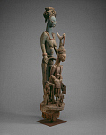  veranda.jpg | Content:  Carved veranda posts supported royal palace courtyards.  The image depicts the Oba (king), sitting. His wife is sitting behind him, "the power behind the throne", who is larger than him.  Oba is depicted with royal crown.  Style:  The work is Yoroba in style.  It is a subtractive wood sculpture.  The sculpture is painted.  Contextual Analysis:  This veranda post is one of four sculpted for the palace at Ikere by the renowned Yoruba artist Olowe of Ise. It is considered among the artist's  masterpieces for the way it embodies his unique style, including the interrelationship of figures, their exaggerated proportions, and the open space between them.  While the king is the focal point, his portrayal suggests a ruler's dependence on others. The stately female figure behind the king represents his first wife.  Her large scale and pose, with hands on the king's throne, underscore her importance.  She had the critical role of placing the crown on the king's head during his coronation and using her spiritual and political knowledge to protect the king's interests during his reign.  http://www.randafricanart.com/Yoruba_Olowe_of_Ise.html

