Nan Madol. Pohnpei, Micronesia. Saudeleur Dynasty. c. 700–1600 C.E. Basalt  boulders and prismatic columns  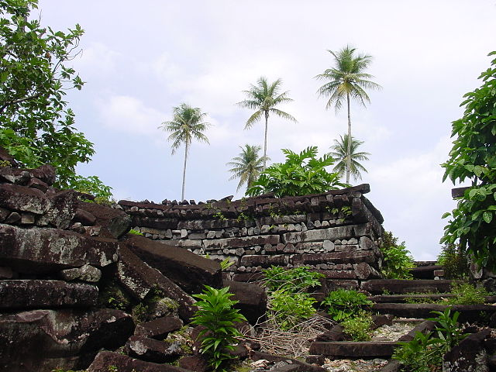  NanMadol.jpeg | Content:  In Micronesia is its Southeast coast, Pohnpei, home to Nan Madol, the largest stone complex in Oceania. The geography of Pohnpei is tropical and mountainous. In the 13th century, a hierarchy ruled it.  Style:  The city, constructed in a lagoon, consists of a series of small artificial islands linked by a network of canals.  The structures are built of masonry construction.  Some of the rocks are basalt logs five meters long in a hexagonal shape, formed naturally through volcanic crystallization and quarried on Pohnpei island. Other stones are huge slabs, roughly cut and dressed  Contextual Understanding:  Nan Madol covers 170 acres and is made up of 92 small man-made islands.These islands are connected by network of canals.  The name Nan Madol means "spaces between" and is a reference to the canals that crisscross the ruins.  The remains of Nan Madol, the t capital of the Saudeleur dynasty, are the only standing monuments of a civilization built entirely over open water, on a coral reef.  The complex included three artificial islets protected by seawalls and breakwaters on three sides.  The islands are oriented northwest to southwest, therefore they receive cooling winds, which is good. Seawalls protect the Nan Madol from the ocean, as well as breakwaters. The islands and structures were built using prismatic basalt in alternating courses.  Nan Madol was constructed mainly in the period after 1100 AD, and served as a residential and ritual center for the highest-ranking members of society.  Other islets were administrative and residential.  The islands were not capable of growing food, nor was there any fresh water - all supplies had to be delivered from the mainland.  They left no other art, no carvings, and no writing.  http://en.wikipedia.org/wiki/Nan_Madol
Female deity. Nukuoro, Micronesia. c. 18th to 19th century C.E. Wood  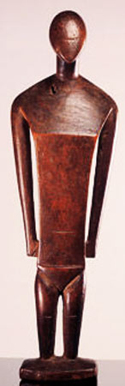  goddess.jpeg | Content:  The anthropomorphic figures, from the tiny island atoll of Nukuoro, are statues of deities with simplified human forms.  Style:  Artists reduced the human body to basic shapes.  Eyes, ears, and mouth are omitted.  Arms and legs are presented only in their simplest forms.  The shoulders are decorated with intricate patterns that correlate to the tattoos of Nukuoro chieftains and their families.  Contextual Understanding:  Images of deities were known as dinonga eidu and were kept in cult houses.  Carved wooden images, as ritual objects are extremely rare in Micronesia.  The sculptures were wrapped on cloth, and were kept in cult houses.  On festival days, the inhabitants would gather around the decorated statue and offer fruits as sacrifice.  https://www.wienand-koeln.de/pdf/978-3-86832-036-7.pdf
Buk (mask). Torres Strait. Mid- to late 19th century C.E. Turtle shell, wood, fiber,  feathers, and shell.  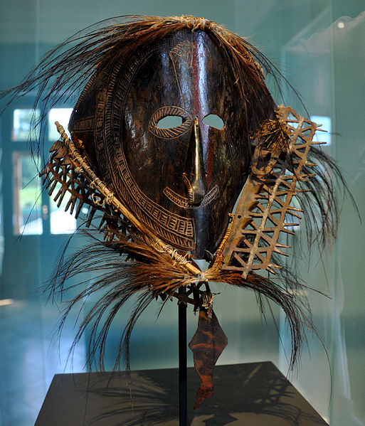  torresstraitmask.jpeg | Content:  The unique turtle-shell masks of the Torres Strait Islands that lie between Australia and New Guinea are among the most striking works of Oceanic art.  Attributed to Mabuiag Island, this work displays the composite human and animal imagery typical of western Torres Strait masks.  Style:  The mask is an assemblage of turtle shell, wood, fiber, and feathers.  Contextual Understanding:  Turtle-shell masks in the western Torres Strait reportedly were used during funerary ceremonies and increase rites (rituals designed to ensure bountiful harvests and an abundance of fish and game).  The ceremonies often involved performances in which senior men, wearing the masks together with rustling costumes of grass, reenacted events from the lives of culture-heroes, drawn from local oral tradition.  Used primarily during male initiation and at funerary rituals, the masks represent mythical culture heroes and their associated totemic species.  Some masks represent human forms, others depict birds, fish, or reptiles, and masks such as this one combine the features of both humans and animals.  Worn over the head like a helmet, this work depicts a human face, possibly portraying one such culture-hero.  It is surmounted by a frigate bird, perhaps representing his personal totemic species.  http://www.metmuseum.org/toah/works-of-art/1978.412.1510
Tamati Waka Nene. Gottfried Lindauer. 1890 C.E. Oil on canvas.  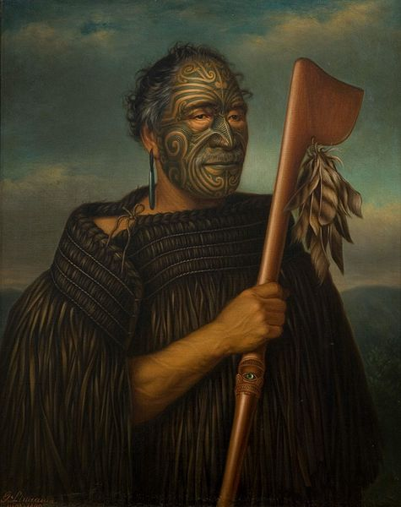  TamatiWakaNene.jpg | Content:  The work is a portrait of a Maori man, Tamati Waka Nene, a leader of Ngati Hao who converted to Wesleyan Christianity and welcomed trade with Europeans.  Style:  The portrait is a naturalistic oil on canvas.  Contextual Understanding:  Gottfried Lindauer was born in Pilsen, Bohemia in 1839. He trained as a portrait and figure painter at the Academy of Fine Arts in Vienna. In 1873 he immigrated to New Zealand and immediately travelled widely, securing many portrait sittings from prominent Māori.
Navigation chart. Marshall Islands, Micronesia. 19th to early 20th century C.E.  Wood and fiber.  . 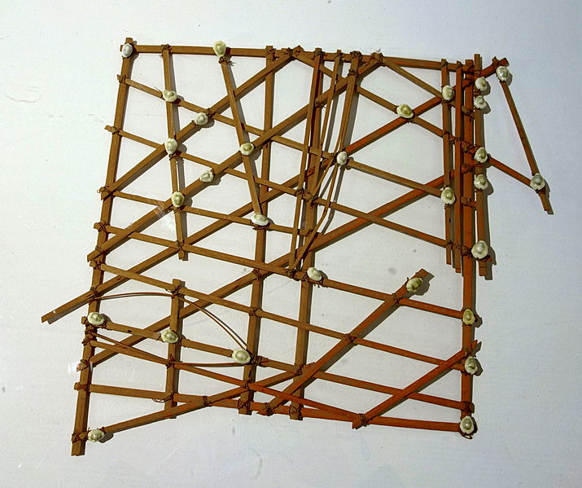  marshallchart.jpeg | Content:  The charts represented major ocean swell patterns and the ways the islands disrupted those patterns, typically determined by sensing disruptions in ocean swells by islands during sea navigation.  Style:  The works is an assemblage of wood and fiber.  It is made up by midribs of coconut fronds tied together to form an open framework.  Contextual Understanding:  The stick charts were the main tool the Marshallese used to navigate on canoe across the islands of the Pacific Ocean, until WWII. Lacking astrolabes, sextants or even a compass, they would rely on maps made up by midribs of coconut fronds tied together to form an open framework.  The location of the islands was represented by shells tied to the framework or by the lashed junction of two or more sticks.  The threads were used to map ocean swells, the prevailing ocean surface wave-crests and the directions they followed to approach an island.  Each chart stick is unique and was made by an individual navigator who was therefore the only person able to fully interpret and use it.  The maps were not taken along during navigation, but studied and memorized prior to a trip.  The Marshallese navigator would crouch down or lying prone in the canoe to feel how the hull was being pitched and rolled by underlying swells.  The stick charts represented a very interesting form of cartography encoding information not traditionally included in navigation maps.  http://socks-studio.com/2014/01/16/sculptural-cartography-how-the-marshall-islands-inhabitants-used-stick-charts-to-map-the-waves/
Moai on platform (ahu). Rapa Nui (Easter Island). c. 1100–1600 C.E. Volcanic tuff  figures on basalt base.  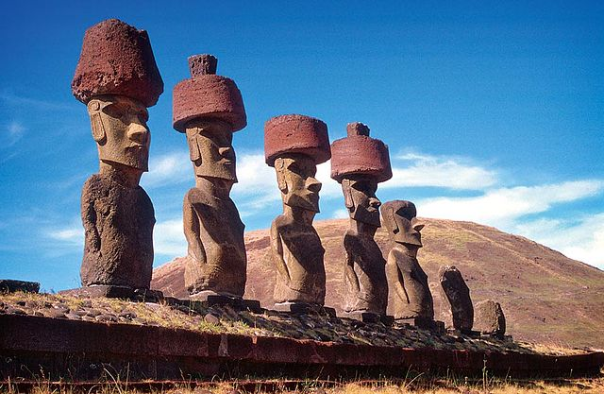  moais.jpg | Content:  Easter Island is the most remote island in Polynesia.  The island is known for their infamous stone sculptures built on stone altars known as ahu.  Style:  Contextual Understanding:  Ahu are common in Polynesia, and were built near the coast.  At around 900 AC, the islanders began to build statues on the ahu.  They were questioned to be statues of dead chiefs.  These statues are called moai, and almost 1,000 moai were built.  Some were left unfinished.  The moai are carved from tufa, a yellow-brown stone.  The statues' height averages at 36 feet high (an unfinished one measured 70 ft tall).  The statues' original condition includes a red tufa topknot on the head and white coral eyes with stone pupils.  The eyes are deep and under a big, thick brow. There is also a slanted, pointed, and concave nose. The chin is angular.  The mouth is small with pursed lips.  The earlobes are long and have parallel lines engraved in them.  Breastbones and pectorals are also indicated.
‘Ahu ‘ula (feather cape). Hawaiian. Late 18th century C.E. Feathers and fiber.  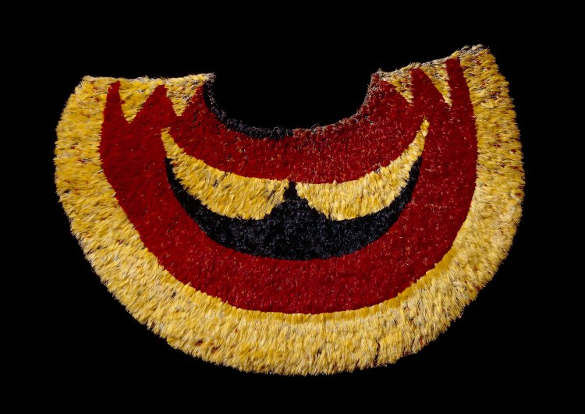  Cape.jpeg | Content:  Hawaiian feather cloaks, known as ʻAhu ʻula in the Hawaiian language, were worn with feather helmets (mahiole). These were symbols of the highest rank reserved for the men of the aliʻI, the chiefly class of Hawaii.  Style:  Hawaiian feather capes and cloaks were constructed by tying bundles of small feathers, usually 6-10 per bundle, to a foundation of netting.  This netting was made from an endemic plant that produced one of the strongest fibers in the world, olonā.  Contextual Understanding:  Kānaka Maoli has long created featherwork of amazing skill and artistry.  These items were worn in battle and different state affairs to signify rank.  The capes, and other feathered articles like cloaks, helmets and kāhili were treasured items of the ali‘i.  Though featherwork was also found in other parts of Polynesia like Tahiti and Aotearoa (New Zealand), the main features of the Hawaiian technique were unique.  Tens of thousands of feather bundles were connected, creating a visually striking garment. These capes and cloaks were important signifiers of rank, and as noble regalia, they were to be worn only by the ali‘i nui.  Red, as a traditional color of royalty in Polynesia, was a dominant color.  Yellow, made valuable by its scarcity, was also oft used.  http://www.hawaiialive.org/realms.php?sub=Wao+Lani&treasure=355&offset=0
Staff god. Rarotonga, Cook Islands, central Polynesia. Late 18th to early 19th  century C.E. Wood, tapa, fiber, and feathers.  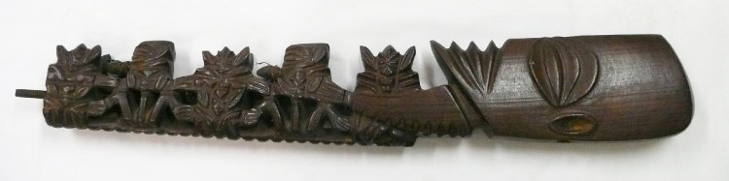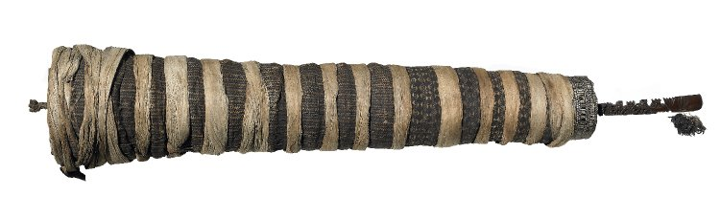  staff.jpg  staffgod2.jpg | Content:  This work is an example of an indigenous art form – a rakau atua - consisteing of a long wooden staff with an elaborately carved top, a phallus at the base of the shaft, and a lesser amount of carving at the base; the central shaft was uncarved and swathed in tapa (barkcloth).  Style:  It is made of wood and features a large, smooth head with stylised eyes, mouth and ears, and a curved neck with notches on the outer side. Five smaller figures are carved on the shaft. They are (from top to bottom): a full-face pair, back-to-back; a downward facing profile figure; another full-face pair; another downward-facing profile figure; and, lastly, what appears to be a pair of turtles back-to-back (rather than a broken version of another back-to-back human pair).  Contextual Understanding:  Cult figures called staff-gods or atua rakau from Rarotonga, apparently combine images of gods with their human descendants.  They range in length between 28 inches (71 cms) and 18 feet (5.5 m) and were carried and displayed horizontally.  At one end there is a schematized blade-shaped head and arms of the progenitive god with a succession of little figures rising from his body, alternatively full-face and in profile with penis erect. The staff itself terminated in a phallus.  But this elaborately carved sexual imagery had less importance for the Rarotongans than the feathers and pieces of shell representing the soul of the god and enclosed in yards of bark cloth wound around the center of the staff.  http://collections.tepapa.govt.nz/exhibitions/ritaangus/artworks.aspx?irn=355
Hiapo (tapa). Niue. c. 1850–1900 C.E. Tapa or bark cloth, freehand painting  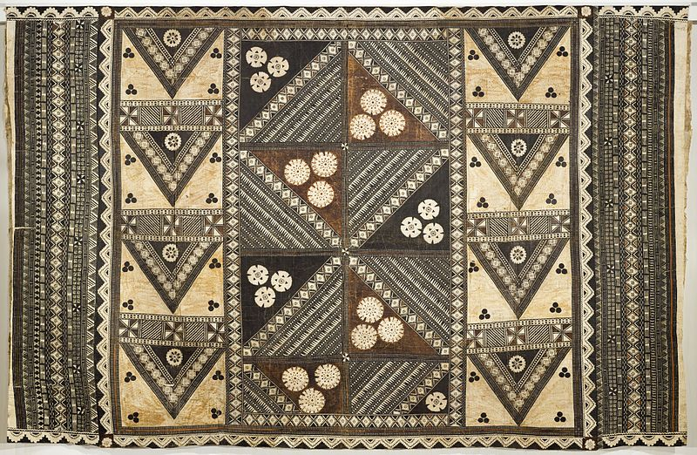  weddinghiapo.jpg | Content:  'Hiapo' is the word for barkcloth or tapa in the language of Niue.The painted hiapo originate on Niue island in central Polynesia.  Style:  The Niuens decorated their hiapo with freehand painting that is similar to the Samoan style. Rectangular or circular design compositions with abstract forms and plant forms are drawn with fine black lines, in a grid formation.  Occasionally, people, stars, and fish are also drawn into the design.  Contextual Understanding:  When Samoan missionaries came to Niue in 1830, it is recorded that they brought hiapo with them.  Hiapo paintings range from abstract patterns to detailed renderings of plants (from taro to missionaries' sunflowers), people and ships. The use of color is restricted.  Samples from Niue, are made by felting layers into a single sheet the way it’s done in the Cook Islands.  The mystery about hiapo of Niue is that no one knows what it is made for, since the size seems to be small for clothing or blankets.  https://kapakulture.wordpress.com/2013/10/02/tapa-in-niue/
Malagan display. New Ireland Province, Papua New Guinea. c. 20th  century C.E. Wood, pigment, fiber, and shell.  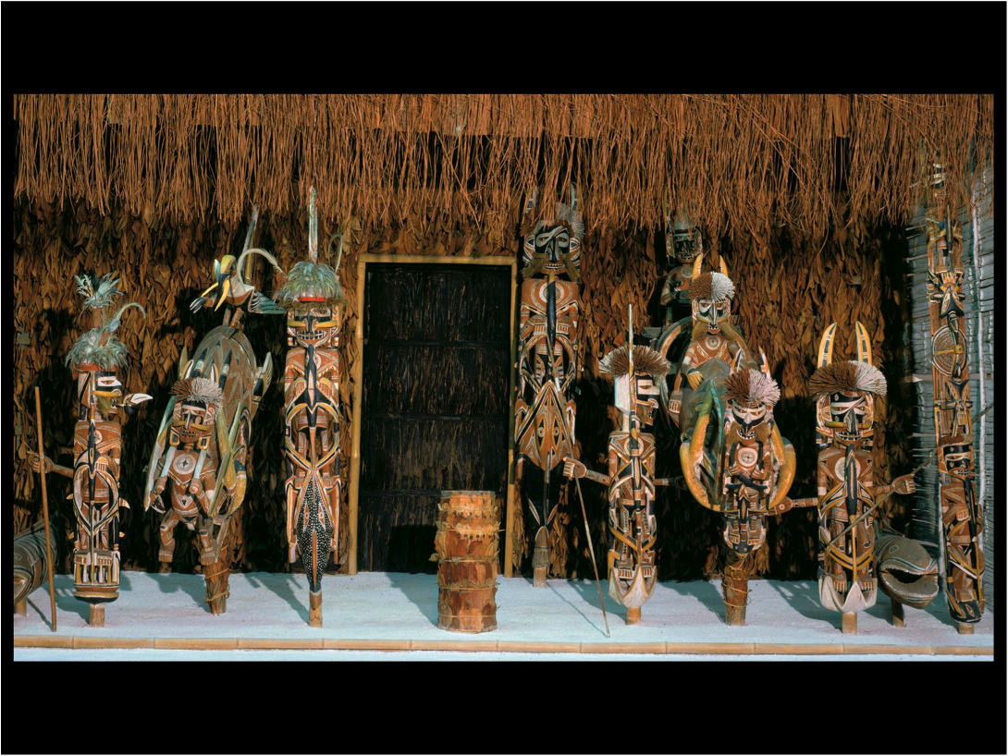  malagan.jpeg | Content:  Spectacular carvings are created and displayed during the final memorial ceremony commemorating the deceased, which often occurs months or years after death.  The figures essentially constitute a visual resume, representing the deceased's lifetime achievements in obtaining malagan rites.  The art of New Ireland traditionally centered on mortuary ceremonies and feasts to honor the dead. In northern New Ireland, the name given to these elaborate ceremonies is malagan, which is also the term used for the carved and painted sculptures associated with the ceremonies.  Style:  The works are subtractively carved and painted.  Contextual Understanding:  The term malagan refers collectively to a complex series of ceremonies and the visual art forms associated with them.  Various malagan rites mark nearly all-important stages of an individual's life.  The most numerous and impressive malagan carvings, however, are commissioned for display during the final memorial ceremony commemorating the deceased.  Throughout life, individuals seek to acquire rights, similar to Western copyrights, to specific malagan images and the rituals associated with them.  Men, in particular, compete to obtain rights to the greatest number of malagan, possession of which confers status and prestige.  The human and animal images in the carvings depict supernatural beings associated with individual clans, each of which represents a different manifestation of the single life-giving force that sustains the clan.  Performance of the final malagan rites frees the living from their obligations to the dead. Afterwards, the malagan carvings, having served their purpose, are destroyed, allowed to rot, or sold to outsiders.  There are several groups of the Malagan carvings – vertical figures (“kobokobor”), horizontal figures (“murumarua”), stacked figures (“eikuar”) and helmet masks (“tatanua”, “miteno” and “wanis”).  http://www.metmuseum.org/toah/works-of-art/1978.412.712
Malagan mask. New Ireland Province, Papua New Guinea. c. 20th  century C.E. Wood, pigment, fiber, and shell.  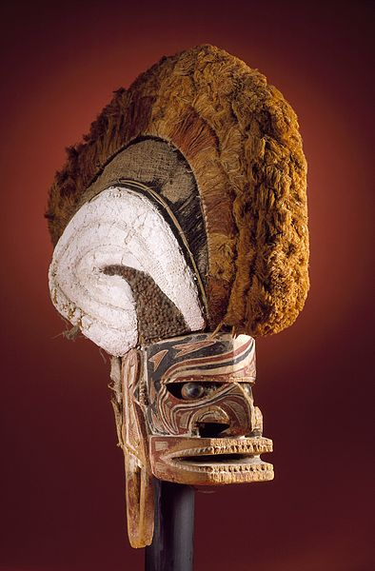  newirelandmask.jpeg | Content:  These masks are normally carved from lime wood, decorated with sugar cane fibers and wool or other animal hair, and painted using chalk and natural dyes.  Style:  The upper part consists of a cane framework held together with string and covered with bark cloth.  Tatanua masks are decorated differently on each side of the crest.  One side is often coated with lime. The crest is of yellow or reddish brown fiber. The face, normally carved from lime wood, is decorated with black, white and reddish brown pigment in an asymmetric design.  Contextual Understanding:  The tatanua mask represents the spirits of the dead who are believed to attend the ceremonies and participate in the dances.  The locals believe that the spirits of the ancestors are present in the mask worn by a dancer.  Villagers clearly associated the different tatanua masks with specific deceased relatives and believed the mask wearers to be the reappearance of the spirit of that individual.  ​In the past, the tatanua ceremony was an exclusive male ritual complex in the preparation of which contact with women was considered taboo, and took place in the men’s enclosure. During the ceremony, the carvings of the masks are painted then displayed on the front of the ceremonial house.  Some masks are used when lifting certain taboos. After the ceremony however, the carvings are disposed of: broken up, burnt, discarded in the forest or sold to outsiders.  https://www.boundless.com/art-history/textbooks/boundless-art-history-textbook/oceania-32/melanesia-197/new-ireland-711-7694/  http://www.turzart.com/new-ireland-malagan-mask.html

