Portrait of Sor Juana Inés de la Cruz. Miguel Cabrera. c. 1750 C.E. Oil on canvas.  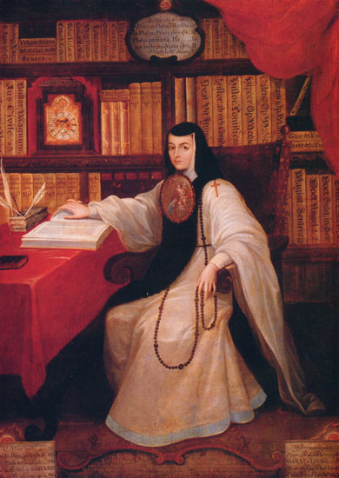 | Content:  The posthumous portrait by Miguel Cabrera shows Sor Juana in the distinctive habit of her order.  She wears her nun’s habit with the escudo de monja (nun’s shield) worn on the front of the habit, just under the face.  This was a painted copper medallion featuring a religious scene of the nun’s choosing. Her’s shows an Annunciation.  Her library contained an estimated 4,000 books, the largest collection in Mexico.  The portrait from 1750 shows her in her amazing library, surrounded by her many books.  Style:  The style is New Spanish Baroque.  The work is an oil on canvas.  Contextual Analysis:  In the relentlessly patriarchal society of New Spain, there was no place for a girl genius.  Juana Inés de la Cruz) was a prodigy: she could read and write by the age of three, was fluent in Latin by the age of ten, and by her late teens was famous for her brilliance in mathematics, theology, Greek logic, and history.  Yet there was no career open to her, no university she could attend. Juana became a nun because the convent was the only place a woman could pursue the life of the mind.  For 25 years, Sor Juana poured out a torrent of stunningly brilliant poems, plays, and letters, all the while battling with church authorities over whether women should be allowed to think.  Today she is revered as the first great poet of Latin America and the first feminist of the New World.
A Philosopher Giving a Lecture at the Orrery. Joseph Wright of Derby. c. 1763–1765 C.E. Oil on canvas.  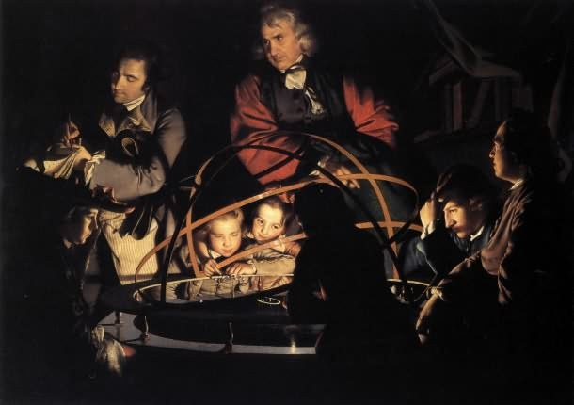 | Content:  An orrery an apparatus for representing the positions, motions, and phases of the planets, satellites, etc., in the solar system.  A lamp in the center represents the sun. In Wright’s composition, the lamp is not visible, but its reflections illuminate the faces of the audience.  Style:  The work is an oil on canvas executed in the Enlightenment period.  The works shows tenebrism with the lighting.  The placement of the figures copies the orrery because it is a circular composition. All the figures are properly lit in reference to the light source.  Contextual Analysis:  It was not unusual to behold such a scene in Wright’s time. In 18th century Britain science was becoming popularized with traveling public demonstrations. Wright very likely attended such demonstrations.  In Wright’s time, the word “philosopher” was a term indicating a scientist.  The work reflects the new enthusiasm for mechanical explanations for the wonders of the universe.
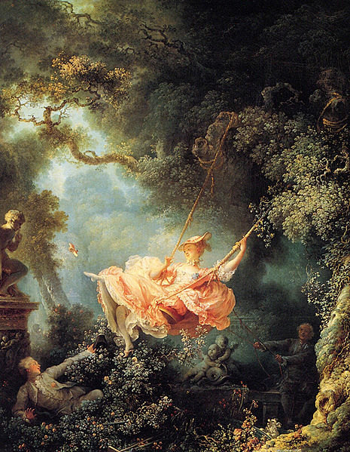  The Swing. Jean-Honoré Fragonard. 1767 C.E. Oil on canvas. | Content:  A woman is on a swing in a lush garden. A clergyman is pushing he in the swing, while he lover hides in the bushes so that he can look up her skirt.  Style:  The work is an intrigue painting.  The style is French Rococo.  Atmospheric perspective.  Rococo attributes can be seen in the bright colors, the painterly brushwork, and the light hearted subject matter.  The pastoral background and lush vegetation is an influence from the Fête Galante style.  Contextual Analysis:  The work is considered to be one of the masterpieces of the Rococo era.  Fragonard painted this for a wealthy patron who wanted to keep this in his private collection for decoration.  The patron is the man on the bottom left of the picture. The husband is in the dark/shadow of the tree.  It is indicative of the Rococo in its emphasis of movement with both the swing and the man taking action to look up his lover's dress.  Women on swings were a popular theme in Rococo paintings, indicative of their fickleness.  (http://quizlet.com/19463467/ap-art-history-rococo-neoclassical-art-flash-cards/)
Monticello. Virginia, U.S. Thomas Jefferson (architect). 1768–1809 C.E. Brick, glass, stone, and wood.  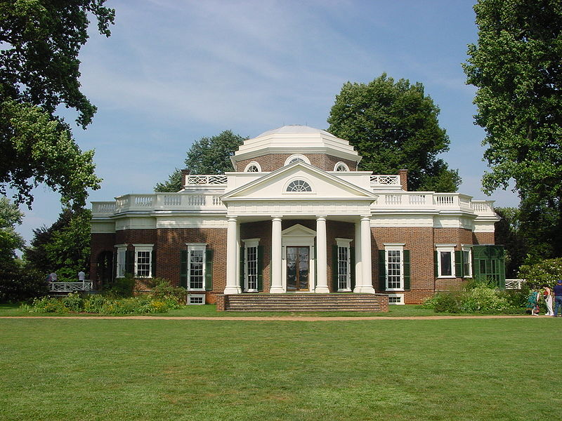 | Content:  "Little mountain" in Italian  Style:  The home is Neoclassical.  The building is a brick structure with, stucco applied to look like marble.  Inspired by Palladio and Roman ruins in France, Monticello had a cross-axial plan like its predecessors.  The structure has an octagonal dome.  There is an emphasis on symmetry, carried out through the use of lots of classical columns.  Contextual Analysis:  Jefferson’s stately self-designed home in Virginia became a model of American architecture.  The home is depicted on the back of the nickel.  The main house contains forty-three rooms.  Monticello contains the first dome ever installed on a house in America. It was added in 1800. The oculus, or glass, of the dome was made in Austria.  http://quizlet.com/19463467/ap-art-history-rococo-neoclassical-art-flash-cards/
The Oath of the Horatii. Jacques-Louis David. 1784 C.E. Oil on canvas.  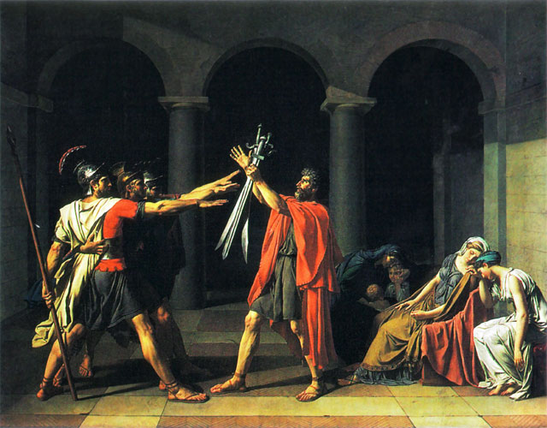 | Content:  The three Horatii sons salute their father who holds their swords as they prepare to protect Rome from the Curiatii of Alba Longa.  The figures are dressed in classicizing robes with roman arches in the back.  Style:  The work is an oil on canvas, 10'x14.'  This neoclassical painting uses Grand Manner style, which is linear and idealistic in physical features.  Contextual Analysis:  The composition is theatrical and the stoicism and rigid stances of the sons prove Rome's unwavering backbone.  Here, the women are more curved and free to lament their sorrow to contrast and heighten the men's stoicism.  Neoclassical works emphasize personal sacrifice for the nation and exemplum virtutis of the figures' virtue and courage.  Though only one of the three sons will live, since two of them receive curved instead of straight swords, they are prepared to die for Rome.  This is commissioned by King Louis XVI of France as an allegory of loyalty to the state, and became a popular image during the French Revolution.  http://quizlet.com/19463467/ap-art-history-rococo-neoclassical-art-flash-cards/
George Washington. Jean-Antoine Houdon. 1788–1792 C.E. Marble.  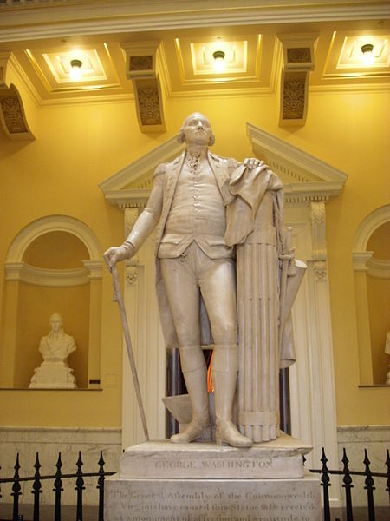 | Content:  The work shows George Washington on a contrapposto stance wearing his  military uniform.  Style:  Marble sculpture in Neoclassical style.  Contextual Analysis:  Houdon was the most accomplished Neoclassical sculptor in France.  The first President of the United States was measured for this  commissioned right after the Revolutionary War ended.  Washington disliked the classicized aesthetic.  The fasces--bundle of thirteen rods, symbolizes the power of the ruler and through unity. It is a symbol of antiquity.  The sword is out of his immediate grasp, meaning he has surrendered military power, and is resigned to the farm and civilian life style.  http://www.cram.com/flashcards/unit-4-ap-art-history-5328599
Self-Portrait. Elisabeth Louise Vigée Le Brun. 1790 C.E. Oil on canvas.  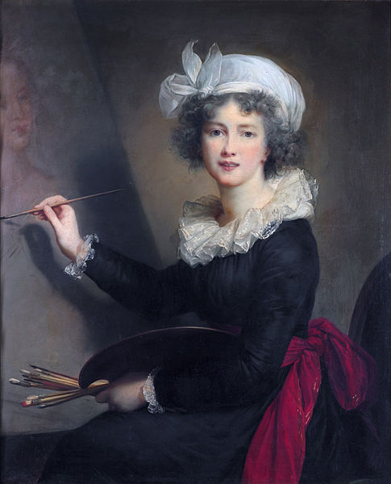 | Content:  The self-portrait painting herself confidently painting Queen Marie Antoinette.  She depicts herself as attractive, elegant, cheerful, and well dressed.  The mood is light lighthearted.  Style:  The portrait is Rococo in style.  The artist is known for her highly idealized self-portraits.  The portraits of Rubens inspired her.  Contextual Analysis:  Vigee Le Brun was famous for her portraiture for Marie Antoinette.  She is one of the few women admitted to France's Royal Academy of Painting and Sculpture.  http://quizlet.com/19463467/ap-art-history-rococo-neoclassical-art-flash-cards/
Y no hai remedio (And There’s Nothing to Be Done), from Los Desastres de la Guerra (The Disasters of War), plate 15. Francisco de Goya. 1810–1823 C.E. (published 1863). Etching, drypoint, burin, and burnishing.  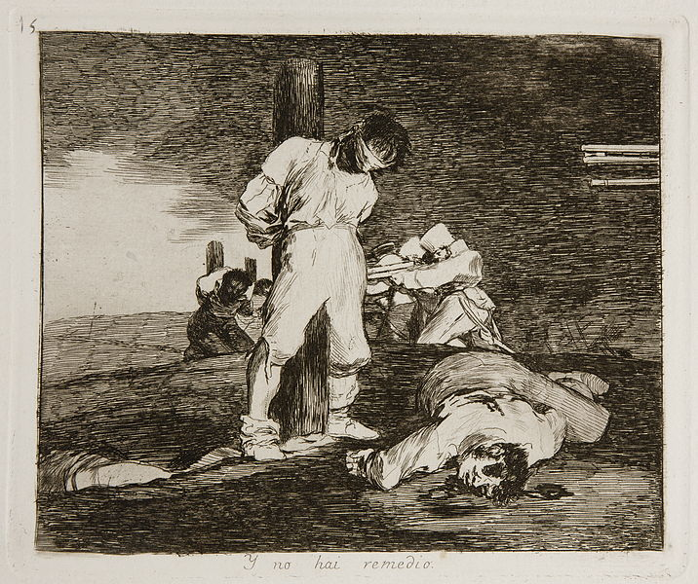 | Content:  Style:  Romanticism in style.  Intaglio print.  Conte Contextual Analysis:  The work shows the atrocities committed by each side in the Spanish War between Spain and France.  The Disasters of War Series has over 62 plates in the series.  The series was not published until after Goya's death. It was most likely not published during his lifetime because he would have gotten into trouble for the grotesque imagery.  The works started as a reaction to the conflict between Napoleon’s occupying army and the Spanish fighters.  -
La Grande Odalisque. Jean-Auguste-Dominique Ingres. 1814 C.E. Oil on canvas.  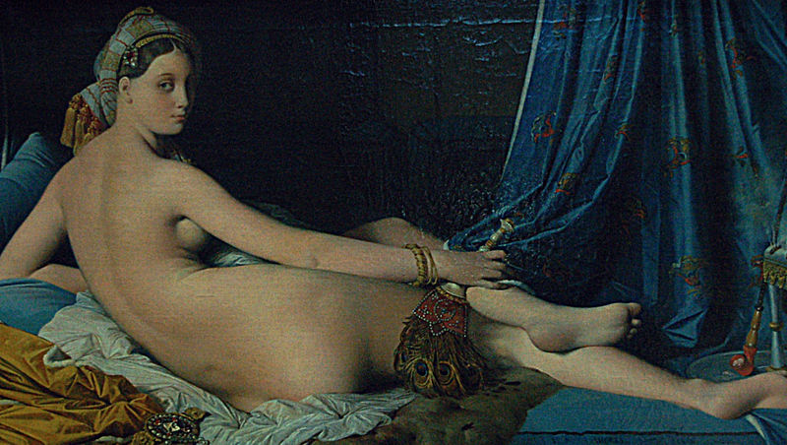 | Content:  The work depicts a harem girl, blacked out background; bold colors, reclining nude and sharp colors were influenced by Titian (High Renaissance).  Odalisque is a specific noun for reclining nudes of the women of the Turkish harem.  Style:  Oil on Canvas in the Romantic style.  Portrait  Contextual Analysis:  Titian was the first to introduce the reclining nude female. Ingres is going back to the Renaissance for this inspiration.  Exotic goods romanticize the idea of people and things elsewhere far away.  Ingres interweave own personal expression of the styles of the time and developing personal style
Liberty Leading the People. Eugène Delacroix. 1830 C.E. Oil on canvas.  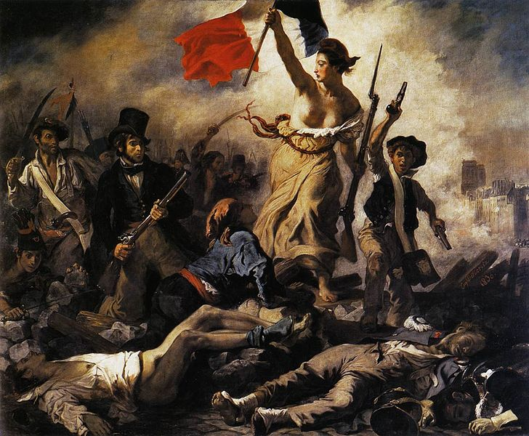 | Content:  A woman personifying the concept and the goddess of Liberty leads the people forward over the bodies of the fallen, holding the flag of the French Revolution – the tricolour flag, which remains France's flag – in one hand and brandishing a bayonetted musket with the other  Style:  Romantic work of art.  Triangular composition.  Contextual Analysis:  In this artwork Liberty is personified in the form of a vibrant, rebellious, bare breasted woman who leads the people to victory. She carries the flag proudly.  Thrilled to have a modern subject to paint, Delacroix took to the canvas with great pride and patriotism. Though he had not taken an active part in the fighting of the revolution he had done his share for his country.  Instead of guns and cannons he used an easel and a paintbrush - he felt it was his duty as a painter to record this event as the revolutionists felt it was their duty to fight.  http://www.artble.com/artists/eugene_delacroix/paintings/july_28:_liberty_leading_the_people  http://quizlet.com/21196925/romanticism-in-art-1800-1848-industrial-revolution-flash-cards/
The Oxbow (View from Mount Holyoke, Northampton, Massachusetts, after a Thunderstorm). Thomas Cole. 1836 C.E. Oil on canvas.  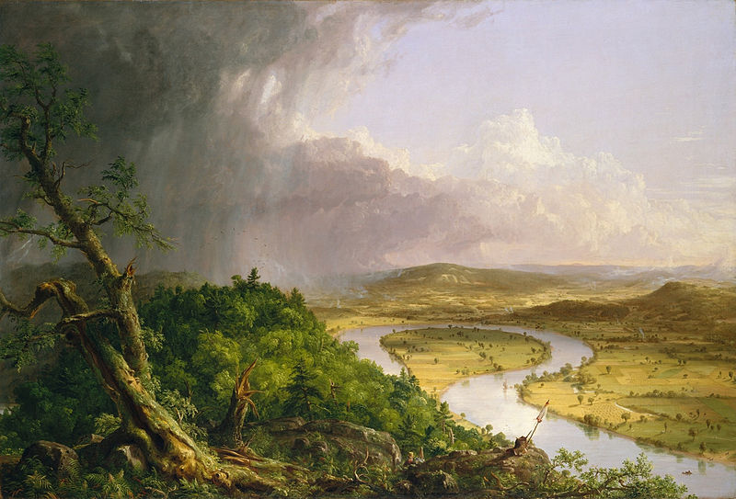 | Content:  The painting depicts a Romantic panorama of the Connecticut River Valley just after a thunderstorm.  Style:  The work is in the style of the Hudson River school.  The work is a landscape.  Contextual Analysis:  Cole is the founder of the Hudson River School.  The actual view is in Massachusetts.  Cole’s division of landscape into two clearly contrasting areas: the romantic on the left and the Claude-like landscape on the right.  The artist’s self-portrait is in the foreground amid a dense forest that is impenetrably thick, with broken trees, and a wild landscape with storms.  On the right: man’s touch is seen in light, cultivated fields, boats drifting down the river.  The work was painted as a reply to a British book that alleged that Americans had destroyed a wilderness with industry.  The left side is a sublime, fearful, wild, stormy view of nature - untouched by man, wild, untamed (summed up in the blasted tree symbolizing the brute force of nature).  The right side is peaceful, pastoral - nature subjugated by man.  The work speaks to the idea of manifest destiny.
Still Life in Studio. Louis-Jacques-Mandé Daguerre. 1837 C.E. Daguerreotype.  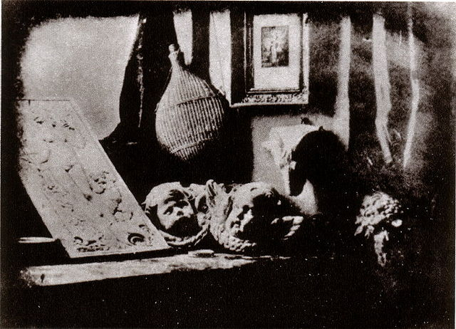 | Content:  The first of this type of photograph was created by the man after whom the process was invented.  Taken in 1837, the image features what looks like a desk against a table. Upon the table is an object, possibly a bottle with a wicker cover, and a couple of ornaments that have cherubic faces. The window has a curtain and on the wall is a painting. Daguerre set the scene in order to show how clearly his new method could show a range of objects.  A daguerreotype (original French: daguerreotype) was the first large-scale commercial photographic process.  Louis Daguerre together with Joseph Nicéphore Niépce developed it. Niepce had produced the first photographic image in the camera obscura using asphaltum on a copper plate sensitized with lavender oil that required very long exposures.  The image in a Daguerreotype is formed by amalgam i.e. a combination of mercury and silver. Mercury vapor from a pool of heated mercury is used to develop the plate that consists of a copper plate with a thin coating of silver rolled in contact that has previously been sensitized to light with iodine vapor so as to form silver iodide crystals on the silver surface of the plate.  Style:  Contextual Analysis:  Louis Daguerre produced pictures remarkable for the perfection of their details and for the richness and harmony.  In the carefully constructed scene, Still Life in Studio, Daguerre captured the details, the subtle shapes, the varied textures, and the diverse tones of light and shadow.  http://famous101.com/famous-daguerreotype-photography
Slave Ship (Slavers Throwing Overboard the Dead and Dying, Typhoon Coming On). Joseph Mallord William Turner. 1840 C.E. Oil on canvas.  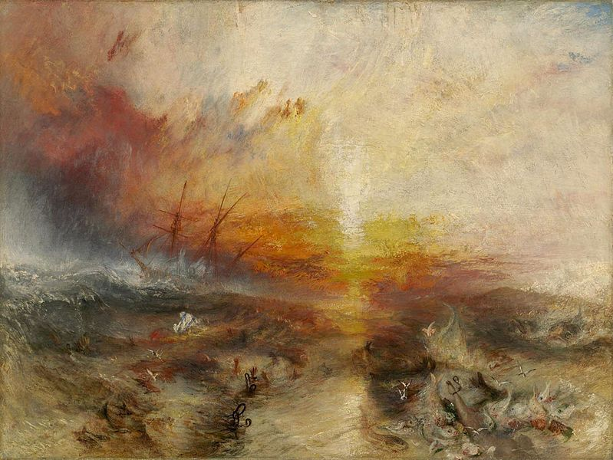 | Content:  William Turner was inspired to paint, "The Slave Ship" after the publishing of a book, "The History of the Abolition of the Slave Trade".  The painting depicts a ship, visible in the background, sailing through a tumultuous sea of churning water and leaving scattered human forms floating in its wake.  Style:  Romanticism is the period of the work.  Contextual Analysis:  This book by, Thomas Clarkson, characterized an incident that happened in 1783, involving a ship filled with slaves. Many of the slaves onboard were sick, but the captain's insurance company would not pay him for slaves that died on board the ship. He would only be paid for the slaves that were lost at sea. In order to earn the money he wished, he ordered all the sick and dying to jump off the ship and into the sea. It was a gruesome scene that influenced Turner to create his landscape. It is noted that the full title of "The Slave Ship" is really, "The Slave Ship (Slavers Throwing Overboard the Dead and Dying, Typhoon Coming On)".  The work is a perfect example of a romantic landscape painting.  His style is expressed more through dramatic emotion, sometimes taking advantage of the imagination.  Instead of carefully observing and portraying nature, William Turner took a landscape of a stormy sea and turned it into a scene with roaring and tumultuous waves that seem to destroy everything in its path.  .
Palace of Westminster (Houses of Parliament). London, England. Charles Barry and Augustus W. N. Pugin (architects). 1840–1870 C.E. Limestone masonry and glass.  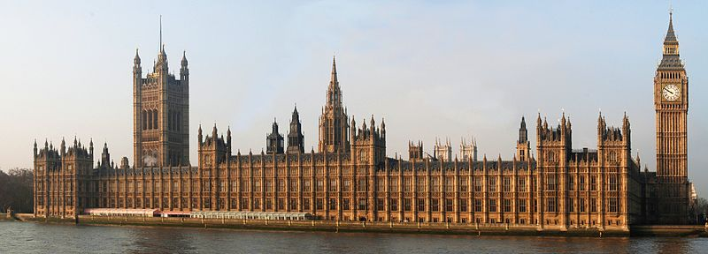 | Content:  The Palace of Westminster is the meeting place of the House of Commons and the House of Lords, the two houses of the Parliament of the United Kingdom.  The original medieval building complex was destroyed by fire in 1834, and its replacement New Palace that stands today.  Style:  The structure is load-bearing masonry.  The structure is Gothic Revival.  Contextual Analysis:  In the 18th century, Romantic architects adopt revival styles.  The Gothic style preferred as a more Christian and English style than Classicism.  In this period, architecture is seen as a reflection of society, should be judged by highest moral standard.  The structure has Gothic inspired features, but with a lower, more horizontal, symmetrical arrangement that Pugin found "too Greek."  http://quizlet.com/53307427/romanticism-works-of-art-flash-cards/

