Learning Object Script

Course Name and Number: AP Art History

Module Name: Module Thirteen

SME Name: Denease McCullough

DS Name: Courtney Perrin

Title of Learning Object: Shiva as Lord of the Dance

Purpose of Learning Object: Review

Narration Needed (Yes or No): No

Content for Learning Object (including answers):

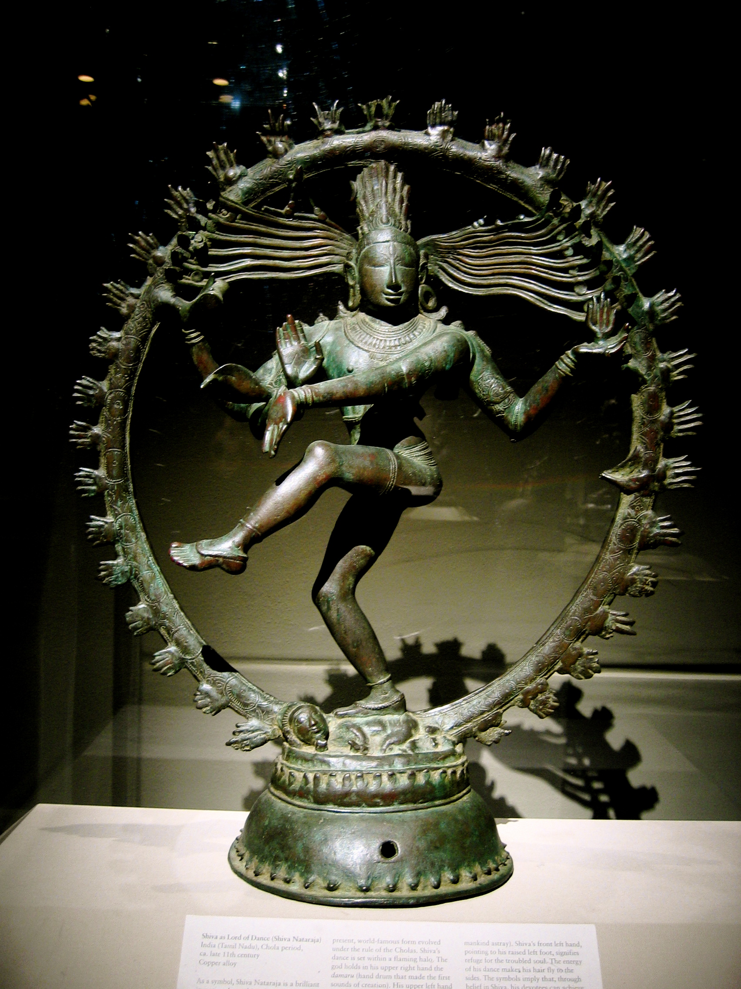

1.

4.

3.

5.

2.

dancingshiva.jpeg
- Flaming halo Shiva dances within a flaming arch that springs from a lotus base. The halo represents the cosmos.
- Pose Shiva's feet are in a dancing pose. His left leg is raised and his right foot is planted on the demon-dwarf, signifying that Shiva overcomes ignorance in the world.
- Multiple hands symbolize Shiva's multiple powers.
- The back right hand holds the drum, the symbol of creation. Sound was the first of the five elements that became manifest in the cosmos.
- The back left hand holds a flame within a bowl. The flame symbolizes destruction leading to creation.
- The front right hand is held in the gesture that tells the devotee to have no fear. This is the gesture of reassurance.
- The front left hand points to the raised leg in a gesture that is called 'like an elephant trunk" and signifies that Shiva's activities will bring salvation.
- Characteristics of the face and head
- Shiva's expression is aloof; he is absorbed in meditation.
- He has an all-seeing, all-knowing third eye.
- Shiva wears the matted locks of a yogi, or holy person. The hair is piled up into a crown at the top of his head. The strands flow towards the flaming halo and are adorned with flowers.
5. Characteristics of the Body
- Shiva wears a short skirt, known as a dhoti (pronunciation "doe-tee"), over which he wears a tiger skin.
- He wears much jewelry: necklace, armlets, bracelets, ankle bracelets, and finger and toe rings.
- A snake is wound around his arms.

Citation:
"Asian Art Outlook Slideshow." Asian Art Outlook Slideshow. Web. 4 Apr. 2015. <http://sites.asiasociety.org/education/AsianArt/slideshow3.htm>

Keywords for Learning Object:

Other files associated with Learning Object (images, etc.):

Image titles are under the pictures.

Citations:
http://www.angkorguide.net/en/temples/temples-in-angkor/angkor_wat/the-churning-of-the-sea-of-milk.html

