Last Judgement of Hu-Nefer, (Book of the Dead)
New Kingdom, 19th Dynasty c. 1275 B.C.E
Source: www.khanacademy.org
Form: A principle of scale is shown as King Osiris is seen sitting down yet appears much larger than the other figures depicted
Context: This scroll is part of Hu-Nefer’s book of the dead, intended to guide him throughout the afterlife
Content: Only depicts once scene of many events Hu-Neffer would have experienced in the afterlife
Content: The scroll depicts a scene of Hu-Nefer entering the judgement area as his heart is weighed against a feather determining if he will be allowed into the afterlife
Material: A Papyrus Scroll
Form: Very rigid structure, figures are rigid, everything aligned in rows and columns, corresponds to much of Egyptian art
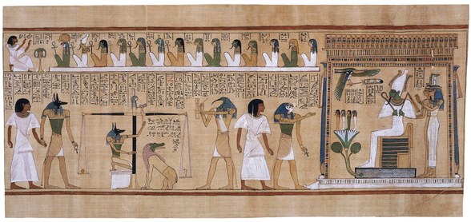
Material: The papyrus scroll itself is painted/written on with drawings and the use of hieroglyphics
Content: The strange beast ready to devour Hu-Nefer’s heart is called Ammit the “devourer” and eats the person’s heart if they do not prove to have lived an ethical life
Form: The scene itself reads from left to right
Context: Period/Style was post Amarna, New kingdom

